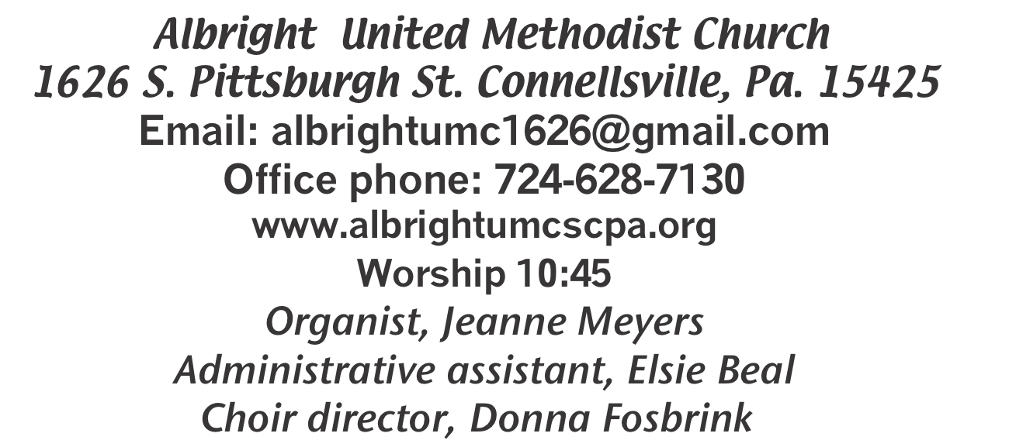



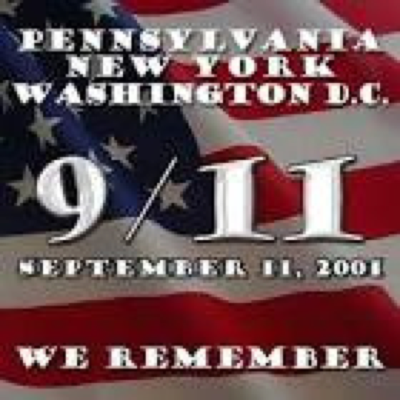

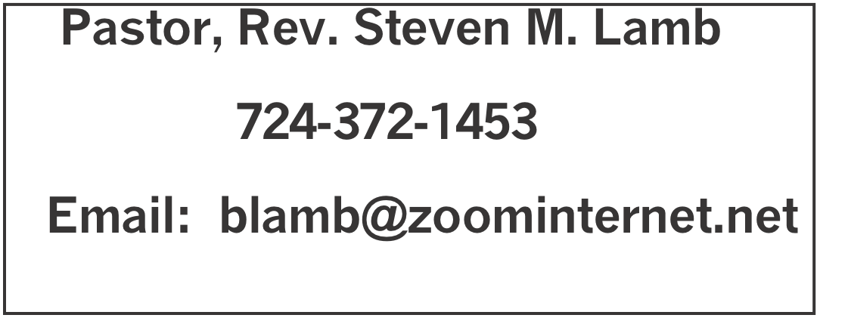

*********************************************************
September 6, 2026 Liturgist, Ed Jacobs 10:45a.m.
*********************************************************
WELCOME AND ANNOUNCEMENTS
PRELUDE “Footsteps of Jesus” Dr. A.B. Everett

BRINGING FORTH THE LIGHT

*OPENING HYMN “America the Beautiful” 696

*CALL TO WORSHIP
L: Come gather together here in the presence of Christ, who
is our friend and healer.
P: We have entered here, and in our worship together, we yearn
for hope and comfort.
L: Let us reach to the heart of Jesus, who is our life.
P: We encounter our Lord, who makes us whole.
L: Here we are welcome and loved and cherished.
P: Here we are the people of God. Let us rejoice and give God
praise.

*OPENING PRAYER
Gentle God, you shepherd us in times of trouble. When the way seems dark, you guide us safely through. When we cannot bear to slow down, you show us the wisdom of Sabbath rest. In your presence there is life, overflowing, abundant and free.
As we rest in your goodness, teach us, O Lord, to see with your heart. Open our eyes to the world beyond our neighborhoods, and to your beloved children both near to us and far. Open our hearts to the blessed fierceness of your creation, which sustains us and yet is more powerful than we can imagine.
Anoint us with your spirit of blessing, that we might be as Christ to one another, in our welcome, compassion and care. Amen.

*GLORIA PATRI 70

OLD TESTAMENT READING Exodus 12:1-14
The word of God for the people of God. Thanks be to God

SPECIAL MUSIC “Where were You” Pastor Steve Lamb

HOLY COMMUNION page 12

LORD’S PRAYER

CHILDREN’S MOMENT & Coin offering

PASSING THE PEACE

OFFERING
OFFERTORY “Will the Circle Be Unbroken” Pastor Steve
*DOXOLOGY
*OFFERTORY PRAYER

PRAYERS OFFERED IN PRAISE AND PETITION

PRAYER HYMN “And Can It Be that I Should Gain” 363

PASTORAL PRAYER

SILENT MEDITATION

EPISTLE READING Romans 13:8-14
The word of God for the people of God. Thanks be to God.
Thy Word is a lamp unto my feet and a light unto my path

MESSAGE “Put On The Lord”

*CLOSING HYMN “Sweet, Sweet Spirit” 334

*BENEDICTION

*POSTLUDE
***************************************************
WELCOME
We welcome you on this Labor Day weekend and the week we remember the attacks of 9/11/01. We are glad to have you with us today. If you are visiting, we hope to see you again next Sunday for our outdoor worship service.

PRAYER CONCERNS THIS WEEK
Don Heckathorne Ray & Nancy Knopsnider Trey Corvin Nassier Thompson Larry Murray
Jack Burke Tina Hiltabidel Lee Mimless Myra Holden Lincoln Dunseth
Twila Filler Larry Bloom Sr. Toni Hiltabidel Kirk Reed Jane Barnhart
Rob & Lynn Kifer Karl Siple Beth Lamb Gary Check Linda Burnworth
Priscilla Smiley Tammy & David Leeder Roger Richter Nancy Witner
Brennen Tressler Clyde Martz Sidney Scarry Kathy Andolina Nancy Uber
Darcy Grote Bill Shupe Jack Knopsnider Janet Snyder Mary Swope
J.R. Swope Karen Nicholson Jamie Mathias Jim & Deanna Sherbondy Jean Shaffer
Todd Porter Judy Morris Patty Blocker Joe Hernandez Katlin Olexa’s father
Earl Anthony Krissy Fisher Susan Gallagher Stefanie Gallagher Marty Halfhill
Mary Jo Bellish Wrin Nicholson Larry Millslagle Ronald Magee Larry Bloom
Ron Magee Jim Burkholder Michael Lamb Pastor Steve & Bev Rev. Paul Ritchey
Bishop Sandra Steiner Ball

Homebound persons: Polly Basinger, Fred & Joan Bates, Sue Corvin, Evelyn Curry, Sherrill Goodwin, Ray Knopsnider, Shirley Mathias, Stephanie Mattis, Ed Miller, Judy Morris,, Ozella Roy

Praise for answered prayers Unspoken Requests All Military
All churches Government leaders Folks with cancer
Those with dementia & their families Those traveling
Those battling addiction Folks on Hospice Homeless people Peace around the World Natural disasters Those with flu & covid Families of those who take their own life

If you want a name on prayer list, please use the prayer cards in the pew - give to acolytes or ushers.

THIS WEEK AT ALBRIGHT
MONDAY: Labor day
TUESDAY: United Women in Faith meeting 7:00
WEDNESDAY: Bible study 6:30
THURSDAY: Choir practice 7:00
SATURDAY: Basket making class 10:00
SUNDAY: Outdoor worship 10:45; picnic to follow

OFFICE HOURS: Tuesday, Wednesday, Thursday 10:00-3:00

September Happenings
7: Labor day
8: United Women in Faith meeting 7:00
10: Feeding the hungry 10:00 at Community Ministries
12: Basket making class 10:00
13: Outdoor worship and picnic
15: Feeding the hungry 10:00 at Community Ministries
15: Church council 7:00
17: Otterbein pasta meal 4-6
19: Saturday Morning Special 11:00
20: News deadline for Oct/Nov newsletter
22: Blue Plate Special 11-1
27: Anniversary Sunday celebrating 128 years at 10:45
Every Monday: T.O.P.S. meets 10 & 5
Every Wednesday: Bible study 6:30 lead by Pastor Steve
Every Thursday: Choir practice 7:00

BIBLE STUDY AT ALBRIGHT
Every Wednesday at 6:30 @ Albright. Led by Rev. Lamb. Everyone welcome!

CHARGE CONFERENCE
Will be Oct. 28 at Albright 6:00. Everyone is welcome to attend this important meeting in the church.

UNITED WOMEN IN FAITH
Will meet Tuesday, September 8 at 7:00. Linda Burnworth will have devotions and Elsie Beal & Kathy Hixson will host. All women of the church are urged to attend. We would be happy to see you.

BASKET MAKING CLASSES
Saturday, September 12 at 10:00 Elsie will be teaching a basket weaving class. Cost is $25. Anyone can make a basket.

OUTDOOR WORSHIP & PICNIC
Sunday, September 13 beginning with 10:45 worship; followed by a covered dish picnic in the pavillion. Bring a lawn chair for your comfort and a covered dish to share.

OUR STEWARDSHIP - August 30
Weekly need for budget ........................................... $ 2,493.30
Sunday offering (envelopes)....................................... $ 1,541.00
Connectional apportionments ....................................$ 98.00
(Original amount $13,536; as of 9/1 bal. is $11,414)
Worship attendance ...................................................... 61

GREETING YOU TODAY: Linda Burnworth
Sept. 13: Greg & Judy Beaver

LITURGIST: Sept. 13: Donna Fosbrink
Sept. 20: Jessica Bortz

ACOLYTES TODAY: Andrew Lynn & Maddox Sanner
Sept. 13: No acolytes for outdoor service
(Please use the schedule I gave you, not the newsletter schedule.)

JUNIOR CHURCH TODAY: Kathy Nebraski & Linda Burnworth
Sept. 13: No children’s church

USHERS: Jackie Bartholomai, Sherry Grote, Jeremy Gray, Ed Jacobs
9/13: Larry Bloom, Scott Murray, Doug Shaffer, Josh Shaffer

COUNTERS: September: Sue Harvey & Sherry Grote
October: Karen Stimmell & Jackie Bartholomai

FEEDING THE HUNGRY
Thursday, September 10 & Tuesday, September 15 at 10:00 at Connellsville Community Ministries. To volunteer to help, see Bev.

CHURCH COUNCIL
Will meet Tuesday, September 15 at 7:00. See you there.

PASTA MEAL
Thurs., Sept. 17 at Otterbein church 4-6 p.m.

SATURDAY MORNING SPECIAL
Saturday, September 19 at 11:00. A ministry for persons of all ages with special needs.

