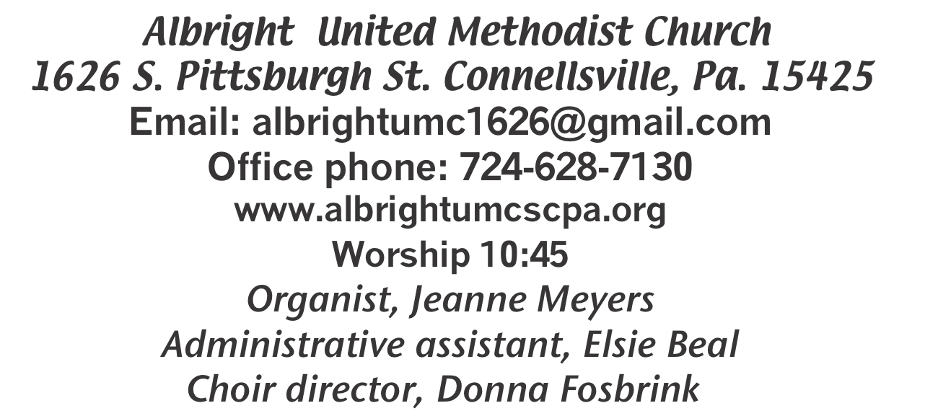

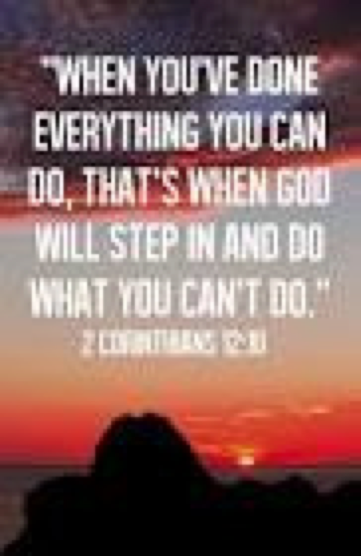

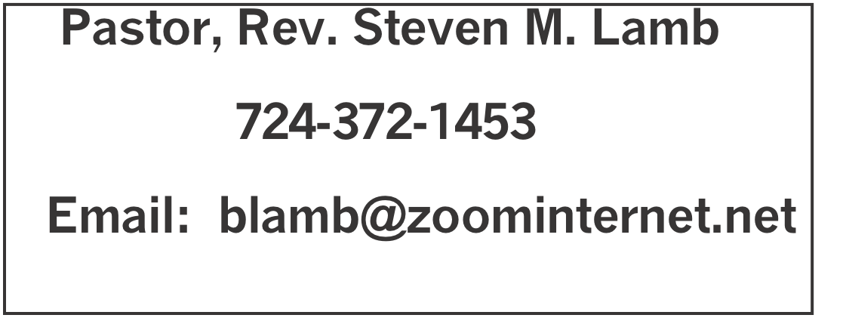

*********************************************************
August 30, 2026 Liturgist, Linda Burnworth 10:45a.m.
********************************************************
WELCOME AND ANNOUNCEMENTS
PRELUDE “Ivory Palaces” Barraclough

BRINGING FORTH THE LIGHT

*OPENING HYMN “Come, Christians Join to Sing” 158

*CALL TO WORSHIP
L: Like a whisper that lures us to safety
P: Strong as a shout that bids us to come,
L: Gentle as a prayer that eases our worry.
P: Like a clear bell that rings out our name,
L: Your Word comes to us, Loving God.
P: It calls us, comforts us, and urges us to depart from evil and
do good, to seek peace and pursue it.
L: Talking God, open our hearts to hear you.
P: And free our voices to praise you.

*OPENING PRAYER
Awesome and gracious God, mold us into a more holy and human shape; build us into a house of faith and freedom. Let our floor be the memories of your love woven through
history--how you freed the oppressed, healed our wounds, set our feet on the narrow path, and planted the stories of faith in our bones. Let our walls be the call to integrity and justice
-- to stand tall and firm for truth and freedom.
Let the roof be our assurance that you hover over us to bring blessing and that you long to shelter all your creation from the stormy blast and the terrors of night.
Let the windows and doors be avenues to the Spirit, who brings light and truth, friends and strangers. Awesome and gracious God, build us into a more holy and human
community, a household of hospitality and mission. Amen

*GLORIA PATRI 70

OLD TESTAMENT READING Exodus 3:1-15
The word of God for the people of God. Thanks be to God.

SPECIAL MUSIC Shelley & Dave Mattis & friends

CHILDREN’S MOMENT & Coin offering

PASSING THE PEACE

OFFERING
OFFERTORY Special music: Shelley, Dave & friends
*DOXOLOGY
*OFFERTORY PRAYER

PRAYERS OFFERED IN PRAISE AND PETITION

PRAYER HYMN “Lord of the Dance” 261

PASTORAL PRAYER

SILENT MEDITATION

THE LORD’S PRAYER

EPISTLE READING Romans 12:9-21
The word of God for the people of God. Thanks be to God.
Thy Word is a lamp unto my feet and a light unto my path

MESSAGE “Overcoming Evil”

*CLOSING HYMN “His Name is Wonderful” 174

*BENEDICTION

*POSTLUDE
************************************************
WELCOME
Welcome to everyone who has come to this worship service. Welcome those around you. If you are new, please introduce yourself to others. Go from here feeling blessed and be a blessing to others.

PRAYER CONCERNS THIS WEEK
Don Heckathorne Ray & Nancy Knopsnider Trey Corvin
Nassier Thompson Larry Murray Jack Burke
Tina Hiltabidel Lee Mimless Myra Holden
Lincoln Dunseth Twila Filler Larry Bloom Sr.
Toni Hiltabidel Kirk Reed Jane Barnhart
Rob & Lynn Kifer Karl Siple Beth Lamb
Gary Check Linda Burnworth Priscilla Smiley
Tammy & David Leeder Roger Richter Nancy Witner
Brennen Tressler Clyde Martz Barb Lynch
Rev. Bob Zilhaver Sidney Scarry Kathy Andolina
Nancy Uber Darcy Grote Bill Shupe
Jack Knopsnider Janet Snyder Mary Swope
J.R. Swope Karen Nicholson Jamie Mathias
Jim & Deanna Sherbondy Jean Shaffer Brittney & Bristyn
Theresa Kerns Todd Porter Judy Morris
Patty Blocker Joe Hernandez Katlin Olexa’s father
Earl Anthony Krissy Fisher Susan Gallagher
Stefanie Gallagher Marty Halfhill Mary Jo Bellish
Wrin Nicholson Larry Millslagle Ronald Magee
Larry Bloom Pastor Steve & Bev Rev. Paul Ritchey
Bishop Sandra Steiner Ball

Homebound persons: Polly Basinger, Fred & Joan Bates, Sue Corvin, Evelyn Curry, Sherrill Goodwin, Ray Knopsnider, Shirley Mathias, Stephanie Mattis, Ed Miller, Judy Morris, Ozella Roy

Praise for answered prayers Unspoken Requests All Military
All churches Government leaders Those with cancer
Our country Those battling addiction Those on Hospice Travelers
Homeless people World Peace
Those with flu & covid Families of those who take their own life

If you want a name put on prayer list, please use the prayer cards in the pew - give to acolytes or ushers

THIS WEEK AT ALBRIGHT
TODAY: Potluck lunch after church
TUESDAY: Trustee meeting 6:30
WEDNESDAY: Bible study 6:30 at Albright
SUNDAY: Special music: Pastor Steve

OFFICE HOURS: Tuesday, Wednesday, Thursday 10-3

September Happenings
1: Trustee meeting 6:30
2: Bible study 6:30 lead by Pastor Steve
7: Labor day
8: United Women in Faith meeting 7:00
10: Feeding the hungry 10:00 at Community Ministries
12: Basket making class 10:00
13: Outdoor worship and picnic
15: Feeding the hungry 10:00 at Community Ministries
15: Church council 7:00
17: Otterbein pasta meal 4-6
19: Saturday Morning Special 11:00
20: News deadline for Oct/Nov newsletter
22: Blue Plate Special 11-1
27: Anniversary Sunday celebrating 128 years at 10:45
Every Monday: T.O.P.S. meets 10 & 5
Every Wednesday: Bible study 6:30 lead by Pastor Steve
Every Thursday: Choir practice 7:00

POTLUCK COVERED DISH
TODAY after church we will have our 5th Sunday potluck covered dish lunch. Please stay and join us!

BIBLE STUDY AT ALBRIGHT
Every Wednesday at 6:30. Lead by Rev. Lamb. Everyone welcome!

CHARGE CONFERENCE
Will be Oct. 28 at Albright 6:00. In preparation for the charge conference the following meeting has been scheduled.
Tuesday, September 1 at 6:30 - Trustee meeting
Members: Don Whittaker, Glenn Siple, Jeremy Gray, Karen Stimmell, Jane Barnhart, Fred Grote, Larry Bloom, David Mattis, Dustin Murray, Randy Fisher

UNITED WOMEN IN FAITH
Will meet Tuesday, September 8 at 7:00. Linda Burnworth will have devotions and Elsie Beal & Kathy Hixson will host. All women of the church are urged to attend. We would be happy to see you.

OUR STEWARDSHIP - August 23
Weekly need for budget ........................................... $ 2,493.30
Sunday offering (envelopes)....................................... $ 1,697.75
Connectional apportionments ....................................$ 83.00
Worship attendance ...................................................... 53

GREETING YOU TODAY: Pamela Lynn
Sept. 6: Linda Burnworth

LITURGIST: Sept. 6: Ed Jacobs
Sept. 13: Donna Fosbrink

ACOLYTES TODAY: Thelma Swope & Kadey Shaffer
Sept. 6: Andrew Lynn & Emmaleigh Kalemba
(Please use the schedule I gave you, not the newsletter schedule.)

JUNIOR CHURCH TODAY Dave & Shelley Mattis
Sept. 6: Kathy Nebraski & Linda Burnworth

USHERS: Volunteers
9/6:Jackie Bartholomai, Sherry Grote, Jeremy Gray, Ed Jacobs

COUNTERS: August: Linda Burnworth & Emilie Davis
September: Sue Harvey & Sherry Grote

FEEDING THE HUNGRY
Thursday, September 10 & Tuesday, September 15 at 10:00 at Connellsville Community Ministries. To volunteer to help, see Bev.

OUTDOOR WORSHIP & PICNIC
Sunday, September 13 beginning with 10:45 worship; followed by a covered dish picnic in the pavillion. Bring a lawn chair for your comfort and a covered dish to share.

BASKET MAKING CLASSES
Saturday, September 12 at 10:00 Elsie will be teaching a basket weaving class. Cost is $25.

