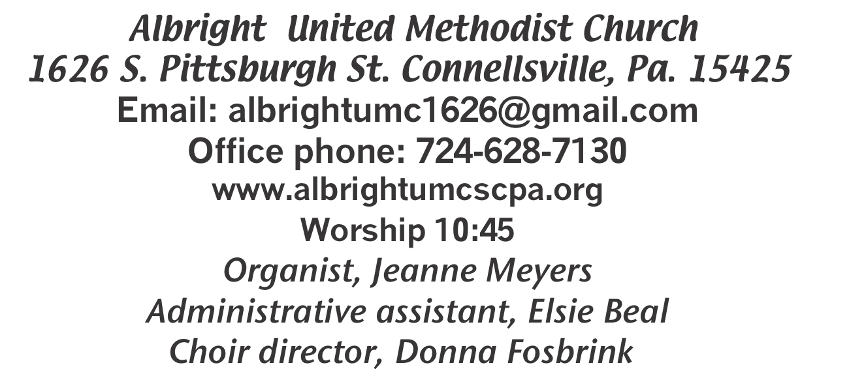

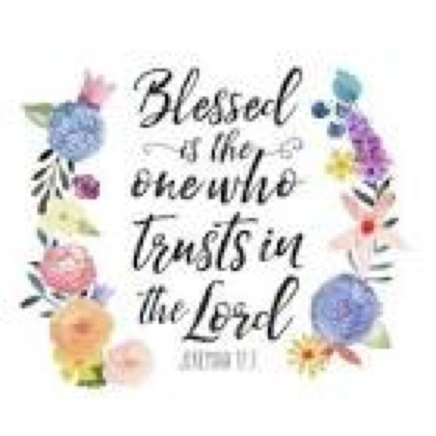

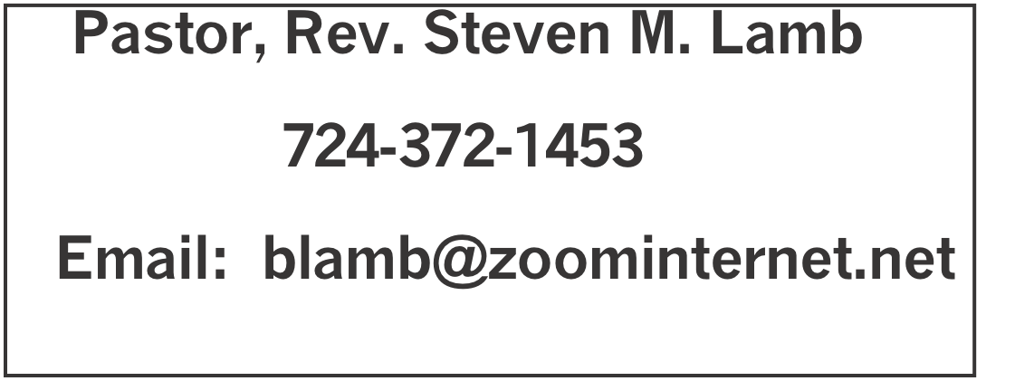

*********************************************************
July 19, 2026 Liturgist, Mark Flair 10:45a.m.
********************************************************
WELCOME AND ANNOUNCEMENTS
PRELUDE “Jesus Will Outshine Them All” Jensen
BRINGING FORTH THE LIGHT

*OPENING HYMN “How Great Thou Art” 77

*CALL TO WORSHIP
L: Let the biblical story be the story of our worship today.
Jacob paused on his journey to Haran and rested.
P: Let us also pause along our journey. May this worship be a time of re-creation for weary souls.
L: Jacob dreamed of a ladder connecting heaven and earth; angels ascended and descended.
P: May the space between heaven and earth be thin and
transparent; let us enter God’s presence in prayer, proclamation and song.
L: God said to Jacob: “I am the God of your ancestors. I will
provide for you.”
P: Let us worship the God who governs all time, who holds past,
present and future in providential care.
L: Jacob awoke from his dream, and in gladness he cried:
“Surely God is in this place, and I did not know it!”
P: Surely God is in this place!
L: Surely, God is!
P: Let us rejoice in this assurance! Let us worship God!

*OPENING PRAYER
Holy God, like a loving father and caring mother, you watch over us and beckon us to follow the right path. But we get stuck: stopped by our fear of trying something new, trapped by our memories of past failures, caught in a web of conflicting choices, halted by the clamor of many voices. We know the distress of worry and the blur of tears. Like staring at an empty page, we feel trapped and hesitant. Free us, O God, to follow with joyful steps, to hear clearly your directions, to be bold in our loving, courageous in our caring and brave in our speaking. Through our Lord, Jesus. Amen.

*GLORIA PATRI 70

GOSPEL READING Matthew 13: 24-30, 36-43
The word of God for the people of God. Thanks be to God.

SPECIAL MUSIC Emma Karfelt

PASSING THE PEACE

OFFERING
OFFERTORY Special music: Emma Karfelt
*DOXOLOGY
*OFFERTORY PRAYER

PRAYERS OFFERED IN PRAISE AND PETITION

PRAYER HYMN “What Wondrous Love is This” 292

PASTORAL PRAYER

SILENT MEDITATION

THE LORD’S PRAYER

OLD TESTAMENT READING Genesis 28: 10-19a
The word of God for the people of God. Thanks be to God.
Thy Word is a lamp unto my feet and a light unto my path

MESSAGE “Benchmarks”

*CLOSING HYMN “Sweet, Sweet Spirit” 334

*BENEDICTION

*POSTLUDE

****************************************************
WELCOME
Welcome on this warm summer day. We are glad you are here and we pray God’s blessings on you and your loved ones. See you next Sunday.

PRAYER CONCERNS THIS WEEK
Don Heckathorne Ray & Nancy Knopsnider Trey Corvin Nassier Thompson Larry Murray
Jack Burke Tina Hiltabidel Jim & Deanna Sherbondy Lee Mimless Myra Holden
Lincoln Dunseth Twila Filler Larry Bloom Sr. Toni Hiltabidel Kirk Reed
Jane Barnhart Rob & Lynn Kifer Karl Siple Beth Lamb Gary Check
Tammy & David Leeder Roger Richter Linda Burnworth Priscilla Smiley Kyle-lukemia
Clyde Martz Kylie Matthews Nancy Witner Brennen Tressler Barb Lynch
Rev. Bob Zilhaver Donna Yauger Jay Whipkey Sidney Scarry Kathy Andolina
Fred Grote James Martin Candy Shire Rck Fosbrink Donna Fosbrink
Nancy Uber Darcy Grote Bill Shupe Aaron Nicholson Ronald Gallagher
Joyce Yohler Jack Knopsnider Janet Snyder Bob Hartley Mary Swope
J.R. Swope Tom Hudoc Daneen Scarry Karen Nicholson Kayla Snyder
Christy – flooded New Charge New districts Pastor Steve & Bev Rev. Paul Ritchey
Bishop Sandra Steiner Ball

Homebound persons: Jane Barnhart, Polly Basinger, Fred & Joan Bates, Sue Corvin, Evelyn Curry, Sherrill Goodwin, Ray Knopsnider, Clyde Martz, Shirley Mathias, Stephanie Mattis, Ed Miller, Judy Morris, Ozella Roy

Praise for answered prayers Unspoken Requests All Military
All churches Government leaders Folks with cancer Those traveling Those battling addiction Folks on Hospice Homeless people Peace around the World Those with flu & covid Those cleaning up after floods
Families of those who take their own life
If you want a name on prayer list, please use the prayer cards in the pew - give to acolytes or ushers

THIS WEEK AT ALBRIGHT
THIS WEEK: Decorating for Vacation Bible School
TUESDAY: Feeding the hungry 10-1 at Community Ministries
SUNDAY: Special music by Eve Shupe & Ed Jacobs

OFFICE HOURS: Tuesday, Wednesday, Thursday 10:00-3:00

July Happenings
19: News deadline for Aug./Sept. newsletter
20-24: Decorating for Vacation Bible School
26: VBS Introduction & pre-registration
28: Blue plate special 11-1
August Happenings
2: Picnic with Otterbein at Yough Park 12:30
3-7: Vacation Bible School 6:00-8:30 p.m.
8: Basket weaving class 10:00
9: V.B.S. Program 10:45
13: Feed the hungry 10-1 at Community Ministries
18: Feed the hungry 10-1 at Community Ministries
20: Otterbein pasta meal 4-6
25: Blue Plate special lunch 11-1
30: Potluck after church
Every Monday: T.O.P.S. meets 10 & 5

BASKET MAKING CLASSES
Saturday, August 8 & September 12 at 10:00 Elsie will be teaching a basket weaving class. Cost is $25. You will make a basket to take with you. Please let Elsie know if you plan to attend.

BLUE PLATE SPECIAL
Tuesday, July 28 at 11:00-1:00. Light lunch including beverage and dessert. Free with donations accepted. $5 for take out.

YOU ARE INVITED TO PICNIC WITH US!
Sunday, August 2 at 12:30. Otterbein church will be hosting a picnic at Yough Park. It is covered dish. Come and join us for the fun and fellowship.

NOTE RECEIVED
Hi everyone!
Hope this finds everyone doing well. We are all pretty good - knock on wood.
Hey, remember those frigid temps we suffered through in January? When we wished for a warm summer day to thaw our creaking joints? Well, be careful what you wish for!!
Hope everyone is enjoying summer! Love, Gayle Martin

OUR STEWARDSHIP - July 12
Weekly need for budget ........................................... $ 2,493.30
Sunday offering.(Envelopes)..................................... $ 2,189.00
Connectional apportionments ................................. $ 46.00
V.B.S. donations ......................................................... $ 130.00
Worship attendance ...................................................... 59

GREETING YOU TODAY: Dave & Shelley Mattis
July 26: Priscilla Smiley

LITURGIST: July 26: Bev Lamb
August 2: Emma Karfelt

ACOLYTES TODAY: Keelan & Kayton Callahan
July 26: Damien Dunseth & Thelma Swope

JUNIOR CHURCH TODAY Bonnie & Larry Bloom
July 26: David & Shelley Mattis

USHERS: Linda Burnworth, Nancy Mimless, Chris Lynn, Paul Bortz
7/26: Jeremy Gray, Kelli Armstrong, Ed Jacobs, Kay Jacobs

COUNTERS: July: Sandy Russell & Rick Tressler
August: Linda Burnworth & Emilie Davis

FEEDING THE HUNGRY
Tues., July 21 at Connellsville Area Community Ministries 10-1. Volunteers are appreciated. To volunteer, see Bev Lamb.

2026 Vacation Bible School
August 3 to August 7 6 p.m. to 8:30 p.m.
Albright United Methodist Church

“Snowball Mountain Challenge to life”
Open to the public for children PreK to 7th grade.
(Older children can be volunteers)
Join us in finding your Strength in God!

Mia Sarnelli: VBS Director 724-858-9710 Email: miasarnelli429@gmail.com
If you are donating items or cash, please get them to the church as soon as possible. Thank you

July 20-24: We will be decorating for V.B.S.
July 26: Introduction to Vacation Bible School and pre registration.

