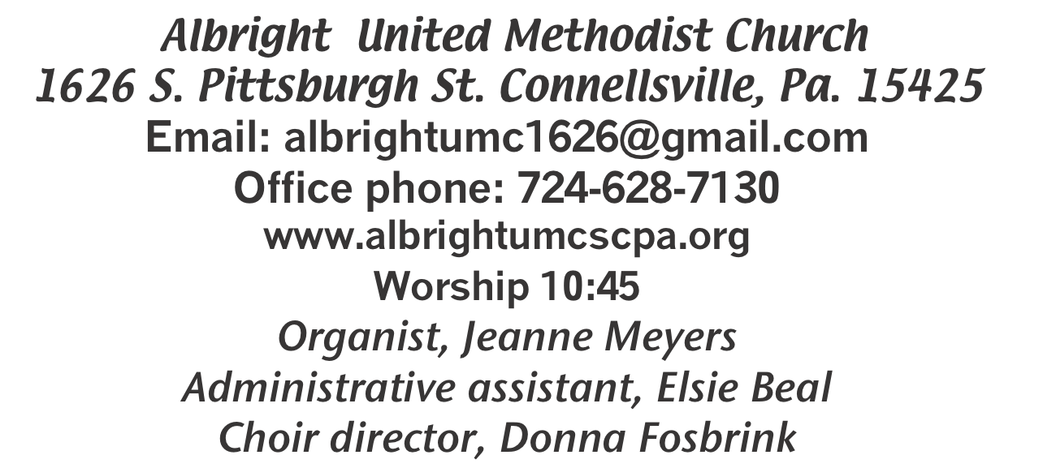



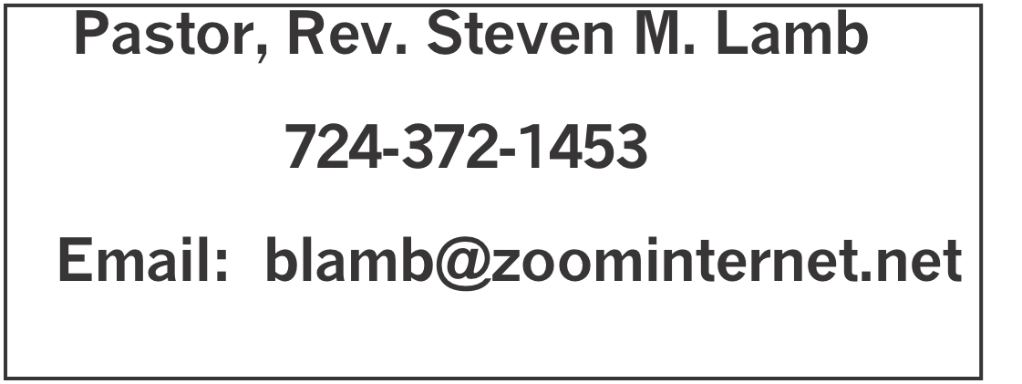

*********************************************************
March 8, 2026 Liturgist, Sherry Grote 10:45a.m.
Third Sunday in Lent
*********************************************************
WELCOME AND ANNOUNCEMENTS
PRELUDE “If That Isn’t Love” Rambo

BRINGING FORTH THE LIGHT

*OPENING HYMN “This is My Father’s World” 144

*CALL TO WORSHIP
One: We are looking for paradise here on Earth.
All: We are searching for a love that lasts.
One: We yearn for a glimpse of God.
All: We thirst for the fountain of life.
One: We hunger for lasting joy.
All: Our hearts ache for something more.
One: Bring all your hopes and longings to this place, for God is big enough to hold us all.
All: God’s love embraces us, calms us and strengthens us. God’s grace surprises us and causes us to sing.

*OPENING PRAYER
Holy God, we want our lives to matter. We want our time on this Earth to count for something — something meaningful, something important, something eternal. We do not want to lead shallow lives, squandering our time and energies on that which ultimately counts for nothing. And so, we come in humility, asking you to remake us.
Reorder our lives that we may truly delight in your word. Grant us wisdom to seek you above all else. Prune what is withered and lifeless in us. Most of all, give us your living water that we may grow and bear fruit for your kingdom. In the name of Christ, we pray. Amen.

*GLORIA PATRI 70

OLD TESTAMENT READING Exodus 17:1-7
The word of God for the people of God. Thanks be to God.

ANTHEM “This Is Amazing Grace”

CHILDREN’S MOMENT & Coin offering

PASSING THE PEACE

OFFERING
OFFEERTORY “Near The Cross” Doane
*DOXOLOGY
*OFFERTORY PRAYER

PRAYERS OFFERED IN PRAISE AND PETITION

PRAYER HYMN “Rock of Ages” 378

PASTORAL PRAYER

SILENT MEDITATION

LORD’S PRAYER

GOSPEL READING John 4:5-42
The word of God for the people of God. Thanks be to God.
Thy Word is a lamp unto my feet and a light unto my path

MESSAGE “Church Shopping”

*CLOSING HYMN “In The Garden” 314

*BENEDICTION
*POSTLUDE
********************************************************
WELCOME
On this Third Sunday in Lent we welcome all who have come to worship with us. We hope you are blessed and share that blessing with others this week.

PRAYER CONCERNS THIS WEEK
Don Heckathorne Ray Knopsnider Nassier Thompson
Trey Corvin Larry Murray Jack Burke
Tina Hiltabidel Patty Lint Jim & Deanna Sherbondy
Lee Mimless Myra Holden Lincoln Dunseth
Twila Filler Larry Bloom Sr. Toni Hiltabide
Kirk Reed Joe Husak Jane Barnhart
Lynn Kifer Wanda Brooks Lisa Evans
Tammy & David Leeder Dale Kesler Bob Shoenberger
Karl Siple Kathy Barnhart Gary Check
Pastor John Friend Nancy Knopsnider Lisa Rowen
Beth Lamb Adan Morris Marsha Hough
Doug Shaffer Paula Kershey Bob Sleighter
Roger Richter Jimi Ann Fosbrink Sandy Reich
Linda Burnworth Margaret Monosky Linda Blystone
Andrea Swan Sally Fosbrink Elsie Beal
Priscilla Smiley James’ nephew Judy Strickler
Tom Murphy Elaine Fosbrink Amber Smith
Stephanie McClain House fire victims Kyle-lukemia Pastor Steve & Bev Rev. Ross Pryor
Bishop Sandra Steiner Ball
DEEPEST SYMPATHY TO FAMILY & FRIENDS OF:
Jack Snyder, 69, who passed away February 27.
Diane Monaco, 75, who passed away February 28.

Homebound persons: Polly Basinger, Fred & Joan Bates, Etheel “Sis” Cole, Sue Corvin, Evelyn Curry, Sherrill Goodwin, Chuck Hall, Ray Knopsnider, Shirley Mathias, Stephanie Mattis, Ed Miller, Judy Morris,, Ozella Roy
Praise for answered prayers Unspoken Requests All Military
All churches Government leaders Folks with cancer Those traveling Those battling addiction Folks on Hospice Homeless people OUR COUNTRY
Those with flu & covid Families of those who take their own life
If you want a name on prayer list, please use the prayer cards in the pew-give to acolytes or ushers.

THIS WEEK AT ALBRIGHT
TUESDAY: United Women in Faith meeting 7:00
WEDNESDAY: Bible study 6:30
THURSDAY: Feeding the hungry
Choir practice 7:00
SATURDAY: Soup sale 10-1
Craft/Vendor Show 9-2

OFFICE HOURS: Tuesday, Wednesday, Thursday 10:00-3:00

March Happenings
10: United Women in Faith meeting 7:00
12: Feed the hungry at Community Ministries
14: Craft Vendor Show 9-2; and Soup sale 10-1
17: Feed the hungry at Community Ministries
17: Church council meeting 7:00
19: Otterbein pasta meal 4-6
21: Saturday Morning Special 11:00
22: News deadline for April/May newsletter
24: Blue Plate Special 11-1
29: Palm Sunday/ Potluck covered dish after church
Every Monday: T.O.P.S. (Take Off Pounds Sensibly) 10a.m. or 5p.m.
Every Wednesday: Bible study 6:30
Every Thursday: Choir practice 7:00 (Except Maundy Thursday

WEEKLY BIBE STUDY
Every Wednesday at 6:30 we have Bible study. Everyone is welcome

UNITED WOMEN IN FAITH
The United Women in Faith will meet Tues., March 10 at 7PM. Shelley M. will host & Donna will have a brief devotional. Angie Hamman from Angie’s Flower Garden will be here to talk about spring plants. All are welcome so come, enjoy some food & fellowship and bring your questions about plants. Hope to see you there.

FEEDING THE HUNGRY
Thurs., 3/12 & Tues., 3/17 @ 10-1 at Community Ministries.
Volunteers appreciated. To volunteer, see Bev.

CRAFT/VENDOR SHOW & SOUP SALE
Sat., March 14 @ 9-2. $25 first table; $20 each additional table. Contact Bev 724-372-1456 of call the office if you would like to set up a table. SOUP SALE: March 14 at 10-1. Please donate soups. If you can’t donate, please support it. $7 pint; $9 quart for take out. Eat in for a donation of your choice.

SATURDAY MORNING SPECIAL
This ministry for persons with special needs is Saturday, March 21 at 11:00.

APRIL/MAY NEWSLETTER
News deadline is March 22. Get any information to Elsie by that date. Thank you.

OUR STEWARDSHIP - March 1
Weekly need for budget ........................................... $ 2,493.30
Sunday offering......................................................... $ 3,334.01
Worship attendance ...................................................... 73

GREETING YOU TODAY: Nancy Mimless & Ed Jacobs
Mach 15: Sally Fosbrink
LITURGIST: March 15: Eve Shupe
March 22: Bonnie Bloom
ACOLYTES TODAY: Damien Dunseth & Andrew Lynn
March 15: Thelma Swope & Estella Gallagher
JUNIOR CHURCH TODAY: Kelli Armstrong & Nancy Mimless
March 15: Larry & Bonnie Bloom
USHERS: Larry Bloom, Saott Murray, Sally Fosbrink, Doug Shaffer
3/15: Linda Burnworth, Pinky Smiley, Chris Lynn, Paul Bortz
COUNTERS: March: Sue Harvey & Sherry Grote
April: Karen Stimmell & Jackie Bartholomai

ATTENTION ALL MEN!!
Sat., March 21 at 8:00a.m. we invite all men of the church to join us for breakfast at Valley Dairy. We will discuss having a regular gathering for the men. Come and join us.

CHURCH COUNCIL MEETING
Will be Tuesday, March 17 at 7:00. Members are: Jeremy Gray, Rick Tressler, Linda Burnworth, Randy Fisher, Fred & Sherry Grote, Donna & Elaine Fosbrink, Shelley Mattis, Kelli Armstrong, Bev Lamb, Eve Shupe, Linda Leonard, Priscilla Smiley, Lynne Corvin, Jackie Bartholomai. If you are a member we would like to see you at these meetings. Any member of the church may also attend.

EASTER CANDY ORDERS
Order forms are out near the bulletins for you to order
Easter candy. We need paid orders by March 29.

EASTER FLOWERS
Please use the order forms to place paid orders for
Easter flowers. Last day to order is March 18.

POTLUCK COVERED DISH
Sunday, March 29 will be a potluck covered dish after church
Bring a dish to share and join us for the fellowship.
UPCOMING EVENTS AT ALBRIGHT

HOLY WEEK
Thursday, April 2 at 6:30p.m.:
Maundy Thursday Service at Otterbein
Friday, April 3 at 7:30 p.m.
Good Friday Service at Albright
Sunday, April 5 at 7:00a.m.
Easter Sunrise Service at Otterbein
followed by a light breakfast.
Sunday, April 5 at 9:00 a.m.
Otterbein United Methodist Church
Easter worship
Sunday, April 5 at 10:45 a.m.
Albright United Methodist Church
Easter worship

Saturday, April 18 at 4:00-7:00 p.m.
Chicken biscuit dinner & bake sale - a fundraiser for baby, Lincoln Dunseth (Grote) to help him get much needed equipment. Tickets are adult $12; child age 3-7 $7; under 3 free

Sunday, April 26 at 4:00
Calendar/Theme Party. A variety of themes will
be at various tables sponsored by individuals. Tickets are $12 each.
There will also be a Silent Auction.
See Sherry Grote for any questions or more info.

TRIP TO LANCASTER
Bev is hosting a bus trip to Lancaster on Thursday, June 18 to see the play about Joshua. Cost is $24O and includes meal at Shady Maple Restaurant, cost of play and bus. She needs reservations now so she can get good seats at the theater. If you are interested, please call her at 724-372-1456 or see her after church.
EASTER FLOWER ORDER FORM 2025
We will get them from Angie’s Flower Garden.
Cannot guarantee specific colors.

Your name ___________________________________________

Phone number: _________________________

Mums 6” $11.95________

In honor or memory of _________________________________________

Given by: __________________________________________________

Tulips: 6” $11.95________; 8” $16.50________; 10” $27.50________

In honor or memory of _________________________________________

Given by __________________________________________________

Lilies: 6” 3-5 bloom $13.95 ________

In honor or memory of _________________________________________

Given by ________________________________________________

Hyacinth: 6” $11.95 ____; 8” $16.50 ________

In honor or memory of _________________________________________

Given by ________________________________________________

Roses: 4” $11.50 _________ 6” $18.95 ________

In honor or memory of _________________________________________

Given by _______________________________________________

Total of my order $____________________

We need all paid orders by March 18. Make checks out to Angie’s Flower Garden.

