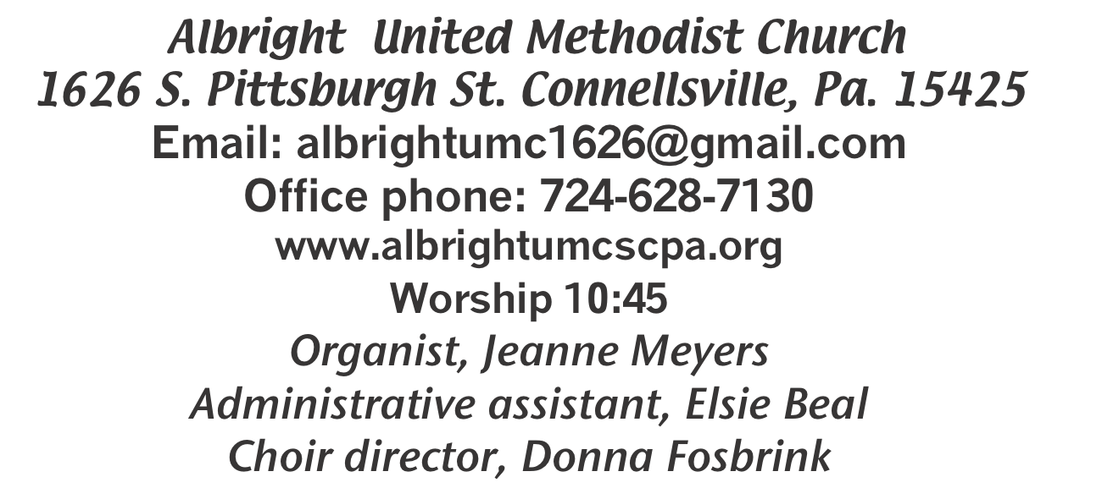

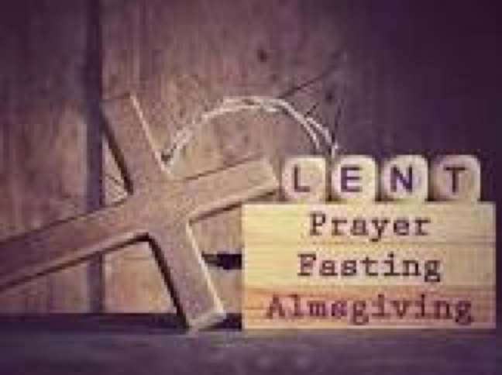

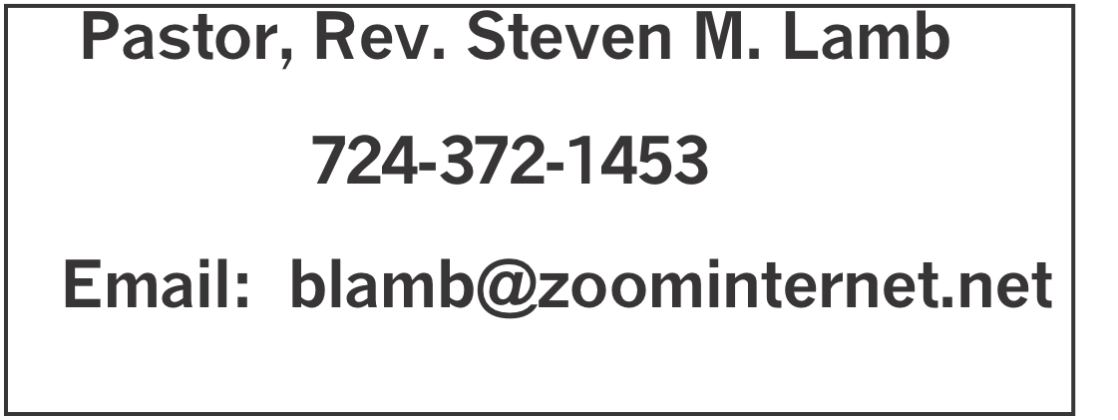

*********************************************************
March 22, 2026 Liturgist, Bonnie Bloom 10:45a.m.
Fifth Sunday in Lent
********************************************************
WELCOME AND ANNOUNCEMENTS
PRELUDE “The Old Rugged Cross Made the Difference”Gaither
BRINGING FORTH THE LIGHT

*OPENING HYMN “Only Trust Him” 337

*CALL TO WORSHIP
One: Day after day, an abundance of God’s love,
All: Morning by morning, new signs of blessing:
One: A gentle rain, an awesome sunset,
All: A friend’s embrace, a child’s smile,
One: A new insight, a sense of peace,
All: A shared meal, a treasured moment.
One: All around us and deep within us are signs of
God’s presence.
All: How can we not sing of God’s faithfulness?

*OPENING PRAYER
Turn our hearts, O God, from anxiety.
Turn them from sadness for what we have lost, or what we fear losing.
Turn them from dread of death itself.
Turn our hearts to the good news of the gospel: good news of resurrection and life! Amen.
*GLORIA PATRI 70

EPISTLE READING Romans 8:6-11
The word of God for the people of God. Thanks be to God

ANTHEM “Lamb of God”

CHILDREN’S MOMENT & Coin offering

PASSING THE PEACE

OFFERING
OFFERTORY “Lead Me to Calvary” Kirkpatrick
*DOXOLOGY
OFFERTORY PRAYER

PRAYERS OFFERED IN PRAISE AND PETITION

PRAYER HYMN “Where He Leads Me” 338

PASTORAL PRAYER

SILENT MEDITATION

THE LORD’S PRAYER

GOSPEL READING John 11:1-45
The word of God for the people of God. Thanks be to God.
Thy Word is a lamp unto my feet and a light unto my path

MESSAGE “A Tomb With A View”

*CLOSING HYMN“Surely the Presence of the Lord” 328
*BENEDICTION
*POSTLUDE
***************************************************
WELCOME
Welcome to our church on this fifth Sunday of Lent. We pray you will be blessed by hearing the Word of the Lord. Looking forward to seeing you next Sunday also.

PRAYER CONCERNS THIS WEEK
Don Heckathorne Ray Knopsnider Nassier Thompson
Trey Corvin Larry Murray Jack Burke
Tina Hiltabidel Patty Lint Jim & Deanna Sherbondy
Lee Mimless Myra Holden Lincoln Dunseth
Twila Filler Larry Bloom Sr. Toni Hiltabidel
Kirk Reed Joe Husak Jane Barnhart
Lynn Kifer Wanda Brooks Bob Shoenberger
Tammy & David Leeder Dale Kesler Karl Siple
Kathy Barnhart Gary Check Pastor John Friend
Nancy Knopsnider Beth Lamb Marsha Hough
Doug Shaffer Paula Kershey Bob Sleighter
Roger Richter Linda Burnworth Margaret Monosky
Sally Fosbrink Priscilla Smiley James’ nephew
Judy Strickler Amber Smith Stephanie McClain
Kyle-lukemia Rev. Marvin & Ann Watson Ralph Hough
Clyde Martz Richard Burnworth Pastor Steve & Bev
Rev. Ross Pryor Bishop Sandra Steiner Ball

Homebound persons: Polly Basinger, Fred & Joan Bates, Ethel “Sis” Cole, Sue Corvin, Evelyn Curry, Sherrill Goodwin, Chuck Hall, Ray Knopsnider, Shirley Mathias, Stephanie Mattis, Ed Miller, Judy Morris, Ozella Roy

Praise for answered prayers Unspoken Requests All Military
All churches Government leaders Folks with cancer Those traveling Those battling addiction Folks on Hospice Homeless people Peace around the World
Those with flu & covid Families of those who take their own life

If you want a name put on prayer list, please use the prayer cards in the pew - give to acolytes or ushers

THIS WEEK AT ALBRIGHT
TODAY: News deadline for April/May newsletter
Last day to order candy
TUESDAY: Blue Plate Special luncheon 11:00-1:00.
WEDNESDAY: Bible Study 6:30
THURSDAY: Choir practice 7:00
SATURDAY: Memorial service 11:00 for Fred’s mom
SUNDAY: Palm Sunday - pick up candy after church
Potluck covered dish after church
Movie “Jesus of Nazareth” part 1 6:30-8:30p.m.
Each evening 3/30, 3/31, 4/1

OFFICE HOURS: Tuesday, Wednesday, Thursday 10:00-3:00

HOLY WEEK
Showing “Jesus of Nazareth” at Albright on
March 29, 30, 31 and April 1 from 6:30-8:30

Thursday, April 2 at 7:00p.m.: Maundy Thursday
Service at Otterbein
Friday, April 3 at 7:30 p.m. Good Friday at Albright
Sunday, April 5 at 7:00a.m. Easter Sunrise Service at Otterbein followed by a light breakfast.
Sunday, April 5 at 9:00 a.m.Otterbein Church - worship
Sunday, April 5 at 10:45 a.m. Albright Church - worship

Saturday, April 18 at 4:00-7:00 p.m. Chicken biscuit
dinner & bake sale - a fundraiser for Lincoln (Grote)
Dunseth to help get much needed equipment. Tickets: adult $12; child age 3-7 $7; under age 3 free

Sunday, April 26 at 4:00 Calendar/Theme Party.
A variety of themes at various tables sponsored by individuals. Tickets $12 each for meal & silent auction. See Sherry Grote for any questions or more info.

March Happenings
22: News deadline for April/May newsletter
24: Blue Plate Special 11-1
29: Palm Sunday/ Potluck covered dish after church
Movie “Jesus of Nazareth” part 1 @ 6:30-8:30
30, 31, April 1: “Jesus of Nazareth” continued each night 6:30-8:30
Every Monday: T.O.P.S. (Take Off Pounds Sensibly) 10a.m. or 5p.m.
Every Wednesday: Bible study 6:30 (except April 1)
Every Thursday: Choir practice 7:00 (Except Maundy Thursday

WEEKLY BIBE STUDY
Every Wednesday at 6:30 we have Bible study. Everyone is welcome

APRIL/MAY NEWSLETTER
News deadline is March 22. Get any information to Elsie by today. Thank you.

POTLUCK COVERED DISH
Sunday, March 29 after church will be a covered dish lunch. Please bring a dish to share and join us for the fellowship.

EASTER CANDY ORDERS
Order forms are out near the bulletins for you to order
Easter candy. We need paid orders by TODAY. You may pick up orders March 29 after church.

A MEMORIAL SERVICE
Saturday, March 28 there will be a memorial service for
LaVonne Grote (Fred’s mother). You are coridally invited to attend in support for Fred and his family.

FEEDING THE HUNGRY
Tuesdays, April 14 & 21 @ 10-1 at Community Ministries.
Volunteers appreciated. To volunteer, see Bev.

OTTERBEIN PASTA MEAL
Thursday, April 16 at 4:00-6:00.

SATURDAY MORNING SPECIAL
Will meet Saturday, April 18 at 11:00

OUR STEWARDSHIP - March 15
Weekly need for budget ........................................... $ 2,493.30
Sunday offering......................................................... $ 1,404.00
Worship attendance ...................................................... 70

GREETING YOU TODAY: Jackie Bartholomai
March 29: Jackie Kimmel

LITURGIST: March 29: Karen Stimmell
April 5: Mark Flair

ACOLYTES TODAY: Aubree & Kadey Shaffer
March 29:Andrew Lynn & Emmaleigh Kalemba

JUNIOR CHURCH TODAY: David & Shelley Mattis
March 29: Mandy & Olivia Lynn

USHERS: Jeremy Gray, Scott Murray, Ed Jacobs, Larry Bloom
3/29: Volunteers - to volunteer see Karen Stimmell

COUNTERS: March: Sue Harvey & Sherry Grote
April: Karen Stimmell & Jackie Bartholomai

