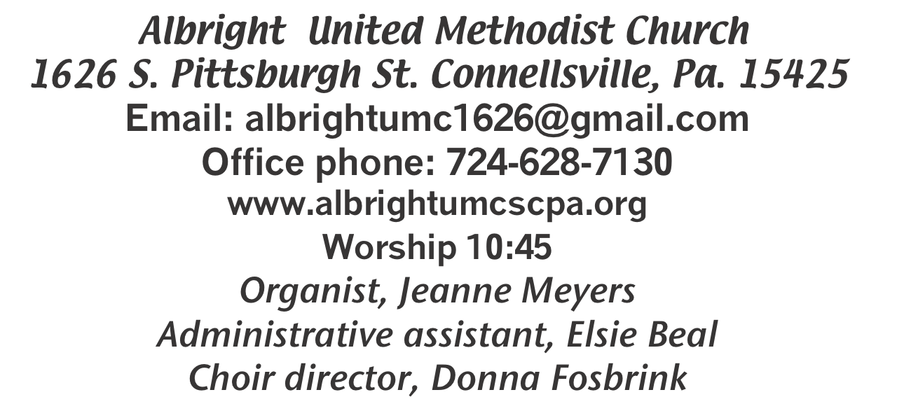

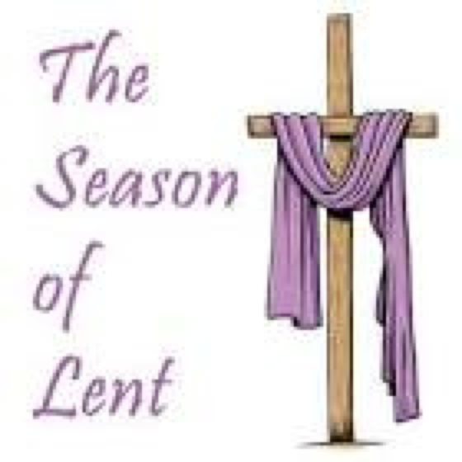

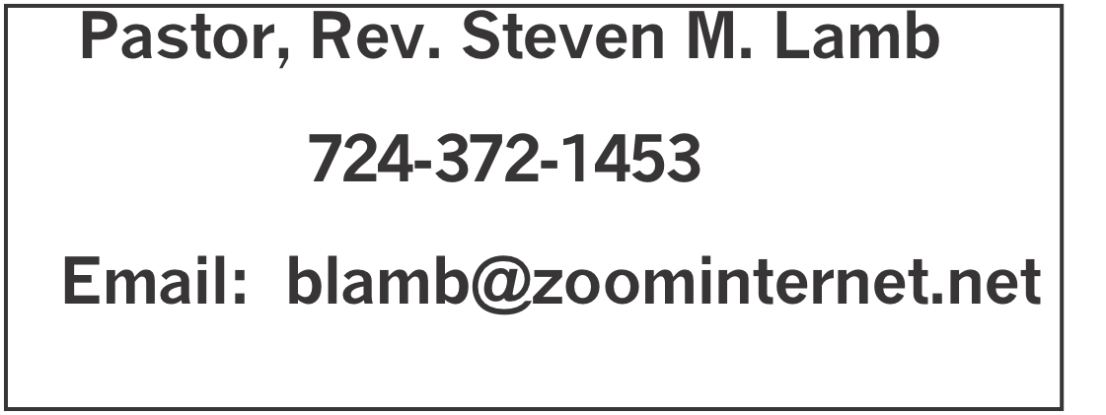

*********************************************************
February 22, 2026 Liturgist, Jessica Bortz 10:45a.m.
First Sunday in Lent
********************************************************
WELCOME AND ANNOUNCEMENTS
PRELUDE “Whisper A Prayer” Peterson

BRINGING FORTH THE LIGHT

*OPENING HYMN
“Lord, Who Throughout These 40 Days” 269

*CALL TO WORSHIP
L: Our Lenten journey has begun.
P: Let us follow the example of Jesus who …
L: listened for the voice of God in the wilderness,
P: followed the leading of the Holy Spirit
L: and resisted temptation.
P: Jesus is the Bread of Life.
All: Let us feast on him during this Lenten season.

*OPENING PRAYER
Pastoral Prayer with Response (Pastor praying)

P: Throughout these days of Lenten discipline, school us in the arts of spiritual growth. Increase our desire to know you intimately and to be known by you. Work on us to develop the habits of obedience and prayer so that we become more firmly rooted in your Word and will, and better able to resist every trick of the Evil One, for Jesus’ sake. Amen.

*GLORIA PATRI 70

EPISTLE READING Romans 5:12-19
The word of God for the people of God. Thanks be to God

ANTHEM “Soon and Very Soon”

CHILDREN’S MOMENT & Coin offering

PASSING THE PEACE

OFFERING
OFFERTORY “Blessed Assurance” Crosby
*DOXOLOGY
OFFERTORY PRAYER

PRAYERS OFFERED IN PRAISE AND PETITION

PRAYER HYMN “Jesus Walked This Lonesome Valley” INSERT

PASTORAL PRAYER

SILENT MEDITATION

THE LORD’S PRAYER

GOSPEL READING Matthew 4:1-11
The word of God for the people of God. Thanks be to God.
Thy Word is a lamp unto my feet and a light unto my path

MESSAGE “Good Guilt”

*CLOSING HYMN “The Gift of Love” 408

*BENEDICTION
*POSTLUDE
***************************************************
WELCOME
Welcome on this first Sunday in Lent. We are excited that you are here. If you are visiting, please introduce yourself to those around you. If you attend regularly, we are pleased to have you with us. Welcome to all!

PRAYER CONCERNS THIS WEEK
Don Heckathorne Ray Knopsnider Nassier Thompson Trey Corvin
Larry Murray Jack Burke Tina Hiltabidel Patty Lint
Jim & Deanna Sherbondy Lee Mimless Lincoln Dunseth Twila Filler
Larry Bloom Sr. Jack & Joni Snyder Toni Hiltabidel Kirk Reed
Joe Husak Jane Barnhart Lynn Kifer Wanda Brooks
Dale Kesler Tammy & David Leeder Lisa Evans Bob Shoenberger
Karl Siple Kevin Leighliter Pastor John Friend Kathy Barnhart
Sue Rowen Nancy Knopsnider Gary Cheek Beth Lamb
Karen Stimmell Dee Porterfield Adan Morris Marsha Hough
Doug Shaffer Marvin Mills Paula Kershey Bob Sleighter
Linda Burnworth Roger Richter Jimi Ann Fosbrink Linda Blystone
Margaret Monosky Sandy Reich Andrea Swan Ian Younkin
Sally Fosbrink Renee Beni Greg Beaver Bob McDowell
Marks & Howard families Amber & staff Liam Victims of trafficking & sexual assault
Pastor Steve & Bev Rev. Ross Pryor Bishop Sandra Steiner Ball

Homebound persons: Polly Basinger, Fred & Joan Bates, Ethel “Sis” Cole, Sue Corvin, Evelyn Curry, Sherrill Goodwin, Chuck Hall, Ray Knopsnider, Shirley Mathias, Stephanie Mattis, Ed Miller, Judy Morris, Ozella Roy

Praise for answered prayers Unspoken Requests All Military All churches Government leaders
Folks with cancer Those traveling Those battling addiction Folks on Hospice Homeless people
Peace around the World Those with flu & covid Families of those who take their own life

If you want a name put on prayer list, please use the prayer cards in the pew - give to acolytes or ushers
THIS WEEK AT ALBRIGHT
TUESDAY: Blue Plate Special luncheon 11:00-1:00.
WEDNESDAY: Bible Study 6:30
THURSDAY: Choir practice 7:00

OFFICE HOURS: Tuesday, Wednesday, Thursday 10:00-3:00

February Happenings
24: Blue plate special lunch 11:00-1:00
Every Monday: T.O.P.S. (Take Off Pounds Sensibly) 10a.m. or 5p.m.
Every Wednesday: Bible study 6:30
Every Thursday: Choir practice 7:00
March Happenings
7: Heart to Hope Telethon
7: Set clocks ahead 1 hour (spring forward)
10: United Women in Faith meeting 7:00
12: Feed the hungry at Community Ministries
14: Craft Vendor Show 9-2; and Soup sale 10-1
17: Feed the hungry at Community Ministries
17: Church council meeting 7:00
19: Otterbein pasta meal 4-6
21: Saturday Morning Special 11:00
22: News deadline for April/May newsletter
24: Blue Plate Special 11-1
29: Palm Sunday/ Potluck covered dish after church
Every Monday: T.O.P.S. (Take Off Pounds Sensibly) 10a.m. or 5p.m.
Every Wednesday: Bible study 6:30(except Ash Wed.)
Every Thursday: Choir practice 7:00 (Except Maundy Thursday

WEEKLY BIBE STUDY
Every Wednesday at 6:30 we have Bible study. Everyone is invited to join us.

UNITED WOMEN IN FAITH
Will meet Tuesday, March 10 at 7:00. Donna will have devotions and Shelley Mattis will host. ALL women of the church are invited to join us.

SOUP SALE
Sat., March 14 at 10-1. We need donations of homemade soup & people to buy soup. Please sign up on the sheet in back of sanctuary to let us know what kind & how much soup. Thank you!

CRAFT/VENDOR SHOW
Sat., March 14 @ 9-2. $25 first table; $20 each additional table. Contact Bev 724-372-1456 of call the office if you would like to set up a table.

OUR STEWARDSHIP - February 15
Weekly need for budget ........................................... $ 2,491.56
Sunday offering......................................................... $ 4,010.00
Worship attendance ..................................................... 63

GREETING YOU TODAY: Kelli Armstrong & Jeremy Gray
March 1:Doris & Dustin Murray

LITURGIST: March 1: Scott Murray
March 8: Sherry Grote

ACOLYTES TODAY: Emmaleigh Kalemba & Andrew Lynn
March 1: Keelan & Kayton Callahan

JUNIOR CHURCH TODAY: David & Shelley Mattis
March 1: Kathy Hixson & Linda Burnworth

USHERS: Jeremy Gray, Scott Murray, Ed Jacobs, Larry Bloom
3/1: Sherry Grote, Jeremy Gray, Ed Jacobs, Jackie Bartholomai

COUNTERS: February: Sally Fosbrink & Linda Burnworth
March: Sue Harvey & Sherry Grote

A NOTE RECEIVED
Hi folks
Just a note with my donation. Hoope everyone is doing well. We’re all doing pretty good. The snowdrifts on our deck are about 4 feet deep. I think it will be August before all this melts away. Stay warm!! Love, Gayle Martin

TRIP TO LANCASTER
There will be a bus trip to Lancaster on Thursday, June 18 to see the play “Joshua”. Cost is $24O and includes meal at Shady Maple Restaurant, the play and bus. Bevneeds reservations now so she can get good seats at the theater. If you are interested, please call 724-372-1456 or see her after church.

NOTE OF THANKS
Thank you so much for coming and serving delicious meals. Your kindness and dedication to feeding the community means so much to us. From all of us here at Connellsville Area Community Ministries we thank you from the bottom of our hearts. May God bless you all abundantly. Gratefully, Courtney

