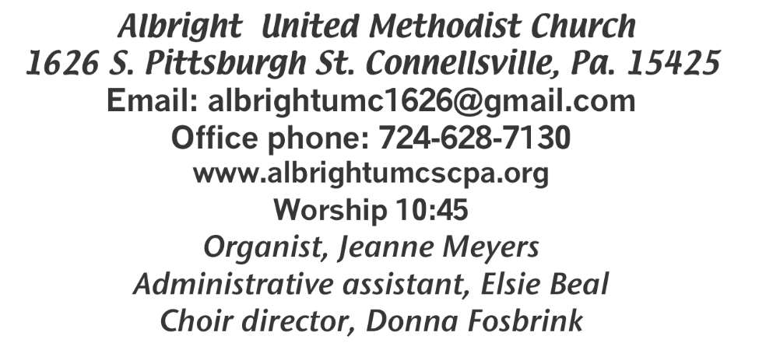



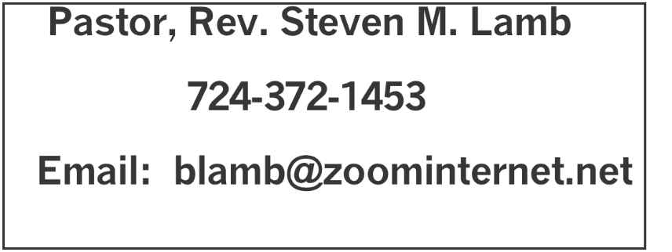

*********************************************************
February 1, 2026 Liturgist, Linda Burnworth 10:45a.m.
*********************************************************
WELCOME AND ANNOUNCEMENTS
PRELUDE “Everyday People” Parks

BRINGING FORTH THE LIGHT

*OPENING HYMN “Blest Be the Tie That Binds” 557

*CALL TO WORSHIP
L: We are a holy tapestry of mystery and meaning,
P: A fine garment of divine blessing and human care,
L: A gentle weave of deep sighs and fervent prayers,
P: A piece of art woven with whispers and exclamation points,
L: We are God’s tapestry --
P: Touched with mystery and filled with meaning.

*OPENING PRAYER
We thank you, O God,
That winning is not everything,
Nor is it the only thing in this beautiful world of yours.
Everyone who receives your blessing is the ultimate winner:
We, the baptized, who confess you as Lord,
And who just may be able to hear you say, if we open our hearts,
“This is my beloved son,
This is my beloved daughter,
In whom I am well pleased.” Amen.

*GLORIA PATRI 70

OLD TESTAMENT READING Micah 6:1-8
The word of God for the people of God. Thanks be to God.

ANTHEM “The Table of Grace”
HOLY COMMUNION

LORD’S PRAYER

CHILDREN’S MOMENT & Coin offering

PASSING THE PEACE

OFFERING
OFFERTORY “Beside the Still Waters” Silva
*DOXOLOGY
*OFFERTORY PRAYER

PRAYERS OFFERED IN PRAISE AND PETITION

PRAYER HYMN “One Bread, One Body” 620

PASTORAL PRAYER

SILENT MEDITATION

GOSPEL READING Matthew 5:1-12
The word of God for the people of God. Thanks be to God.
Thy Word is a lamp unto my feet and a light unto my path

MESSAGE “Blessed

*CLOSING HYMN “Blessed Assurance” 369

*BENEDICTION

*POSTLUDE
**************************************************
WELCOME
We welcome all who have come out in the cold weather to help us worship our Lord and Savior. Blessings to you and your family.
PRAYER CONCERNS THIS WEEK
Don Heckathorne Ray Knopsnider Nassier Thompson
Trey Corvin Larry Murray Jack Burke
Tina Hiltabidel Patty Lint Jim & Deanna Sherbondy
Myra Holden Mary Swope Lee Mimless
Lincoln Dunseth Twila Filler Larry Bloom Sr.
Marilyn Brown Charles Smiley Jack & Joni Snyder
Toni Hiltabidel Kirk Reed Joe Husak
Jane Barnhart Lynn Kifer Wanda Brooks
Ginny Habina Tammy & David Leeder Dick Goodwin
Dale Kesler John Shaw Fred Grote
Rita Bair Lisa Evans Pete Smith
Linda Burnworth Bob Shoenberger Karl Siple
Mark Flair Kevin Leighliter Pastor John Friend
Kathie Crislip Kathy Barnhart Mark Heckman
Adrian Shultz Carter Luchack Sue Rowen
Nancy Knopsnider Gary Cheek Beth Lamb
Karen Stimmell Dee Porterfield Adan Morris
Marsha Hough Karis Harden Doug Shaffer
Marvin Mills Paula Kershey Bobbie Jean
Sue Corvin Michael, for heart Bob Sleighter
Marcia Whittaker Roger Richter Jimi Ann Fosbrink
Josh Logan Pastor Steve & Bev Rev. Ross Pryor Bishop Sandra Steiner Ball

Homebound persons: Polly Basinger, Fred & Joan Bates, Etheel “Sis” Cole, Sue Corvin, Evelyn Curry, Sherrill Goodwin, Chuck Hall, Ray Knopsnider, Shirley Mathias, Stephanie Mattis, Ed Miller, Judy Morris,, Ozella Roy

Praise for answered prayers Unspoken Requests All Military All churches Government leaders
Folks with cancer Those traveling Those battling addiction Folks on Hospice Homeless people
eace around the World Those with flu & covid Families of those who take their own life

If you want a name on prayer list, please use the prayer cards in the pew - give to acolytes or ushers.

THIS WEEK AT ALBRIGH
WEDNESDAY: Bible study 6:30
THURSDAY: Choir practice 7:00
SUNDAY: Souper bowl offering for food pantry

OFFICE HOURS: Tuesday, Wednesday, Thursday 10:00-3:00

February Happenings
8: Souper Bowl offering for food pantry
12 Feed the hungry at Community Ministries
14: Soup sale 10:00-1:00
17: Feed the hungry; SPPRC meeting 7:00
18: Ash Wednesday. Service 6:00 at Albright
19: Otterbein pasta meal 4:00-6:00
21: Sweetheart breakfast 9a.m. for ladies
24: Blue plate special lunch 11:00-1:00
Every Monday: T.O.P.S. (Take Off Pounds Sensibly) 10a.m. or 5p.m.
Every Wednesday: Bible study 6:30(except Ash Wed.)
Every Thursday: Choir practice 7:00 (Except Maundy Thursday)

BIBLE STUDY
Every Wednesday at 6:30 p.m. lead by Pastor Steve.
Everyone is welcome.

2026 OFFERING ENVELOPES
Are out in back of sanctuary. Small bunch if you give once a month; bigger bunch if you give every week. Please get them today.

NEED DONATIONS
Near the bulletins we have a wooden box with a slot on it to make your donations to help feed the hungry. There are blue envelopes out if you wish to use them for donations. All donations are appreciated. They will help us continue to prepare meals for hungry people through Community Ministries.

FEEDING THE HUNGRY
Thursday, February 12 & Tuesday, February 17 at Community Ministries. Volunteers appreciated.

SOUP SALE
Saturday, February 14 at 10-1. We need donations of homemade soup and people to buy that soup. Please sign up on the sheet in back of sanctuary to let us know if you will bring soup and what kind. Thank you

OUR STEWARDSHIP - January 25
Weekly need for budget ........................................... $ 2,491.56
No church due to snow.

GREETING YOU TODAY: Fred & Sherry Grote
Feb. 8: Pamela Lynn

LITURGIST: Feb. 8: Ed Jacobs
Feb. 15: Mark Flair

ACOLYTES TODAY: Damien Dunseth & Andrew Lynn
Feb. 8: Thelma Swope & Estella Gallagher

JUNIOR CHURCH TODAY: Kathy Hixson & Linda Burnworth
Feb. 8: Kelli Armstrong & Nancy Mimless

USHERS: Jackie Bertholomai, Sherry Grote, Jeremy Gray, Ed Jacobs
2/8:Lary Bloom, Scott Murray, Sally Fosbrink, Josh Shaffer

COUNTERS: February: Sally Fosbrink & Linda Burnworth
March: Sue Harvey & Sherry Grote

SPPRC MEETING
Will be Tuesday, February 17 at 7:00 at Albright. Members are: Linda Burnworth, chair, David Mattis, Bonnie Bloom, Kelli Armstrong, Sandy Russell, Chris Lynn & Rick Tressler

ASH WEDNESDAY WORSHIP SERVICE
February 18 at 6:30 at Otterbein church.
This begins our Lenten Season. OPEN TO THE PUBLIC.

PASTA MEAL
Thursday, February 18 at 4:00-6:00 is Otterbein monthly Pasta Meal. Free with donations accepted. We ask $5 for take out meals.

SWEETHEART BREAKFAST
Saturday, February 21 at 9:00a.m. the men will cook for the ladies. All ladies of the church are invited to join us. Please register so we know how many to cook for.

jk

