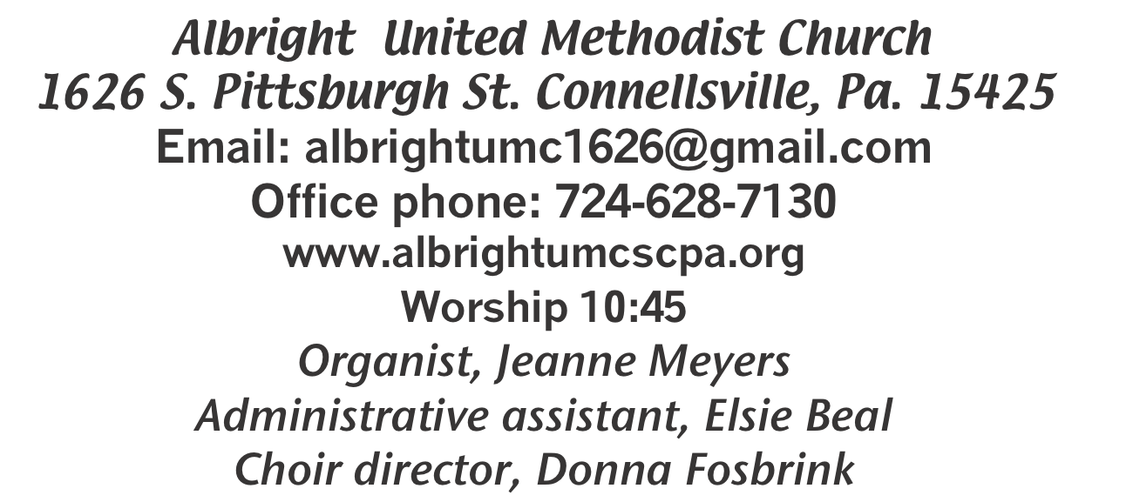



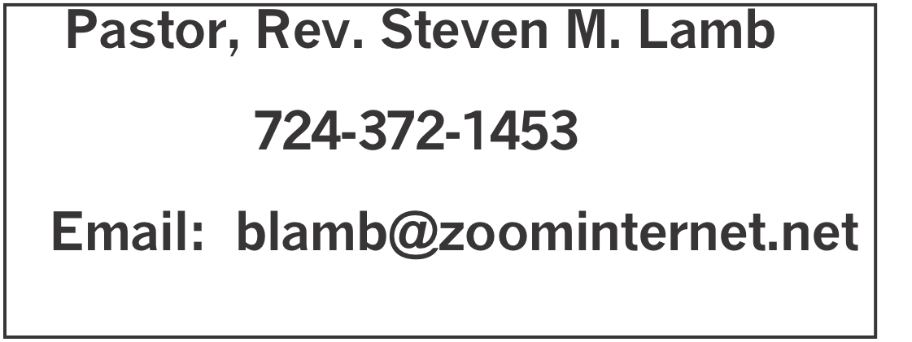

*********************************************************
January 18, 2026 Liturgist, Rick Tressler 10:45a.m.
********************************************************
WELCOME AND ANNOUNCEMENTS
PRELUDE “In His Time” Ball

BRINGING FORTH THE LIGHT

*OPENING HYMN “Crown Him with Many Crowns” 327

*CALL TO WORSHIP
L: Christ is calling, inviting, urging and wooing: Come and
follow me!
P: Let us set aside our worry and fear, our busyness and
competing agendas to respond to Christ’s call.
L: Christ offers us the opportunity to walk with him, to come
to know his heart more deeply day by day.
P: Nothing is more precious than opening our hearts to God,
who fills us with love.
L: Christ grants us the privilege of working alongside him in
our Father’s business.
P: There is no higher call and no greater joy than making a
difference in the kingdom of God.
L: Come, let us worship the One who calls us to follow!
P: We worship in joy, in gratitude, in praise: Jesus Christ is Lord of all!

*OPENING PRAYER
God of all wisdom, and of profound mystery:
We are grateful for the signs and intimations you scatter in our world like so many seeds.
By your grace, may they take root in our hearts and grow: that, one day, in the fullness of time, we may not only be welcomed into your eternal realm, but may recognize it as home. Amen.

*GLORIA PATRI 70

OLD TESTAMENT READING Isaiah 49:1-7
The word of God for the people of God. Thanks be to God

ANTHEM “Come to Jesus, Rest in Him”

CHILDREN’S MOMENT & Coin offering

PASSING THE PEACE

OFFERING
OFFERTORY “The Family of God” Gaither
*DOXOLOGY
*OFFERTORY PRAYER
PRAYERS OFFERED IN PRAISE AND PETITION

PRAYER HYMN “Just As I Am” 357

PASTORAL PRAYER

SILENT MEDITATION

THE LORD’S PRAYER

GOSPEL READING John 1:29-42
The word of God for the people of God. Thanks be to God.
Thy Word is a lamp unto my feet and a light unto my path

MESSAGE “Effective Invitation”

*CLOSING HYMN “Pass it On” 572

*BENEDICTION

*POSTLUDE
****************************************************
WELCOME
We welcome you who have come to worship with us. We pray you will be blessed and will share that blessing with others this week. Hoping to see you next Sunday.

PRAYER CONCERNS THIS WEEK
Don Heckathorne Ray Knopsnider Nassier Thompson Trey Corvin Larry Murray
Jack Burke Tina Hiltabidel Patty Lint Jim & Deanna Sherbondy Myra Holden
Mary Swope Lee Mimless Lincoln Dunseth Twila Filler Larry Bloom Sr. Marilyn Brown Charles Smiley Jack & Joni Snyder Toni Hiltabidel Kirk Reed
Joe Husak Jane Barnhart Lynn Kifer Wanda Brooks Ginny Habina
Tammy & David Leeder Dick Goodwin Dale Kesler John Shaw Fred Grote
Rita Bair Lisa Evans Pete Smith Linda Burnworth Bob Shoenberger
Karl Siple Mark Flair Kevin Leighliter Pastor John Friend Kathie Crislip
Kathy Barnhart Mark Heckman Adrian Shultz Carter Luchack Sue Rowen
Nancy Knopsnider Gary Cheek Beth Lamb Karen Stimmell Dee Porterfield
Adan Morris Marsha Hough Karis Harden Doug Shaffer Marvin Mills
Paula Kershey Bobbie Jean Sue Corvin Michael, for heart Bob Sleighter
Marcia Whittaker Roger Richter Jimi Ann Fosbrink Tim Ritenour Pastor Steve & Bev Rev. Ross Pryor Bishop Sandra Steiner Ball
Homebound persons: Polly Basinger, Fred & Joan Bates, Ethel “Sis” Cole, Sue Corvin, Evelyn Curry, Sherrill Goodwin, Chuck Hall, Shirley Mathias, Stephanie Mattis, Ed Miller, Judy Morris, Ozella Roy

Praise for answered prayers Unspoken Requests All Military
All churches Government leaders Folks with cancer Those traveling Those battling addiction Folks on Hospice Homeless people Peace around the World Those with flu & covid
Families of those who take their own life

If you want a name on prayer list, please use the prayer cards in the pew - give to acolytes or ushers.

THIS WEEK AT ALBRIGHT
TODAY: News deadline for Feb/March newsletter
Brief Counters meeting after church
TUESDAY: Church council meeting 7:00
THURSDAY: Choir practice 7:00

OFFICE HOURS: Tuesday, Wednesday, Thursday 10:00-3:00
January Happenings
18: News deadline for Feb./March newsletter
18: Counters meeting after church
20: Church council meeting 7:00
27: Blue plate special lunch 11:00-1:00
Every Monday: T.O.P.S. (Take Off Pounds Sensibly) 10a.m. or 5p.m. Every Thursday: Choir practice 7:00

BRIEF COUNTERS MEETING
TODAY after worship service we will have a brief meeting with counters of the church. They are: Sandy Russell, Rick Tressler, Sally Fosbrink, Jackie Bartholomai, Karen Stimmell, Linda Burnworth, Sue Harvey, Sherry Grote, Ed Jacobs, Nancy Mimless, Larry & Bonnie Bloom. If you are a counter, it is important for you to be at this meeting.

FEB./MARCH NEWSLETTER
News deadline is TODAY. Please get any information you want in the newsletter to Elsie. Thank you.

CHURCH COUNCIL
Will meet Tuesday, January 20 @ 7:00. Members are: Jeremy Gray, Rick Tressler, Linda Burnworth, Tanner Barko, Fred &
Sherry Grote, Randy Fisher, Donna & Elaine Fosbrink, Shelley Mattis, Kelli Armstrong, Priscilla Smiley, Lynne Corvin, Jackie Bartholomai, Sandy Russell, Eve Shupe, Shelly Siple, Bev Lamb. All members of the church may attend the meeting.

BIBLE STUDY
Every Wednesday at 6:30 p.m. we have Bible study lead by Pastor Steve. Everyone is welcome.

BLUE PLATE SPECIAL LUNCH
Tues.,Jan. 27 at 11:00-1:00. Light lunch free to eat in with donations accepted. We ask $5 for take out.

NOTES OF THANKS
We thank those who donated to, helped with and supported our soup sale in January. Your help and support are always appreciated.
Thank you to everyone who helped undecorate the church this week.

OUR STEWARDSHIP - January 11
Weekly need for budget ........................................... $ 2,491.56
Sunday offering......................................................... $ 3,218.00
Worship attendance ..................................................... 74

GREETING YOU TODAY: Vicky Adey
Jan. 25: Elsie Beal
LITURGIST: Jan 25: Nancy Mimless
Feb. 1: Linda Burnworth
ACOLYTES TODAY: Emmaleigh Kalemba & Andrew Lynn
Jan. 25: Kayton & Keelan Callahan
JUNIOR CHURCH TODAY: Larry & Bonnie Bloom
Jan. 25: David & Shelley Mattis
USHERS: Linda Burnworth, Pinky Smiley, Chris Lynn, Paul Bortz
1/25: Jeremy Gray, Scott Murray, Ed Jacobs, Larry Bloom

COUNTERS: January: Sandy Russell & Rick Tressler
February: Sally Fosbrink & Linda Burnworth

NEED DONATIONS
Near the bulletins we have a wooden box with a slot on it to make your donations to help feed the hungry. There are blue envelopes out if you wish to use them for donations. All donations are appreciated. They will help us continue to prepare meals for hungry people through Community Ministries.

SOUP SALE
Saturday, February 14 at 10-1. We need donations of homemade soup and people to buy that soup. Please sign up on the sheet in back of sanctuary to let us know if you will bring soup and what kind. Thank you!

CRAFT VENDOR SHOW
Will be Saturday, March 14 at 9:00-2:00. $25 first table; $20 each additional table. Contact Bev 724-372-1456 or the office 724-628-7130 if you are interested in setting up a table.

LANCASTER TRIP
Thursday, June 18 Bev will be taking a trip to Lancaster to see Joshua on stage. If you are interested, please contact Bev for more information.

jk

