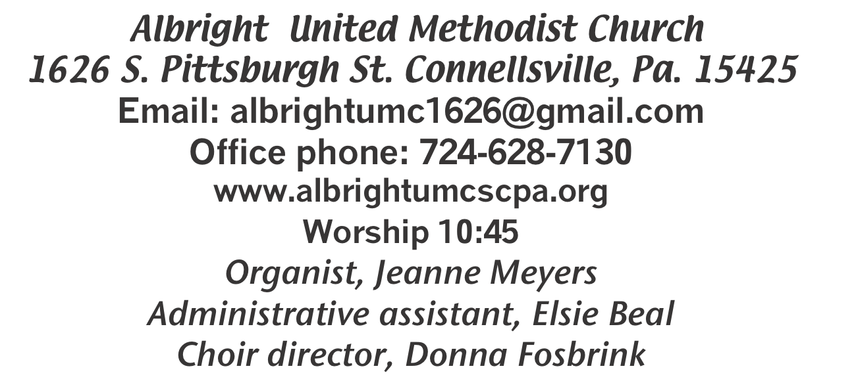





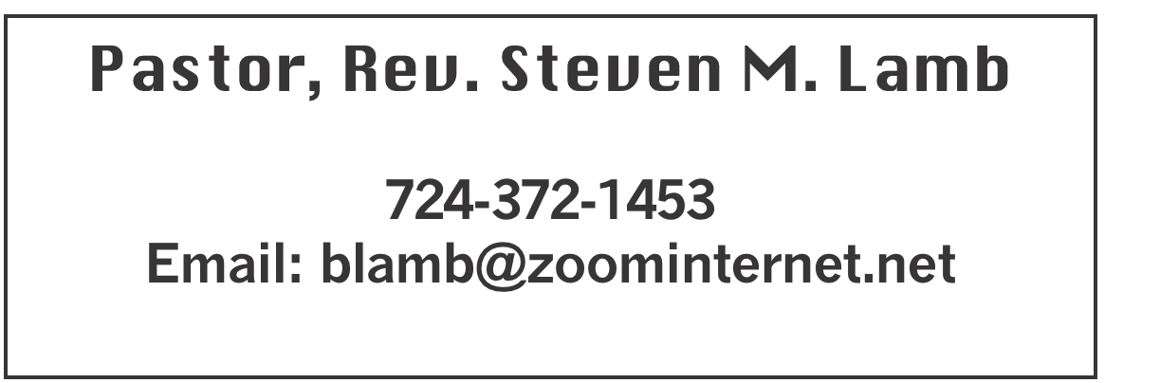

*******************************************************
November 23, 2025 Liturgist, Sherry Grote 10:45a.m.
Christ the King Sunday
********************************************************
WELCOME AND ANNOUNCEMENTS
PRELUDE “Thanks To Him” Croft

BRINGING FORTH THE LIGHT

*OPENING HYMN “All Hail the Power of Jesus’ Name” 154

*CALL TO WORSHIP
L: The earth is the Lord’s and the fullness thereof;
P: The world, and they that dwell therein.
L: For it is God who founded it upon the seas,
P: And established it upon the floods.
L: Who may ascend the mountain of the Lord,
P: And who may stand in his holy place?
L: You that have clean hands and a pure heart,
P: Who set not your hearts upon falsehood,
L: Nor swear deceitfully.
P: Will we receive a blessing from the Lord,
L: And help from the God of our deliverance?

*OPENING PRAYER
We affirm and celebrate Christ the King and Christ’s kingdom. Christ is a different kind of king and his is a different kind of kingdom. Christ the King shows power through suffering love rather than overwhelming might. Christ the King draws to his side the least, the lowly, the outcast and the vulnerable rather than those who have wealth and status. Christ the King calls for peace in place of violence, generosity instead of “getting ahead,” compassion rather than selfish ambition. In his topsy-turvy kingdom, the last are first, the least are greatest and enemies are loved. One day every knee will bow before this king and every tongue will confess that Jesus Christ is Lord. Let our knees be the first to bend and our voices first to proclaim that Christ the King is worthy to receive all glory and honor and praise, forevermore. Amen

*GLORIA PATRI 70

OLD TESTAMENT READING Jeremiah 23:1-6
The word of God for the people of God. Thanks be to God

ANTHEM “I Have Seen Jesus In You”

CHILDREN’S MOMENT & Coin offering

PASSING THE PEACE

OFFERING
OFFERTORY “Thanks for Loving Me” Webster & Younce
*DOXOLOGY
OFFERTORY PRAYER

PRAYERS OFFERED IN PRAISE AND PETITION

PRAYER HYMN “Softly and Tenderly” 348

PASTORAL PRAYER

SILENT MEDITATION
THE LORD’S PRAYER

GOSPEL READING Luke 1:68-79
The word of God for the people of God. Thanks be to God.
Thy Word is a lamp unto my feet and a light unto my path

MESSAGE “Blessed”

*CLOSING HYMN “Turn Your Eyes Upon Jesus” 349

*BENEDICTION
*POSTLUDE
***************************************************
WELCOME
A wise man once said, “The worship most acceptable to God comes from a thankful and cheerful heart.” Let this time of worship be spent in gratitude for God’s abundant goodness toward us all. And with cheerful hearts, let us praise the Lord and greet one another. Welcome friends!
Make every day Thanksgiving Day.

PRAYER CONCERNS THIS WEEK
Don Heckathorne Ray Knopsnider Nassier Thompson Trey Corvin Larry Murray
Jack Burke Tina Hiltabidel Patty Lint Scott Wagner Jim & Deanna Sherbondy
Myra Holden Mary Swope Lee Mimless Lincoln Dunseth Twila Filler
Peggy Chase Larry Bloom Sr. Barb & Buzz Stuart Harper Grace & Connor Jay Schrin Marilyn Brown Charles Smiley Jack & Joni Snyder Toni Hiltabidel Kirk Reed
Joe Husak Rick Fosbrink Diane Monico Jane Barnhart Lynn Kifer
Wanda Brooks Ginny Habina Tammy & David Leeder Dick Goodwin Dale Kesler
John Shaw Fred Grote LaVonne Grote Rita Bair Lisa Evans
Geno McFadden Pete Smith Art McGann Linda Burnwort Bob Shoenberger
Karl Siple Mark Flair Kevin Leighliter Pastor John Friend Stephanie Mattis
Kathie Crislip Kathy Barnhart Mark Heckman Adrian Shultz Elise Olexa
Daniel Swope Jr. Mary Riley Carter Luchack Mike & Debbie Petrone Sue Rowen
Nancy Knopsnider Pastor Steve & Bev Rev. Ross Pryor Bishop Sandra Steiner Ball

Homebound persons: Edna Baker, Polly Basinger, Ethel “Sis” Cole, Evelyn Curry, Sherrill Goodwin, Chuck Hall, Shirley Mathias, Stephanie Mattis, Ed Miller, Judy Morris, Ozella Roy

Praise for answered prayers Unspoken Requests All Military
All churches Government leaders Folks with cancer Those traveling Those battling addiction Folks on Hospice Homeless people Peace around the World Those with flu Families of those who take their own life

If you want a name on prayer list, please use the prayer cards in the pew - give to acolytes or ushers

THIS WEEK AT ALBRIGHT
TUESDAY: Co-op West meeting 6:30 at Albright
Church Conferences to follow
WEDNESDAY: Thanksgiving Eve worship 7:00 at Otterbein
SATURDAY: Hanging of Greens 6:00; time of fellowship and Goofy Gift exchange
SUNDAY: First Sunday of Advent
Potluck covered dish lunch after church

OFFICE HOURS: Tuesday, Wednesday, Thursday 10-3

November Happenings
25: Co-op West meeting 6:30 at Albright
26: Thanksgiving eve worship 7:00 at Otterbein
29: Hanging of the Greens program 6:00 & Goofy gift & fellowship
30: Fifth Sunday potluck covered dish after church
Choir practices every Thursday at 7:00 (except Thanksgiving)
Every Monday: T.O.P.S. (Take Off Pounds Sensibly) 10a.m. or 5p.m.
NO Blue Plate Special this month.

CO-OP WEST & CHURCH CONFERENCE
Tuesday, November 25 beginning at 6:30 at Albright church.

THANKSGIVING EVE WORSHIP
Wednesday, November 26 at 7:00 will be our annual Thanksgiving Eve Worship service at Otterbein church.
Let us gather together to give thanks for our many blessings from God. NO Bible study that Wednesday!

HANGING OF THE GREENS
Will be Saturday, Nov. 29 at 6:00p.m. It will be followed by a time of fellowship and a goofy gift exchange. As part of this service there is a time for giving gifts. We are asking you to bring the following items to be brought up front at that time: warm hats, socks, gloves, scarves. They will be given our when we serve in Dec. at Community Ministries.

POTLUCK LUNCH
Sunday, Nov. 30 potluck covered dish lunch following morning worship. Bring a dish to share and join us for the fellowship.

NEW PICTORIAL DIRECTORY
We will be having photos taken December 4, 5 & 6. Someone will be in the back of the sanctuary before & after church to schedule a time for you (and/or family). For getting your photo taken you receive a free 8x10 and a directory. Other pictures will be available to order.

UNITED WOMEN IN FAITH
All women are invited to join us Tuesday, December 9 at 5:30 for a meal followed by a program presented by the Mon Valley Cloggers. They are always enjoyable.
Wear a Christmas shirt or sweater if you wish (beautiful or ugly). Come and enjoy this evening for ladies only.

OUR STEWARDSHIP - November 16
Weekly need for budget ........................................... $ 2,491.56
(Coin offering 11/12 $79.15)
Sunday offering......................................................... $ 2,047.00
Worship attendance ...................................................... 68

GREETING YOU TODAY: Jackie Kimmel
Nov. 30: Don & Marcia Whittaker
LITURGIST: Nov. 30: Eve Shupe
Dec. 7: Bonnie Bloom
ACOLYTES TODAY: Kayton & Keelan Callahan
Nov. 30: Thelma Swope & Estella Gallagher
JUNIOR CHURCH TODAY: David & Shelley Mattis
Nov. 30: Mandy & Olivia Lynn
USHERS: Jeremy Gray, Scott Murray, Ed Jacobs, Larry Bloom
11/30: Volunteers - to volunteer see Karen Stimmell

COUNTERS: November: Ed Jacobs & Nancy Mimless
December: Larry & Bonnie Bloom

COOKIE WALK/SALE & CRAFT SHOW
Cookie Walk: Saturday, Dec. 13 at 9:00-12:00. Come and get cookies. A wide variety is always available.
Craft/Vendor Show: Saturday, Dec. 13 at 9:00-2:00. Come and Christmas shop with us.

PASTA MEAL
Otterbein’s pasta meal is December 18 at 4-6p.m. Free with donations accepted. $5 for take out.

SATURDAY MORNING SPECIAL
Sat., Dec. 20 at 11:00. It will be their Christmas party with a $5 gift exchange for them.

Weekly Praise Music
Sunday morning 10:15 praise music as we come to prepare our hearts for the Word before service. We will have 3or4 songs. If you’re interested in sharing a song for the Lord & our congregation, or have any questions, please contact Emma Karfelt at 724-466-1680. I look forward to sharing this joyous time with you, and I hope to see more and more faces each Sunday! God bless! ~Emma K

POINSETTIAS
We are taking orders for poinsettias for Christmas Eve.
They are available in Red, Pink, White & Red Glitter. We are getting them from Angie’s Flower Garden & Greenhouse on Springfield Pike. We need paid orders in to the office by December 7.

Please use the form below to put with your money and place in offering plate or drop off at the office.

No orders accepted after December 7
----------------------------------------------------------------------

POINSETTIA ORDER FORM Order by Dec. 7

_____ Red _____ White _____ Pink _____Red glitter
(How many)

6” $12.00 each ____ 81/2” $26.95 ____

10” $39.95 ____ 14” Deco $49.95 ____

In Loving Memory Of: In Loving Honor Of:
(Please circle one)

_______________________________________________

_______________________________________________

Given By: _____________________________________

______________________________________________

Make checks payable to Angie’s Flower Garden.

Amount enclosed $__________________

