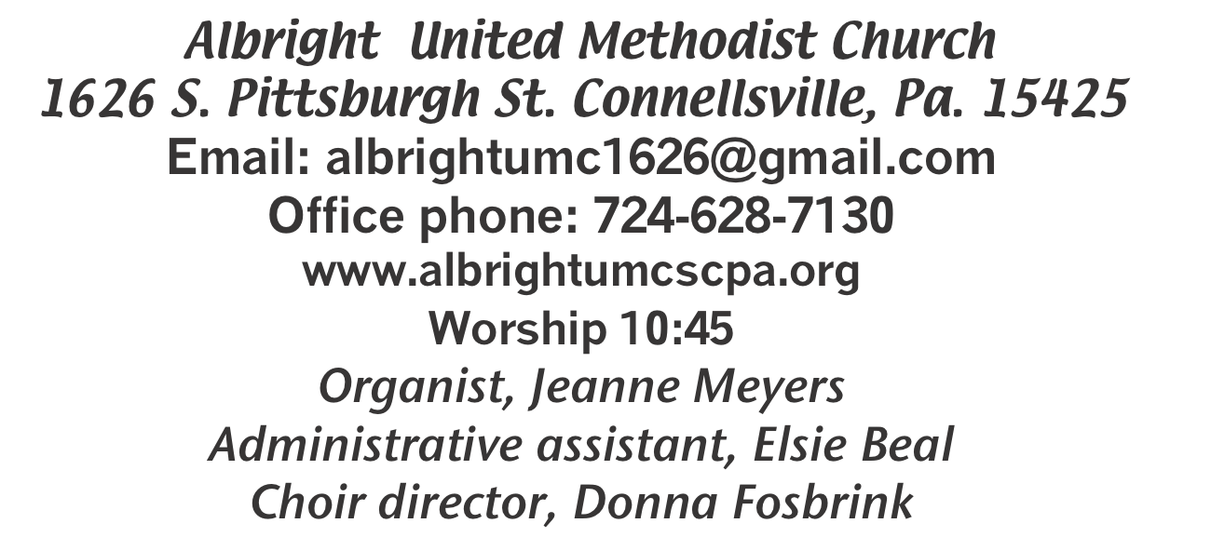



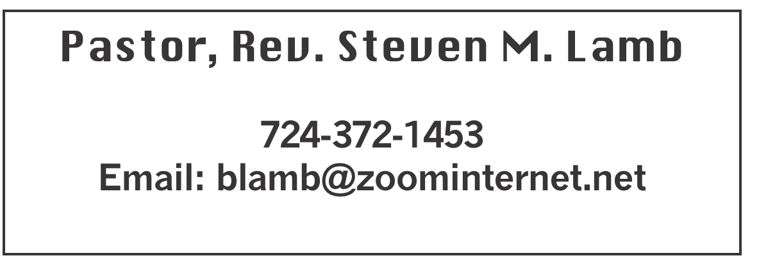

*******************************************************
November 16, 2025 Liturgist, Scott Murray 10:45a.m.
********************************************************
WELCOME AND ANNOUNCEMENTS

PRELUDE “Let’s Just Praise the Lord” Gaither

BRINGING FORTH THE LIGHT

*OPENING HYMN “Joy to the World” 246

*CALL TO WORSHIP
L: Great is the Lord and greatly to be praised! One
generation shall extol your works to another,
P: We shall declare your mighty acts.
L: They will recount the glorious splendor of your
majesty,
P: On your wondrous works we will meditate.
L: They will proclaim the might of your awesome deeds,
P: We will declare your greatness.
L: They shall celebrate the fame of your abundant
goodness,
P: We shall sing aloud of your righteousness.

*OPENING PRAYER
Make us worthy, Lord, to serve those throughout the world who live and die in poverty and hunger. Give them, through our hands, their daily bread; and by our understanding love, give peace and oy. Amen.

*GLORIA PATRI 70

OLD TESTAMENT READING Isaiah 65:17-25
The word of God for the people of God. Thanks be to God

ANTHEM “Angels Unaware”

CHILDREN’S MOMENT & Coin offering

PASSING THE PEACE

OFFERING
OFFERTORY “Thank You, Sweet Jesus” Croft
*DOXOLOGY
*OFFERTORY PRAYER

PRAYERS OFFERED IN PRAISE AND PETITION

PRAYER HYMN “In The Garden” 314

PASTORAL PRAYER

SILENT MEDITATION

THE LORD’S PRAYER

EPISTLE READING 2 Thessalonians 3:6-13
The word of God for the people of God. Thanks be to God.
Thy Word is a lamp unto my feet and a light unto my path

MESSAGE “Accept or Decline”

*CLOSING HYMN “He Lives” 310

*BENEDICTION

*POSTLUDE
****************************************************
WELCOME
With genuine joy, we welcome all of you here today. Please join us as we seek God’s guidance in our lives. Extend a hand of Christian love to those around you.

PRAYER CONCERNS THIS WEEK
Don Heckathorne Ray Knopsnider Nassier Thompson Trey Corvin Larry Murray
Jack Burke Tina Hiltabidel Patty Lint Scott Wagner Jim & Deanna Sherbondy
Myra Holden Mary Swope Lee Mimless Lincoln Dunseth Twila Filler
Peggy Chase Larry Bloom Sr. Barb & Buzz Stuart Harper Grace & Connor Jay Schrin Marilyn Brown Charles Smiley Jack & Joni Snyder Toni Hiltabidel Kirk Reed
Joe Husak Rick Fosbrink Diane Monico Jane Barnhart Baby Carly Jane
Lynn Kifer Wanda Brooks Ginny Habina Tammy & David Leeder Dick Goodwin
Dale Kesler John Shaw Fred Grote LaVonne Grote Rita Bair
Margie Lyons Lisa Evans Randy Lake Geno McFadden Pete Smith
Art McGann Linda Burnworth Amber Bob Shoenberger Karl Siple
Mark Flair Kevin Leighliter Pastor John Friend Stephanie Mattis Kathie Crislip
Kathy Barnhart Mark Heckman Adrian Shultz Elise Olexa Daniel Swope Jr.
Mary Riley Bob McDowell Carter Luchack
Richard & Michelle Pastor Steve & Bev Rev. Ross Pryor
Bishop Sandra Steiner Ball
Homebound persons: Edna Baker, Polly Basinger, Ethel “Sis” Cole, Evelyn Curry, Sherrill Goodwin, Chuck Hall, Shirley
Mathias, Stephanie Mattis, Ed Miller, Judy Morris, Ozella Roy
Praise for answered prayers Unspoken Requests All Military
All churches Government leaders Folks with cancer Those traveling Those battling addiction Folks on Hospice Homeless people Peace around the World Those with flu
Families of those who take their own life

If you want a name on prayer list, please use the prayer cards in the pew - give to acolytes or ushers.

THIS WEEK AT ALBRIGHT
TODAY: News deadline for Dec/Jan newsletter
Need donations for turkey boxes
TUESDAY: Serving a meal at Comm. Min 10-1
Church council meeting 7:00
WEDNESDAY: Bible study 6:30 at Albright
THURSDAY: Choir practice 7:00
SUNDAY: Thanksgiving turkey boxes given out

OFFICE HOURS: Tuesday, Wednesday, Thursday 10:00-3:00

November Happenings
16: News deadline for Dec/Jan newsletter
18: Church council meeting 7:00
25: Co-op West meeting 6:30 at Albright; Church conference to follow
26: Thanksgiving eve worship 7:00 at Otterbein
29: Hanging of the Greens program 6:00; Fellowship & Goofy gift
30: Fifth Sunday potluck covered dish after church
Choir practices every Thursday at 7:00 (except Thanksgiving)
Every Monday: T.O.P.S. (Take Off Pounds Sensibly) 10a.m. or 5p.m.

DECEMBER/JANUARY NEWSLETTER
TODAY is the news deadline. They will be printed and distributed this week.

CHURCH COUNCIL MEETING Nov. 18 at 7:00
Members are: Jeremy Gray, Rick Tressler, Linda Burnworth, Tanner Barko, Fred & Sherry Grote, Donna & Elaine Fosbrink, Shelley Mattis, Kelli Armstrong, Bev Lamb, Priscilla Smiley, Lynne Corvin, Jackie Bartholomai, Eve Shupe. All members of the church are welcome to attend this meeting.

THANKSGIVING FOOD BOXES
Sun., Nov. 23 we will be giving boxes of food to those in need. Complete Thanksgiving meal fixings. We ask for cash donations to buy those items. Please give by TODAY. There are envelopes on the board in sanctuary for your donations.

CO-OP WEST & CHURCH CONFERENCE
Tuesday, November 25 beginning at 6:30 at Albright church.

THANKSGIVING EVE WORSHIP
Wednesday, November 26 at 7:00 will be our annual Thanksgiving Eve Worship service at Otterbein church.
Let us gather together to give thanks for our many blessings from God. NO Bible study that Wednesday!

HANGING OF THE GREENS
Will be Saturday, Nov. 29 at 6:00p.m. It will be followed by a time of fellowship and a goofy gift exchange.

POTLUCK LUNCH
Sunday, Nov. 30 potluck covered dish lunch following morning worship. Bring a dish to share and join us for the fellowship.

OUR STEWARDSHIP - November 9
Weekly need for budget ........................................... $ 2,491.56
(Coin offering 11/2 - $72.07)
Sunday offering......................................................... $ 2,912.00
Worship attendance ...................................................... 83

GREETING YOU TODAY: Jane Barnhart
Nov. 23: Jackie Kimmel

LITURGIST: Nov. 23: Sherry Grote
Nov. 30: Eve Shupe

ACOLYTES TODAY: Emmaleigh Kalemba & Andrew Lynn
Nov. 23: Kayton & Keelan Callahan

JUNIOR CHURCH TODAY: Larry & Bonnie Bloom
Nov. 23: David & Shelley Mattis

USHERS: Linda Burnworth, Pinky Smiley, Chris Lynn, Paul Bortz
11/23: Jeremy Gray, Scott Murray, Ed Jacobs, Larry Bloom

COUNTERS: November: Ed Jacobs & Nancy Mimless
December: Larry & Bonnie Bloom

NEW PICTORIAL DIRECTORY
We will be having photos taken December 4, 5 & 6. Someone will be in the back of the sanctuary before & after church to schedule a time for you (and/or family). For getting your photo taken you receive a free 8x10 and a directory. Other pictures will be available to order.

United Women In Faith
All women are invited to join us Tuesday, December 9 at 6:30 for our Christmas party. The Mon Valley Cloggers will be doing a program. They are always enjoyable. There will be refreshments. Wear a Christmas shirt or sweater if you wish (beautiful or ugly). Come and enjoy this evening for ladies only.

COOKIE WALK/SALE & CRAFT SHOW
Cookie Walk: Saturday, Dec. 13 at 9:00-12:00. Come and get cookies. A wide variety is always available.
Craft/Vendor Show: Saturday, Dec. 13 at 9:00-2:00. Come and Christmas shop with us.

