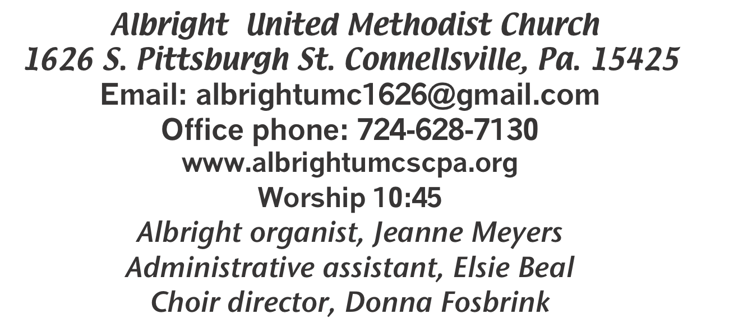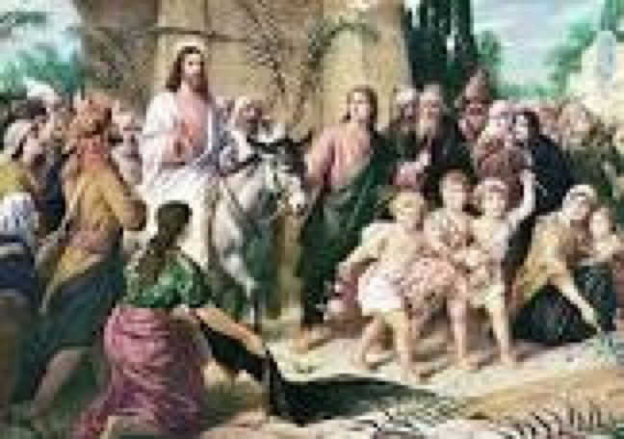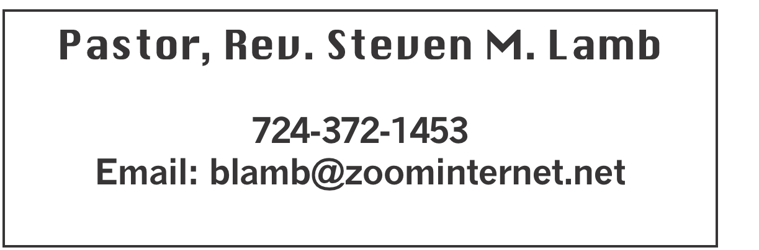

**\*\*\*\*\*\*\*\*\*\*\*\*\*\*\*\*\*\*\*\*\*\*\*\*\*\*\*\*\*\*\*\*\*\*\*\*\*\*\*\*\*\*\*\*\*\*\*\*\*\*\*\*\*\*\***

**April 13, 2025 Liturgist, Jessica Bortz 10:45a.m.**

**Palm Sunday**

**\*\*\*\*\*\*\*\*\*\*\*\*\*\*\*\*\*\*\*\*\*\*\*\*\*\*\*\*\*\*\*\*\*\*\*\*\*\*\*\*\*\*\*\*\*\*\*\*\*\*\*\*\*\*\*\*\***

**WELCOME AND ANNOUNCEMENTS**

**PRELUDE “The Man on the Middle Cross” Lister**

**BRINGING FORTH THE LIGHT**

**\*OPENING HYMN “Come, Christians Join to Sing” 158**

**\*CALL TO WORSHIP**

**Psalter 839 Psalm 118:14-29**

**\*OPENING PRAYER**

**Merciful Savior, it is our privilege and delight to be in your presence and to bring our praises and worship to you. You are our teacher and friend, our rock and hope, and our strength and light. We celebrate your arrival in Jerusalem; we anticipate the agony that is before you; we await your victory over death. Grant that we might walk this journey alongside you as faithful disciples, rather than as participants of the fickle crowd. Amen.**

**\*GLORIA PATRI 70**

**EPISTLE READING Philippians 2:5-11**

**The word of God for the people of God. Thanks be to God**

**ANTHEM “Hosanna, Hosanna”**

**CHILDREN’S MOMENT & Coin offering**

**\*PASSING THE PEACE**

**OFFERING**

**OFFEERTORY “Hosanna!” Weston**

**\*DOXOLOGY**

**\*OFFERTORY PRAYER**

**PRAYERS OFFERED IN PRAISE AND PETITION**

**PRAYER HYMN “Hosanna, Loud Hosanna” 278**

**PASTORAL PRAYER**

**SILENT MEDITATION**

**LORD’S PRAYER**

**GOSPEL READING Luke 19:28-40**

**The word of God for the people of God. Thanks be to God.**

***Thy Word is a lamp unto my feet and a light unto my path***

**MESSAGE “Palms of Passion”**

**\*CLOSING HYMN “Victory in Jesus” 370**

**\*BENEDICTION**

**\*POSTLUDE**

**\*\*\*\*\*\*\*\*\*\*\*\*\*\*\*\*\*\*\*\*\*\*\*\*\*\*\*\*\*\*\*\*\*\*\*\*\*\*\*\*\*\*\*\*\*\*\*\*\***

WELCOME

***We wave our palm branches in praise to Jesus who rode into Jerusalem on a donkey that first Palm Sunday. Prayers for you and your family for this holy week.***

***Welcome to our worship service.***

**PRAYER CONCERNS THIS WEEK**

**Don Heckathorne Ray Knopsnider Baby Thompson**

**Trey Corvin Larry Murray Jack Burke**

**Randy Jacobs Tina Hiltabidel Patty Lint**

**Scott Wagner Jim & Deanna Sherbondy Randy Fisher**

**George Mariotti Mary Swope Lee Mimless**

**Lincoln Dunseth**  **Sandy Reich Daniel Swope**

**Wanda Brooks Paula Shaffer Twila Filler**

**Peggy Chase Sue Capo Larry Bloom Sr.**

**Jeffrey Sarmelli Carol Hunter Elton & Noah Schrock**

**Liam Lewandowski Harper Grace & Connor Jay Schrin**

**Jim Pennington Joyce Shaffer Kim Welsh**

**Ron Barry Emmalyn & Olivia Hixon Judy Whipkey**

**Sandy Russell Kelly Thompson Margaret Syner**

**Lynn Kiefer Margaret Coughenour Lynn White**

**Danielle Longo Bill Shirey Ashley from SMS**

**Larry Metsger Nancy Hamill Fran Harshman**

**Preston Robinson Bub Sleighter Debbie Shipley**

**Connie Clark Susan Logston John Colomiso**

**Brian Roofner Steven McCune Pastor Steve & Bev**

**Rev. Ross Pryor Bishop Sandra Steiner Ball**

Homebound persons: **Edna Baker, Polly Basinger, Evelyn Curry, Sherrill Goodwin, Chuck Hall, Dolly King, Shirley Mathias, Stephanie Mattis, Ed Miller, Judy Morris,, Ozella Roy**

Unspoken Requests All Military All churches

Government leaders Folks with cancer Those traveling

Those battling addiction Folks on Hospice Homeless people

Praise for answered prayers Peace around the World

Those with flu Families of those who take their own life

If you want a name on prayer list, please use the prayer cards in the pew - give to acolytes or ushers.

THIS WEEK AT ALBRIGHT **-** HOLY WEEK

**THURSDAY: Roast beef dinner 6:00. Free with donations accepted**

**Easter play 7:30 - ALL at Otterbein church.**

**FRIDAY: Good Friday worship service 7:30 at Albright**

**SATURDAY: Sat. Morn. Special 11:00 - Their egg hunt day**

**SUNDAY: Sunrise service 7:00 at Albright followed by breakfast**

**Regular worship service 10:45**

OFFICE HOURS: Tuesday, Wednesday, Thursday 10:00-3:00

**EASTER CANDY**

**If you ordered Easter candy, please pick it up today after church.**

TRIP TO SEE NOAH IN JUNE

Bev can still take reservations for this

overnight trip June 20-21. See her if you are interested. She must know TODAY.

MOTHER’S DAY CARNATIONS

We are taking orders for pink or white carnations for Mother’s Day. $2.50 each.Please use the order forms in the bulletin to place your orders by April 27.

April Happenings

**Sun., 13th: Pick up candy**

**Thurs., 17th: Holy Thursday Easter Play 7:30 at Otterbein**

**Roast beef dinner 6:00 at Otterbein**

**Fri., 18th: Good Friday worship 7:30 at Albright**

**Sun., 20th: Sunrise svc. 7a.m. followed by breakfast-Alb.**

**Tues., 22: Blue plate special 11-1**

**Sun., 27: Last day to order carnations for mother’s day.**

May Happenings

**2nd & 3rd: Sub sale both days $12 fir 12” subs. Order ahead**

**3rd: Basket class at 10:00 - $25 a person. Sign up with Elsie**

**11th: Mother’s day**

**12th: Mother/daughter/friend dinner 6:00**

**15th Otterbein pasta meal 4-6**

**17th: Saturday morning special 11:00 - Carnival**

**20th: Church council meeting 7:00**

**News deadline for June/July newsletter**

**24: Otterbein Sundae sale 11-1**

**22nd: Last choir practice for this year**

**BLUE PLATE SPECIAL**

**Tuesday, April 22 at 11:00-1:00. Light lunch includes dessert & beverage. Free with donations accepted. $5 for take out. Open to the public.**

**DONATIONS NEEDED**

**Community Ministries needs peanut butter & jelly, pancake mix, syrup & bottled water.**

**We need washcloths brought to church for health kits that will be made at Annual Conference this year.**

OUR STEWARDSHIP - April 6

**Weekly need for budget ........................................... $ 2,491.56**

**Sunday offering......................................................... $ 4,216.50**

**(Recent coin offerings $64.05) (Craft show tables $205; Pies $217)**

**Worship attendance ...................................................... 70**

**GREETING YOU TODAY: Kay Jacobs**

**April 20: Sally Fosbrink**

**LITURGIST: April 20: Scott Murray**

**April 27: Sherry Grote**

**ACOLYTES TODAY: Aubree & Kadey Shaffer**

**April 20: Thelma Swope & Beau Wagner**

**JUNIOR CHURCH TODAY: Kelli Armstrong & Nancy Mimless**

**April 20: Larry & Bonnie Bloom**

**USHERS: Larry Bloom, Scott Murray, Sally Fosbrink, Michelle Reich**

**Apr. 20: Jay & Judy Whipkey, Linda Burnworth, Pinky Smiley**

**COUNTERS: April: Karen Stimmell & Jay Whipkey**

**May: Sue Harvey & Sherry Grote**

HOLY WEEK EVENTS

Sunday, April 13: Palm Sunday Worship 10:45

BRING A FRIEND TO CHURCH SUNDAY!

Thursday, April 17: Holy Thursday at Otterbein

Roast beef dinner at 6:00. Free with donations accepted. Play 7:30

Friday, April 18: Good Friday

Worship 7:30 at Albright

Sunday, April 20: Easter Sunday

Sunrise service 7a.m. at Albright with breakfast

to follow. Regular worship 10:45.

SATURDAY MORNING SPECIAL

**Will meet April 19 at 11:00. They will do a craft, sing & have an egg hunt. Pizza is for lunch.**

SUB SALE

**Fri., May 2 & Sat., May 3 will be a sub sale at 10:00 $12 each.Order ahead to be sure you get what you want.**

BASKET MAKING CLASS

***Saturday, May 3 at 10:00. $25 a person. Sign up with Elsie Beal***

**MOTHER’S DAY CARNATIONS**

**Mother’s day is May 11. We are offering carnations for you to purchase in Loving Memory or Loving Honor of someone special to you. All will be to the GLORY OF GOD. They are available in pink or white and cost $2.50 each.**

**Please use the order form below to place your paid order before April 27.**

**Fill out the form below and put it with your money in an envelope and put in offering plate or drop off at the office.**

**We need paid orders in to the office by April 27.**

**NO ORDERS ACCEPTED AFTER THAT DATE**

**-----------------------------------------------------------------------------**

**Mother’s Day Carnation Order - $2.50 each**

**ORDER BY APRIL 27**

**______ White _______ Pink**

**(How many) (How many)**

**IN LOVING MEMORY OF IN LOVING HONOR OF**

**(Please circle one)**

**___________________________________________________**

**___________________________________________________**

**Given by: __________________________________________**

**___________________________________________________**

**Amount enclosed $______________**

**------------------------------------------------------------------------------------------------------------**

**SUB SALE**

**Seller _______________________________ 12” Subs $12.00**

**Day Name Phone # How many Total Due Paid**

**1. ______________________________________________________________**

**2._______________________________________________________________**

**3._______________________________________________________________**

**4._______________________________________________________________**

**5._______________________________________________________________**

**6._______________________________________________________________**

**7._______________________________________________________________**

**8._______________________________________________________________**

**9._______________________________________________________________**

**Orders due by April 27. May be picked up Fri., May 2 or Sat., May 3 @ 10-1 or until sold out at Albright UM Church.**