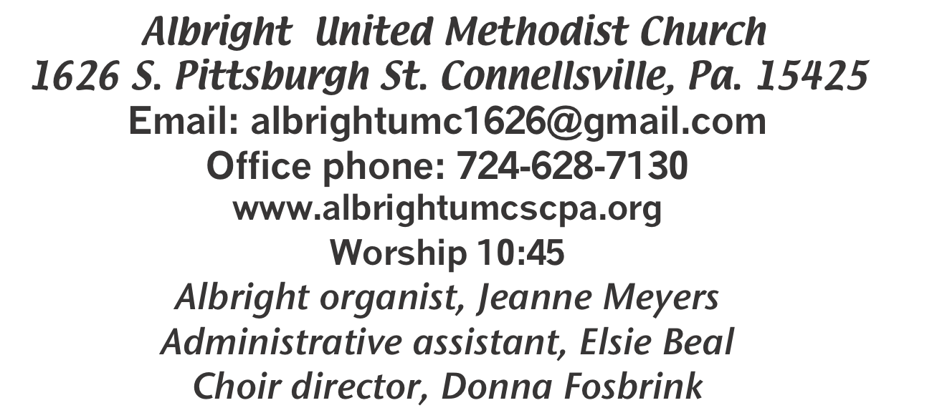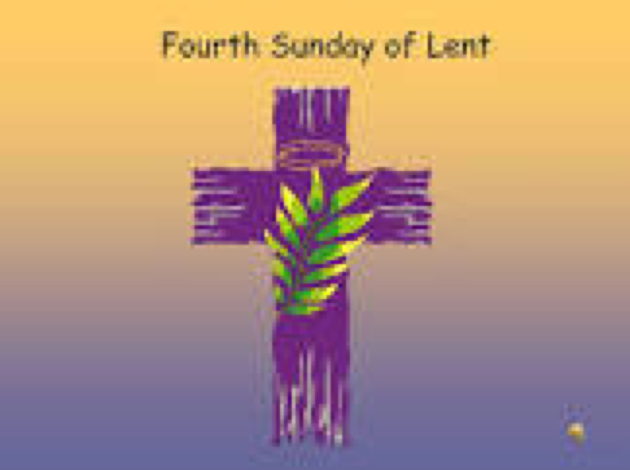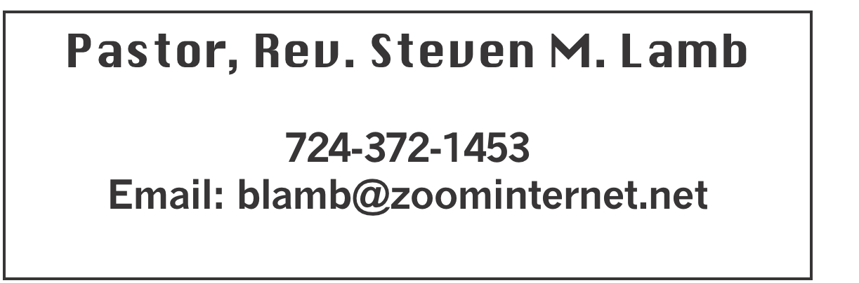

**\*\*\*\*\*\*\*\*\*\*\*\*\*\*\*\*\*\*\*\*\*\*\*\*\*\*\*\*\*\*\*\*\*\*\*\*\*\*\*\*\*\*\*\*\*\*\*\*\*\*\*\*\*\*\***

**March 30, 2025 Liturgist, Ed Jacobs 10:45a.m.**

**Fourth Sunday in Lent**

**\*\*\*\*\*\*\*\*\*\*\*\*\*\*\*\*\*\*\*\*\*\*\*\*\*\*\*\*\*\*\*\*\*\*\*\*\*\*\*\*\*\*\*\*\*\*\*\*\*\*\*\*\*\*\***

**WELCOME AND ANNOUNCEMENTS**

**PRELUDE “Calvary” Culross**

**BRINGING FORTH THE LIGHT**

**\*OPENING HYMN “Blessed Be the Name” 63**

**\*CALL TO WORSHIP**

**L: We get a fresh start. Our slate is wiped clean.**

P: We are blessed! God is a forgiving God.

**L: God does not hold our sin and failure against us.**

P: When we kept it all inside, our bones turned to powder and

we groaned all day long.

**L: Then we let it all out. We told God all our shortcomings.**

P: Suddenly our guilt dissolved and our sin disappeared.

**L: We are blessed! God hears our prayer and forgives and**

**protects us.**

P: God’s counsel to us is wise. God’s guidance is straight and

true.

***All: We are blessed! Let us celebrate God together!***

**\*OPENING PRAYER**

**Lord God, you are the source of all truth, wisdom, justice, and love, lead us through this time of worship and throughout this day of service to you. Help us constantly rest our lives upon the eternal foundations of your love and presence. Save us from haste and confusion, from wrongful desires and the net of evil. Through the inspiration of your Holy Spirit, enlighten, instruct, and guide us all day long. In the name of Jesus. Amen.**

**\*GLORIA PATRI 70**

**OLD TESTAMENT READING Joshua 5:1-9**

**The word of God for the people of God. Thanks be to God.**

**ANTHEM “Lamb of God”**

**CHILDREN’S MOMENT & Coin offering**

**PASSING THE PEACE**

**OFFERING**

**OFFERTORY “The Old Rugged Cross” Bennard**

**\*DOXOLOGY**

**\*OFFERTORY PRAYER**

**PRAYERS OFFERED IN PRAISE AND PETITION**

**PRAYER HYMN “What Wondrous Love is This?” 292**

**PASTORAL PRAYER**

**SILENT MEDITATION**

**THE LORD’S PRAYER**

**GOSPEL READING Luke 15:1-3,11b-32**

**The word of God for the people of God. Thanks be to God.**

***Thy Word is a lamp unto my feet and a light unto my path***

**MESSAGE “Unfail”**

**\*CLOSING HYMN “Pass It On” 572**

**\*BENEDICTION**

**\*POSTLUDE**

**\*\*\*\*\*\*\*\*\*\*\*\*\*\*\*\*\*\*\*\*\*\*\*\*\*\*\*\*\*\*\*\*\*\*\*\*\*\*\*\*\*\*\*\*\*\*\*\*\*\*\***

WELCOME

***Welcome to the fourth Sunday in Lent as we worship in the name of Jesus our Savior. Lent is a time of spiritual growth. We hope you will feel the presence of Him as you worship with us.***

**PRAYER CONCERNS THIS WEEK**

**Don Heckathorne Ray Knopsnider Baby Thompson**

**Trey Corvin Larry Murray Jack Burke**

**Randy Jacobs Tina Hiltabidel Patty Lint**

**Scott Wagner Jim & Deanna Sherbondy Randy Fisher**

**John Shaw George Mariotti Mary Swope**

**Lee Mimless Lincoln Dunseth**  **Sandy Reich**

**Daniel Swope Rob Miller Wanda Brooks**

**Paula Shaffer Twila Filler Jeff Regish**

**Tom Dewhurst Carol Ward Peggy Chase**

**George Seighman Sue Capo Larry Bloom Sr.**

**Jeffrey Sarmelli Carol Hunter Elton & Noah Schrock**

**Liam Lewandowski Harper Grace & Connor Jay Schrin**

**Jason Mayer Jim Pennington Joyce Shaffer**

**Kim Welsh Ron Barry Emmalyn & Olivia Hixon**

**Judy Whipkey** **Justin Olexa** **Sandy Russell**

**Kelly Thompson Margaret Syner Lynn Kifer**

**Margaret Coughenour Lynn White** **Danielle Longo**

**Bill Shirey Ashley from SMS** **Ray Vukson**

**Larry Metsger Nancy Hamill Fran Harshman**

**Pete Smith Bub Sleighter** Pastor Steve & Bev

**Rev. Ross Pryor Bishop Sandra Steiner Ball**

Homebound persons:  **Edna Baker, Polly Basinger, Evelyn Curry, Sherrill Goodwin, Chuck Hall, Dolly King, Shirley Mathias, Stephanie Mattis, Ed Miller, Judy Morris, Ozella Roy**

Unspoken Requests All Military All churches Government leaders Those with cancer

Our country Those battling addiction Those on Hospice Travelers Praise for answered prayers Homeless people Those with flu & pneumonia Families of those who take their own life

IF YOU WANT A NAME ON PRAYER LIST, PLEASE USE THE PRAYER CARDS IN THE PEW - give to Acolytes or Ushers.

**THIS WEEK AT ALBRIGHT**

**TODAY: Covered dish potluck after church service. Join us!**

**WEDNESDAY: Bible study 6:30**

**THURSDAY: Choir practice 7:00**

OFFICE HOURS: Tuesday, Wednesday, Thursday 10-3

Office phone 724-628-7130 Elsie at home 742-628-7467

OUR STEWARDSHIP - March 23

**Weekly need for budget ........................................... $ 2,491.56**

**Sunday offering......................................................... $ 1,656.00**

**(Recent coin offerings $56.94)**

**Worship attendance ...................................................... 68**

**GREETING YOU TODAY: Jackie Bartholomai**

**April 6: Cathy Dillinger**

**LITURGIST: April 6: Myra Holden**

**April 13: Jessica Bortz**

**ACOLYTES TODAY: Kayton & Keelan Callahan**

**April 6: Emmaleigh Kalemba & Andrew Lynn**

**JUNIOR CHURCH TODAY Mandy & Olivia Lynn**

**April 6: Kathy Hixson & Linda Burnworth**

**USHERS: Volunteers**

**Apr. 6: Jackie Bartholomai, Sherry Grote, Jeremy Gray, Ed Jacobs**

**COUNTERS: March: Sally Fosbrink & Jackie Bartholomai**

**April: Karen Stimmell & Jay Whipkey**

EASTER CANDY

**We are taking orders for homemade Easter candy. Order forms are out in back of sanctuary. Need orders by April 1.**

**Pick up April 13.**

HOLY WEEK EVENTS

Sunday, April 13: Palm Sunday Worship 10:45

Thursday, April 17: Holy Thursday

Roast beef dinner at 6:00. Free with donations accepted. Play 7:30 at Otterbein

Friday, April 18: Good Friday

Worship 7:30 at Albright

Sunday, April 20: Easter Sunday

Sunrise service 7a.m. at Albright with breakfast

to follow. Regular worship 10:45.

OTTERBEIN SELLING CANDY

**Peanut clusters or coconut clusters. $8 for 1/2 lb. box. Need orders TODAY. Pick up April 13.**

FREE COMMUNITY EASTER DINNER

**Will be Saturday, April 12 at 4:00-7:00.**

**Call 724-628-7130 to pre-register. Eat in free. Take out available for $5 each. There are pink envelopes out for your donations to help with expense.**

**REGISTRATION IS GREATLY APPRECIATED.**

TRIP TO SEE NOAH IN JUNE

Bev can still take reservations for this

overnight trip June 20-21. See her if you are interested. She must know by April 13.

**UNITED WOMEN IN FAITH**

***Will meet Tuesday, April 8 at 7:00. Elsie will have devotions. Michelle & Donna will host. We will finalize plans for Mother/Daughter/Friend dinner May 12.***

April Happenings

**Tues., 8th: United Women in Faith mtg. 7:00**

**Sat., 12th: Community Easter Dinner 4-7; Eat in free, take out $5**

**Sun., 13th: Pick up candy**

**Thurs., 17th: Holy Thursday worship 7:30 at Otterbein**

**Dinner 6:00 at Otterbein**

**Fri., 18th: Good Friday worship 7:30 at Albright**

**Sun., 20th: Sunrise svc. 7a.m. followed by breakfast-Alb.**

**Tues., 22: Blue plate special 11-1**

**Every Thursday: Choir practice 7:00**

May Happenings

**2nd & 3rd: Sub sale both days $12 fir 12” subs. Order ahead**

**3rd: Basket class at 10:00 - $25 a person.Sign up with Elsie**

**11th: Mother’s day**

**12th: Mother/daughter/friend dinner 6:00**

**15th Otterbein pasta meal 4-6**

**17th: Saturday morning special 11:00 - Carnival**

**20th: Church council meeting 7:00**

**News deadline for June/July newsletter**

**24: Otterbein Sundae sale 11-1**

**22nd: Last choir practice for this year**

PLANET AID BOXES

**We now have the yellow planet aid containers our near the church. It is for clothes & shoes. When they pick up, the church gets 5¢ a pound for items in them.**

**EASTER FLOWER ORDER FORM 2025**

**We will get them from Angie’s Flower Garden.**

**Cannot guarantee specific colors.**

**Your name ___________________________________________**

**Phone number: _________________________**

**Mums 6” deluxe $11.95________**

**In honor or memory of _________________________________________**

**Given by: _________________________________________________**

**Tulips: 6” $11.95________ Color requested ____________**

**In honor or memory of _________________________________________**

**Given by __________________________________________________**

**Lilies: 6” 3 bloom $13.95; 8” 2 stem $29.95________**

**In honor or memory of _________________________________________**

**Given by ________________________________________________**

**Hyacinth: 6” $11.95 ____; 8” $16.50 ____ Color requested _____________**

**In honor or memory of _________________________________________**

**Given by ________________________________________________**

**Roses: 4” $11.50 _________ 6” $18.95 ________**

**In honor or memory of _________________________________________**

**Given by _______________________________________________**

**Total of my order $____________________**

***We need all paid orders by March 30. Make checks out to Angie’s Flower Garden.***

EASTER CANDY

**We are taking orders for homemade Easter candy.**

***Albright church Candy order form orders due by April 1***

**__________________________________________________________________________________________**

**Item Price Mlk.Ch/quan WhiteCh/quan DrkCh/quan Total**

**Cross sucker $ 1.00 _______**

**Bunny sucker $ 1.00 ________**

**Pretzel/2 $ 3.00 ______**

**Marshmallows (3) $ 2.00 _______**

**Solid bunny $ 4.00 _______**

**Solid cross $ 4.00 _______**

**Oreos (3) $ 5.00 _______**

**Rice Crispy disc(3) $ 3.50 _______**

**Variety bag $ 4.50 ______**

**LG. Peanut butter egg $12.00 _______**

**LG. Coconut egg $12.00 _______**

**LG. Maple egg $12..00 _______**

**LG. Cherry nougat egg $12.00 _______**

**LG Maple nut egg $13.50 _______**

**LG Cherry nut egg $13.50 _______**

**SM. Penut butter egg $ 2.50 _______**

**SM. Coconut egg $ 2.50 _______**

**SM. Maple egg $ 2.50 _______**

**SM. Cherry nougat egg $ 2.50 _______**

**SM Maple nut egg $ 3.50 ______**

**SM. Cherry nut egg $ 3.50 ______**

**Pick up 13 April Total due $______________**

**Customer Name ____________**

**Phone # __________________**

**Sold by:___________________________Paid by: Check #__________Cash_________**

**MOTHER’S DAY CARNATIONS**

**Mother’s day is May 11. We are offering carnations for you to purchase in Loving Memory or Loving Honor of someone special to you. All will be to the GLORY OF GOD. They are available in pink or white and cost $2.50 each.**

**Please use the order form below to place your paid order before April 27.**

**Fill out the form below and put it with your money in an envelope and put in offering plate or drop off at the office.**

**We need paid orders in to the office by April 27.**

**NO ORDERS ACCEPTED AFTER THAT DATE**

**-----------------------------------------------------------------------------**

**Mother’s Day Carnation Order - $2.50 each**

**ORDER BY APRIL 27**

**______ White _______ Pink**

**(How many) (How many)**

**IN LOVING MEMORY OF IN LOVING HONOR OF**

**(Please circle one)**

**___________________________________________________**

**___________________________________________________**

**Given by: __________________________________________**

**___________________________________________________**

**Amount enclosed $______________**