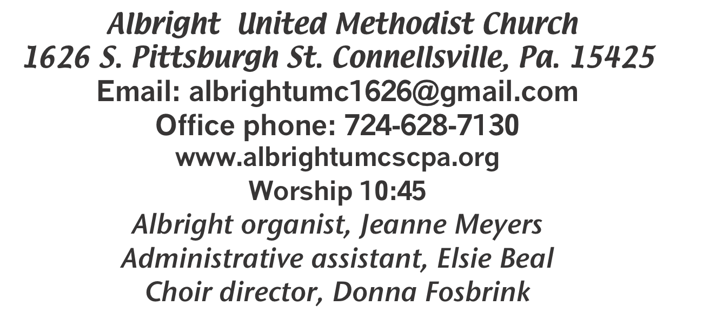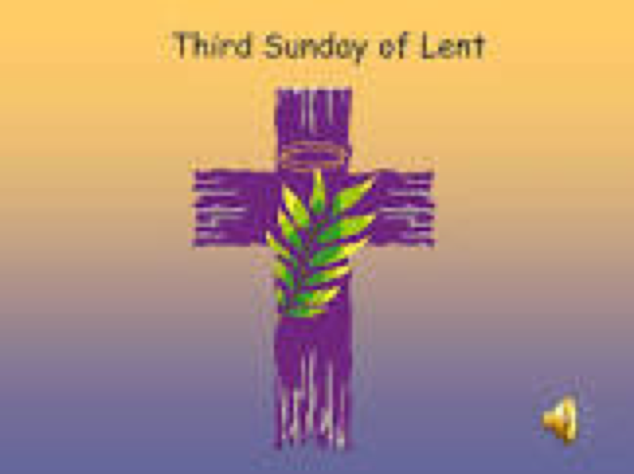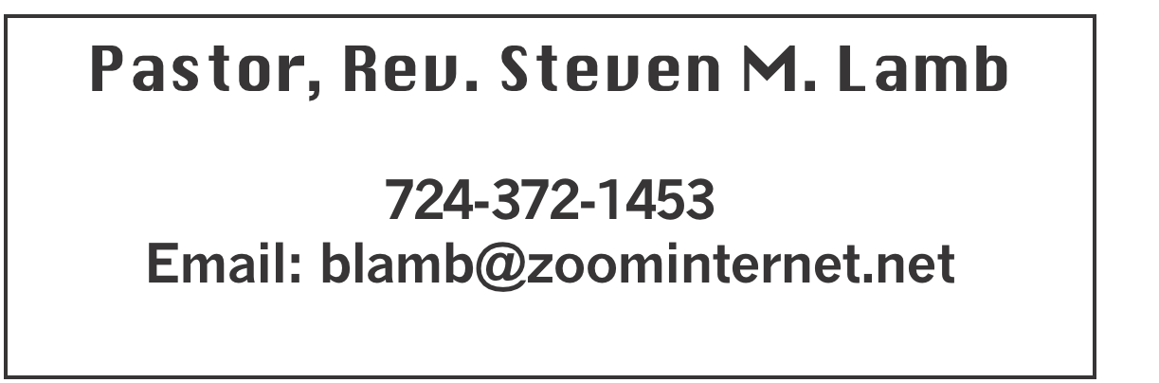

**\*\*\*\*\*\*\*\*\*\*\*\*\*\*\*\*\*\*\*\*\*\*\*\*\*\*\*\*\*\*\*\*\*\*\*\*\*\*\*\*\*\*\*\*\*\*\*\*\*\*\*\*\*\*\***

**March 23, 2025 Liturgist, Linda Burnworth 10:45a.m.**

**Third Sunday in Lent**

**\*\*\*\*\*\*\*\*\*\*\*\*\*\*\*\*\*\*\*\*\*\*\*\*\*\*\*\*\*\*\*\*\*\*\*\*\*\*\*\*\*\*\*\*\*\*\*\*\*\*\*\*\*\*\*\***

**WELCOME AND ANNOUNCEMENTS**

**PRELUDE “The Old Rugged Cross Made the Difference”**

**Gaither**

**BRINGING FORTH THE LIGHT**

**\*OPENING HYMN “O For A Thousand Tongues to Sing” 57**

**\*CALL TO WORSHIP**

**L: Isaiah 40:31 says, “Those who wait upon the LORD will**

**renew their strength.”**

***All: We will wait on you, Lord.***

**L: Psalm 37:7 says, “Be still before the LORD and wait**

**patiently for him.”**

***All: We will wait on you, Lord.***

**L: Psalm 40:1 says, “I waited patiently for the LORD; he**

**turned to me and heard my cry.”**

***All: We will wait on you, Lord.***

**L: Lamentations 3:24 says, “The LORD is my portion,**

**therefore I will wait for him.”**

***All: We will wait on you, Lord.***

**\*OPENING PRAYER**

**Lord of life and love, help us to worship you in the holiness of beauty, that beauty of holiness may appear in us. Quiet our souls in your presence with the stillness of wise trust. Lift us above our dark moods, and the shadow of sin, that we may find your will in our lives; through Jesus Christ our Lord. Amen.**

**\*GLORIA PATRI 70**

**OLD TESTAMENT READING Isaiah 55:1-9**

**The word of God for the people of God. Thanks be to God.**

**ANTHEM “This Lonesome Valley”**

**CHILDREN’S MOMENT & Coin Offering**

**PASSING THE PEACE**

**OFFERING**

**OFFERTORY “Lead Me To Calvary” Kirkpatrick**

**\*DOXOLOGY**

**\*OFFERTORY PRAYER**

**PRAYERS OFFERED IN PRAISE AND PETITION**

**PRAYER HYMN “Blessed Assurance” 369**

**PASTORAL PRAYER**

**SILENT MEDITATION**

**THE LORD’S PRAYER**

**GOSPEL READING Luke 13:1-9**

**The word of God for the people of God. Thanks be to God.**

***Thy Word is a lamp unto my feet and a light unto my path***

**MESSAGE “In Time”**

**\*CLOSING HYMN “Standing on the Promises” 374**

**\*BENEDICTION**

**\*POSTLUDE**

**\*\*\*\*\*\*\*\*\*\*\*\*\*\*\*\*\*\*\*\*\*\*\*\*\*\*\*\*\*\*\*\*\*\*\*\*\*\*\*\*\*\*\*\*\*\*\*\*\***

WELCOME

***Welcome to this worship service this Third Sunday in Lent. May the blessings you receive today help you grow closer to Jesus our Savior.***

**PRAYER CONCERNS THIS WEEK**

**Don Heckathorne Ray Knopsnider Baby Thompson**

**Trey Corvin Larry Murray Jack Burke**

**Randy Jacobs Tina Hiltabidel Patty Lint**

**Scott Wagner Rick Miller Randy Fisher**

**John Shaw George Mariotti Mary Swope**

**Lee Mimless Lincoln Dunseth**  **Sandy Reich**

**Daniel Swope Wanda Brooks Paula Shaffer**

**Twila Filler Jeff Regish Tom Dewhurst**

**Carol Ward Peggy Chase George Seighman**

**Sue Capo Larry Bloom Sr. Caitlin Pellick**

**Jamey Klonowski Jeffrey Sarmelli Carol Hunter**

**Elton & Noah Schrock Liam Lewandowski Harper Grace & Connor Jay Schrin**

**Jason Mayer Jim Pennington Beth Lamb**

**Joyce Shaffer Wisaloski family Kim Welsh**

**Ron Barry Emmalyn & Olivia Hixon Judy Whipkey**

**Justin Olexa** **Sandy Russell Kelly Thompson**

**Margaret Syner Lynn Kifer Margaret Coughenour**

**Lynn White**  **Danielle Longo Bill Shirey**

**Ashley from SMS** **Robert Miller’s family** Pastor Steve & Bev

**Rev. Ross Pryor Bishop Sandra Steiner Ball**

Homebound persons: **Edna Baker, Polly Basinger, Evelyn Curry, Sherrill Goodwin, Chuck Hall, Dolly King, Shirley Mathias, Stephanie Mattis, Ed Miller, Judy Morris, Ozella Roy**

Unspoken Requests All Military All churches

Government leaders Folks with cancer Those traveling

Those battling addiction Folks on Hospice Homeless people

Praise for answered prayers Peace around the World

Those with flu Families of those who take their own life

**THIS WEEK AT ALBRIGHT**

**TUESDAY: Blue Plate Special 11:00-1:00**

***Play rehearsal 6:30 at Otterbein***

**THURSDAY: Choir practice 7:00**

**SATURDAY: Pick up pies you ordered**

OFFICE HOURS: Tuesday, Wednesday, Thursday 10-3

Office phone 724-628-7130 Elsie at home 742-628-7467

PIE ORDERS

**Pies can be picked up on Saturday, March 29.**

FREE COMMUNITY EASTER DINNER

**Will be Saturday, April 12 at 4:00-7:00.**

**Call 724-628-7130 to pre-register. Eat in free. Take out available for $5 each. There are pink envelopes out for your donations to help with expense.**

**REGISTRATION IS GREATLY APPRECIATED.**

TRIP TO SEE NOAH IN JUNE

Bev can still take reservations for this

overnight trip June 20-21. See her if you are interested. She must know by April 13.

***POTLUCK LUNCH***

**Sunday, March 30 will be a potluck covered dish lunch after church. Bring a dish to share and join us.**

**UNITED WOMEN IN FAITH**

***Will meet Tuesday, April 8 at 7:00. Elsie will have***

***devotions. Michelle & Donna will host. We will finalize plans for Mother/Daughter/Friend dinner May 12.***

March Happenings

**Tues., 25th: Blue plate special 11-1**

**Sat., 29th: Pies can be picked up**

**Sun., 30th: Potluck covered dish after church**

**Every Thursday: Choir practice 7:00**

April Happenings

**Tues., 8th: United Women in Faith mtg. 7:00**

**Sat., 12th: Community Easter Dinner 4-7; Take out $5**

**Sun., 13th: Pick up candy**

**Thurs., 17th: Holy Thursday worship 7:30 at Otterbein**

**Dinner 6:00 at Otterbein**

**Fri., 18th: Good Friday worship 7:30 at Albright**

**Sun., 20th: Sunrise svc. 7a.m. followed by breakfast-Alb.**

**Tues., 22: Blue plate special 11-1**

**Every Thursday: Choir practice 7:00**

OUR STEWARDSHIP - March 16

**Weekly need for budget ........................................... $ 2,491.56**

**Sunday offering......................................................... $ 2,580.00**

**(Recent coin offerings $74.29)**

**Worship attendance ...................................................... 61**

**We made $570 on the recent soup sale.**

**We made $2,237.00 on sub sale.**

**GREETING YOU TODAY: Nancy Mimless & Ed Jacobs**

**March 30: Jackie Bartholomai**

**LITURGIST: March 30: Ed Jacobs**

**April 6: Myra Holden**

**ACOLYTES TODAY: Beau Wagner & Andrew Lynn**

**March 30:Kayton & Keelan Callahan**

**JUNIOR CHURCH TODAY David & Shelley Mattis**

**March 30: Mandy & Olivia Lynn**

**USHERS: Jeremy Gray, Scott Murray, Ed Jacobs, Larry Bloom**

**Mar. 30: Volunteers**

**COUNTERS: March: Sally Fosbrink & Jackie Bartholomai**

**April: Karen Stimmell & Jay Whipkey**

EASTER CANDY

**We are taking orders for homemade Easter candy.**

**Order forms are out in back of sanctuary.**

HOLY WEEK EVENTS

Sunday, April 13: Palm Sunday

Worship 10:45

Thursday, April 17: Holy Thursday

Roast beef dinner at 6:00. Free with donations accepted.

A Play 7:30 at Otterbein

Friday, April 18: Good Friday

Worship 7:30 at Albright

Sunday, April 20: Easter Sunday

Sunrise service 7a.m. at Albright with breakfast to follow.

Regular worship 10:45.

**EASTER FLOWER ORDER FORM 2025**

**We will get them from Angie’s Flower Garden.**

**Cannot guarantee specific colors.**

**Your name ___________________________________________**

**Phone number: _________________________**

**Mums 6” deluxe $11.95________**

**In honor or memory of _________________________________________**

**Given by: _________________________________________________**

**Tulips: 6” $11.95________ Color requested ____________**

**In honor or memory of _________________________________________**

**Given by __________________________________________________**

**Lilies: 6” 3 bloom $13.95; 8” 2 stem $29.95________**

**In honor or memory of _________________________________________**

**Given by ________________________________________________**

**Hyacinth: 6” $11.95 ____; 8” $16.50 ____ Color requested _____________**

**In honor or memory of _________________________________________**

**Given by ________________________________________________**

**Roses: 4” $11.50 _________ 6” $18.95 ________**

**In honor or memory of _________________________________________**

**Given by _______________________________________________**

**Total of my order $____________________**

***We need all paid orders by March 30. Make checks out to Angie’s Flower Garden.***

EASTER CANDY

**We are taking orders for homemade Easter candy.**

***Albright church Candy order form orders due by April 1***

**__________________________________________________________________________________________**

**Item Price Mlk.Ch/quan WhiteCh/quan DrkCh/quan Total**

**Cross sucker $ 1.00 _______**

**Bunny sucker $ 1.00 ________**

**Pretzel/2 $ 3.00 ______**

**Marshmallows (3) $ 2.00 _______**

**Solid bunny $ 4.00 _______**

**Solid cross $ 4.00 _______**

**Oreos (3) $ 5.00 _______**

**Rice Crispy disc(3) $ 3.50 _______**

**Variety bag $ 4.50 ______**

**LG. Peanut butter egg $12.00 _______**

**LG. Coconut egg $12.00 _______**

**LG. Maple egg $12..00 _______**

**LG. Cherry nougat egg $12.00 _______**

**LG Maple nut egg $13.50 _______**

**LG Cherry nut egg $13.50 _______**

**SM. Penut butter egg $ 2.50 _______**

**SM. Coconut egg $ 2.50 _______**

**SM. Maple egg $ 2.50 _______**

**SM. Cherry nougat egg $ 2.50 _______**

**SM Maple nut egg $ 3.50 ______**

**SM. Cherry nut egg $ 3.50 ______**

**Pick up 13 April Total due $______________**

**Customer Name ____________**

**Phone # __________________**

**Sold by:___________________________Paid by: Check #__________Cash_________**