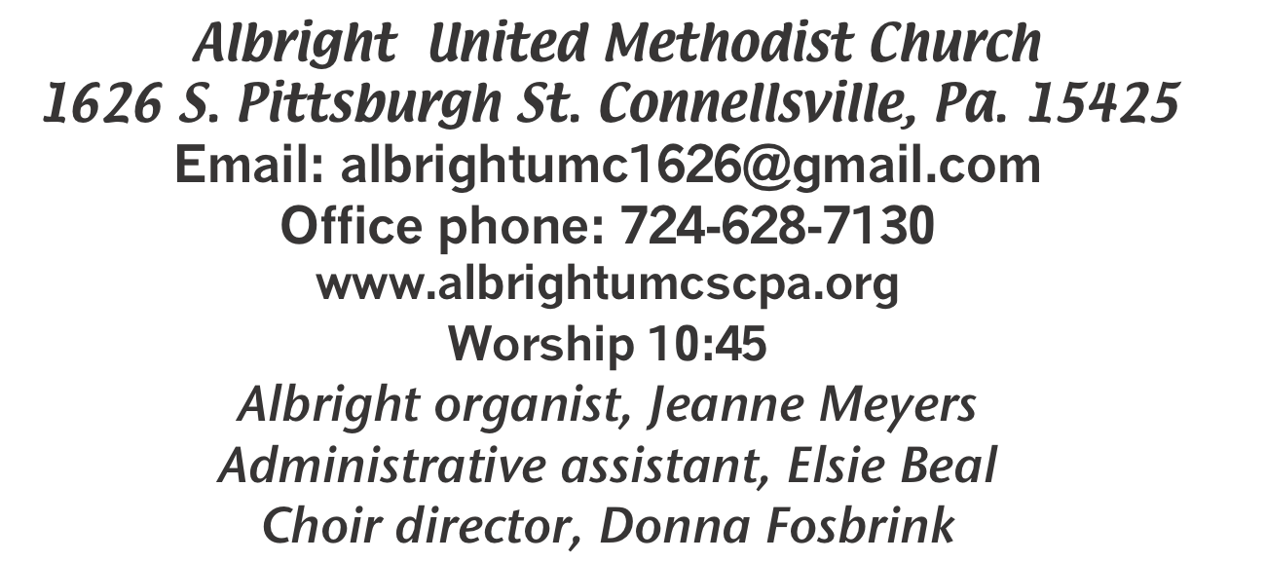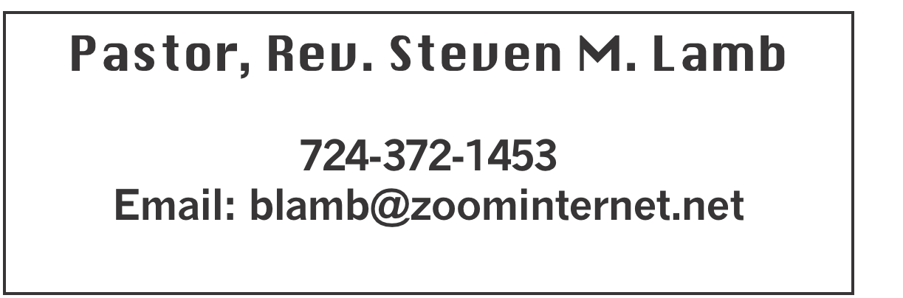

**\*\*\*\*\*\*\*\*\*\*\*\*\*\*\*\*\*\*\*\*\*\*\*\*\*\*\*\*\*\*\*\*\*\*\*\*\*\*\*\*\*\*\*\*\*\*\*\*\*\*\*\*\*\*\***

**December 22, 2024 Liturgist, Rick Tressler 10:45a.m.**

**Fourth Sunday of Advent - Love**

**\*\*\*\*\*\*\*\*\*\*\*\*\*\*\*\*\*\*\*\*\*\*\*\*\*\*\*\*\*\*\*\*\*\*\*\*\*\*\*\*\*\*\*\*\*\*\*\*\*\*\*\*\*\*\*\***

**WELCOME AND ANNOUNCEMENTS**

**PRELUDE “Mary’s Little Boy Child” Hairston**

**BRINGING FORTH THE LIGHT**

**\*OPENING HYMN“O Come, O Come Emmanuel” 211 v.4**

**\*LIGHTING THE FOURTH ADVENT CANDLE**

**Nancy Mimless & Ed Jacobs**

**Reader: When the people were looking for deliverance, the prophet Micah declared, “But you, O**

**Bethlehem of Ephrathah...from you shall come forth for me one who is to rule in Israel, whose origin is**

**from of old, from ancient day” (Micah 5:2). But what if Micah is also talking to us, proclaiming “But**

**you, O Albright church in Connellsville, from you shall come forth for us...” What? What might**

**God be calling forth from us?**

Congregation: God invited us to receive the promise of God’s salvation and the sustenance of God’s mercy and

grace, enabling us to live the premise as God-bearers to the world. As Christ was born in Bethlehem, so too we

answer God’s invitation to have Christ born among us today and every day.

**Reader: We light this candle of love as a sign of our commitment to live as people of God’s promise, a**

**promise of salvation and flourishing for all people that springs forth from God’s love for all creation.**

**Light the fourth candle of the Advent wreath.**

**\*OPENING PRAYER**

**Almighty God, the time of waiting is almost over. Like new parents eagerly awaiting the birth of a child, we impatiently wait with you for the birth of your Son. We stand in awe, knowing what the birth of this particular baby means for our lives yet unable to fully comprehend the depth of your love for us. We come before you in worship this morning, hoping that our thoughts, prayers and songs of praise are pleasing to you. We pray in Jesus’ name. Amen**

**\*GLORIA PATRI 70**

**OLD TESTAMENT READING Micah 5:2-5a**

**The word of God for the people of God. Thanks be to God.**

**CHILDREN’S MOMENT & Coin Offering**

**PASSING THE PEACE**

**OFFERING**

**OFFERTORY “The Virgin Mary Had a Baby Boy” Traditional**

**\*DOXOLOGY**

**\*OFFERTORY PRAYER**

**PRAYERS OFFERED IN PRAISE AND PETITION**

**PRAYER HYMN “Angels We Have Heart on High” 238**

**PASTORAL PRAYER**

**SILENT MEDITATION**

**THE LORD’S PRAYER**

**ANTHEM “Way Down Yonder”**

**GOSPEL READING Luke 2:39-56**

**The word of God for the people of God. Thanks be to God.**

***Thy Word is a lamp unto my feet and a light unto my path***

**MESSAGE “Why Not Me?”**

**\*CLOSING HYMN “O Come, All Ye Faithful” 234**

**\*BENEDICTION**

**\*POSTLUDE**

**\*\*\*\*\*\*\*\*\*\*\*\*\*\*\*\*\*\*\*\*\*\*\*\*\*\*\*\*\*\*\*\*\*\*\*\*\*\*\*\*\*\*\*\*\*\*\*\*\***

WELCOME

***This fourth and last Sunday of Advent we light the candle of Love. May the Love you feel during this Advent season be a lasting feeling beyond Christmas day. Join us again next Sunday.***

**name. Amen.**

**PRAYER CONCERNS THIS WEEK**

**Don Heckathorne Ray Knopsnider Thomas Leeder Paul & Myra Holden Baby Thompson Becky Irwin James & Deanna Sherbondy Trey Corvin Paula Snyder Allen Mellinger Chadd Tressler Larry Murray Jack Burke Mark Stash Pat Tinkey**

**Bobby Kozel Randy Jacobs Tina Hiltabidel Rev. Rob & Lynn Kifer**

**Shannon Mack Patty Lint Scott Wagner Paula Shaffer Gary Bungard Justin Teets Rick Miller Randy Fisher John Shaw George Mariotti**

**Mary Swope Lee Mimless Kathy Meyers Sandy Fox Ted Zigler**

**Pat Schroyer Shirley Metsger Buzz & Barb Stuart Lincoln Dunseth Nancy Hough**

**Sandy Reich John North Rob Miller Pete Darno James Lynn**

**Judy Eversdyke Jane Barnhart John Shay Wanda Brooks Susan Ramage Daniel Swope Jr. Lila Yauger Cathy Dillinger Ray Vukson Edward John**

**Robert Stewart George Hinklie Ed Butela Myra Holden Bishop Bayshore’s family**

Pastor Steve & Bev  **Rev. Ross Pryor Bishop Sandra Steiner Ball**

Homebound persons: **Edna Baker, Polly Basinger, Evelyn Curry, Sherrill Goodwin, Chuck Hall, Dolly King, Jimmy Lynn, Shirley Mathias, Stephanie Mattis, Mariloyd**

**McClintock, Ed Miller, Judy Morris, Ozella Roy**

Unspoken Requests All Military All churches

Government leaders Folks with cancer Those traveling

Those battling addiction Folks on Hospice Homeless people

Praise for answered prayers Peace around the World

Families of those who take their own life

**THIS WEEK AT ALBRIGHT**

**TUESDAY: Christmas Eve Candlelight Service 7:00 at**

**Otterbein church**

**WEDNESDAY:** MERRY CHRISTMAS TO YOU

**SUNDAY: Potluck Covered dish lunch after church**

**NO BLUE PLATE SPECIAL THIS MONTH**

Elsie on vacation Dec. 24-Jan.2. Office closed, will reopen Jan.7

Christmas Eve Service

December 24 at Otterbein 7:00p.m. A candlelight service celebrating the birth of our Savior, Jesus Christ our Lord. We hope to see you there.

***POTLUCK COVERED DISH***

***Sunday, December 29 we will have our 5th Sunday potluck covered dish lunch after church. Bring a dish to share and join us for the fellowship.***

**POINSETTIAS ORDERED**

**To the Glory of God and IN LOVING MEMORY OF:**

**Mom, Dad & Brother**

**BY: Cathy Dillinger 1Red**

**Family & Friends**

**BY: Doris and Dustin Murray 1 Pink**

**My dear husband, Gene & other loved ones**

**BY: Elsie Beal 1 Red glitter**

**Luther & Bernice Winemiller**

**BY: Gary & Sandy Winemiller 1 White**

**Mary Lou, Stephen & James**

**BY: David, Shelley, Andy & Stephanie 1 White**

**Guy & Rose Tressler; and The Tressler Family**

**BY: Sandy Russell, Rick & Mark Tressler 1W;1 Red glit.**

**IN LOVING HONOR OF:**

**Shelley Mattis**

**BY: David, Andy, Stephanie & Elliot 1 Red**

**Phyllis Kimmel**

**BY: Shelley, David, Andy Stephanie & Elliot 1 Red**

**My wife, Bev & my family**

**BY: Pastor Steve 1 Red**

CHRISTMAS GREETING

***May your holiday be filled with joyful music and praise for the Lord.***

***Merry Christmas. With Christian love to all. Linda Burnworth***

**NOTE OF THANKS**

***I just want to thank you for the Thanksgiving food box. It is***

***greatly appreciated. Trey Corvin***

OUR STEWARDSHIP - December 15

**Weekly need for budget ........................................... $ 2,214.00**

**Sunday offering ............................................................... $ 2,151.00**

**(Includes Coin offering $55.00)**

**Sunday morning worship attendance ..................................... 60**

General Fund balance as of Dec. 1...... Minus - $23,419.35

Monthly need is $10, 506.38

OCTOBER income for the month $8,051.00

NOVEMBER income for the month $8,013.00

WE NEED YOUR HELP & SUPPORT!

**GREETING YOU TODAY: Jay & Judy Whipkey**

**Dec. 29: Lynne Corvin**

**LITURGIST: Dec. 29: Ed Jacobs**

**Jan. 5: Scott Murray**

**ACOLYTES TODAY: Olivia Lynn & Emmaleigh Kalemba**

**Dec. 29: Kadey & Aubree Shaffer**

**JUNIOR CHURCH TODAY: Dave & Shelley Mattis**

**Dec. 29: Mandy Lynn & Shelley Mattis**

**USHERS: Jeremy Gray, Scott Murray, Ed Jacobs, Larry Bloom**

**Dec. 29: Karen will recruit volunteers.**

**COUNTERS: December: Larry & Bonnie Bloom**

**January: Sandy Russell & Rick Tressler**

SOUP & SUB SALE

SOUP: Sat., Jan. 11 at 10:00-1:00. $9 quart; $7 pint. Eat in for a donation of your choice. **There is a sheet out in back of sanctuary for you to let us know if you will bring soup. Please sign up. Thank you.**

SUB SALE: Fri., Jan. 10 & Sat.,Jan 11 Subs will be available and will be $12. Order forms for subs are out near bulletins.

**NOTES OF THANKS**

***Dear Choir members;***

***Thank you for participating in the “Thanksgiving Festival of Choirs” this õvember. It is a special evening for our Community to gather and offer thanks and praise for our many blessings.***

***Sincerely Mozart Music Club***

***Dear Church Choir & Donna;***

***Just a note to say how much you are appreciated for all your hard work throughout the year. Also, for all the time out of your busy days. Your music touches our hearts. Please keep up your sweet songs. Linda Burnworth***

**SUB SALE**

**Seller _______________________________ 12” Subs $12.00**

**Day Name Phone # How many Total Due Paid**

**1. ______________________________________________________________**

**2._______________________________________________________________**

**3._______________________________________________________________**

**4.____________________________________________________________**

**Orders due by Jan. 5. May be picked up Fri., Jan 10 & Sat., Jan 11 @ 10-1 or until sold out at Albright UM Church.**