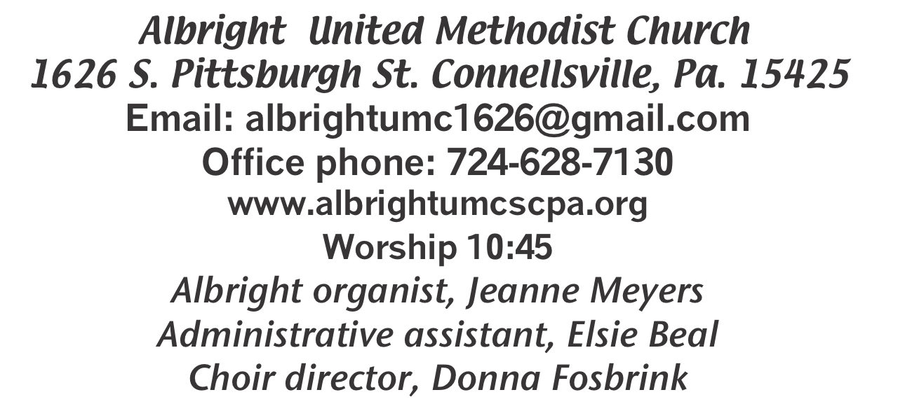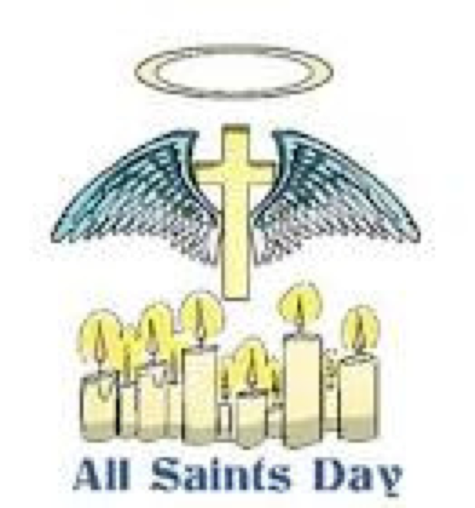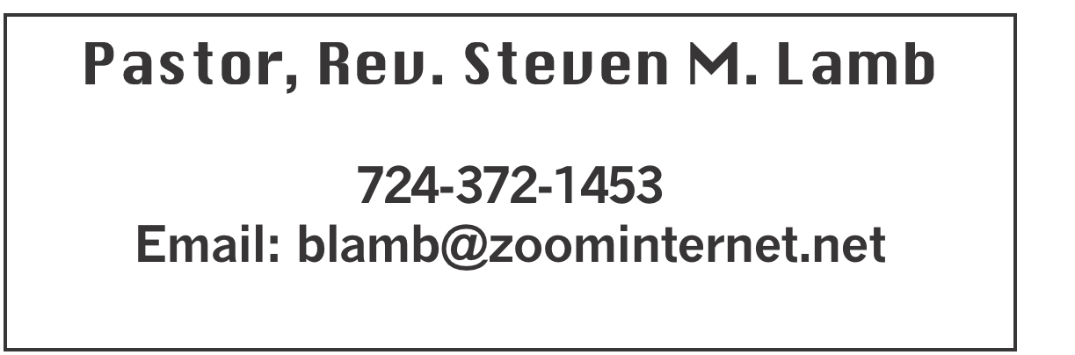

**\*\*\*\*\*\*\*\*\*\*\*\*\*\*\*\*\*\*\*\*\*\*\*\*\*\*\*\*\*\*\*\*\*\*\*\*\*\*\*\*\*\*\*\*\*\*\*\*\*\*\*\*\*\***

**November 3, 2024 Liturgist, Donna Fosbrink 10:45a.m.**

**All Saints Day**

**\*\*\*\*\*\*\*\*\*\*\*\*\*\*\*\*\*\*\*\*\*\*\*\*\*\*\*\*\*\*\*\*\*\*\*\*\*\*\*\*\*\*\*\*\*\*\*\*\*\*\*\*\*\*\*\*\*\*\*\*\*\***

**WELCOME AND ANNOUNCEMENTS**

**PRELUDE “So Send I You” Peterson**

**BRINGING FORTH THE LIGHT**

**\*OPENING HYMN “How Firm A Foundation” 529**

**\*CALL TO WORSHIP**

**L: When the Lord redeemed a people, he gave a first**

**commandment: Thou shalt worship the Lord thy God,**

**and him only shalt thou serve.**

P: A law to lift up our hearts to God.

**L: And again, they who worship must worship in Spirit and in truth.**

P: Lord, grant us your free Spirit of worship, and sanctify

our hearts wholly in truth.

**\*OPENING PRAYER**

**When we are called saints the idea jars us, for we are not saintly people. But we are seekers after God’s will, who have been powerfully claimed by Jesus Christ. Remembering who we are intended to be, let us come to God’s holy place to find forgiveness, healing and empowerment.**

**O God, our God, we confess that we have lifted up our souls to what is false. We have deceived ourselves and other people. The life we have led is not worthy of our Sovereign, Jesus Christ. Our words and actions have imprisoned others rather than setting them free, and we ourselves are bound by our prejudices and inhumanity. Forgive us, O God, for we cannot live in our deceit and unfaithfulness. Amen.**

**\*GLORIA PATRI 70**

**GOSPEL READING Mark 12:28-34**

**The word of God for the people of God. Thanks be to God.**

**ANTHEM “Celtic Communion”**

**SERVICE OF HOLY COMMUNION**

**THE LORD’S PRAYER**

**CHILDREN’S MOMENT & Coin offering**

**PASSING THE PEACE**

**OFFERING**

**OFFERTORY “O That Will Be Glory” Gabriel**

**\*DOXOLOGY**

**\*OFFERTORY PRAYER**

**PRAYERS OFFERED IN PRAISE AND PETITION**

**PRAYER HYMN “Trust and Obey” 467**

**PASTORAL PRAYER**

**SILENT MEDITATION**

**OLD TESTAMENT READING Deuteronomy 6:1-9**

**The word of God for the people of God. Thanks be to God.**

***Thy Word is a lamp unto my feet and a light unto my path***

**MESSAGE “Faith Pillars”**

**\*CLOSING HYMN “Jesus is All the World to Me” 469**

**\*BENEDICTION**

**\*POSTLUDE**

**\*\*\*\*\*\*\*\*\*\*\*\*\*\*\*\*\*\*\*\*\*\*\*\*\*\*\*\*\*\*\*\*\*\*\*\*\*\*\*\*\*\*\*\*\*\*\*\*\*\***

**WELCOME**

***Welcome everyone who has come to join us for this worship service and Holy Communion. We ask God’s blessings on all who are here. Go and be a blessing to others.***

**PRAYER CONCERNS THIS WEEK**

**Don Heckathorne Ray Knopsnider Thomas Leeder Paul & Myra Holden Baby Thompson Becky Irwin James & Deanna Sherbondy Trey Corvin Paula Snyder Allen Mellinger Chadd Tressler Mary Swope Jeffrey Sarnelli Larry Murray Jack Burke**

**Pat Tinkey Bobby Kozel Kenny Urbach Rev. Rob & Lynn Kifer Shannon Mack Bradley Sharp Randy Jacobs Tina Hiltabidel Patty Lint Scott Wagner**

**Paula Shaffer Gary Bungard Taran Miller Justin Teets Rick Miller**

**Randy Fisher John Shaw Eddie John George Mariotti Mary Swope**

**Lee Mimless Kathy Meyers Buzz & Barb Stuart Sue Billeaudeau Sandy Fox**

**Ted Zigler Pat Schroyer Lincoln Dunseth Shirley Metsger** **Sandy Reich**

**John North Rob Miller Pete Darno Judy Eversdyke James Lynn**

**Jane Barnhart Mark Stash John Shay** Pastor Steve & Bev  **Rev. Ross Pryor Bishop Sandra Steiner Ball**

Homebound persons:  **Edna Baker, Polly Basinger, Evelyn Curry, Sherrill Goodwin, Chuck Hall, Dolly King, Jimmy Lynn, Shirley Mathias, Stephanie Mattis, Mariloyd**

**McClintock, Ed Miller, Judy Morris, Ozella Roy**

Unspoken Requests All Military All churches

Government leaders Folks with cancer Those traveling

Those battling addiction Folks on Hospice Homeless people

Praise for answered prayers Peace around the World

Families of those who take their own life

If you want a name on prayer list, please use the prayer cards in the pew - give to acolytes.

**THIS WEEK AT ALBRIGHT**

**TUESDAY: ELECTION DAY!! VOTE!!**

**WEDNESDAY: Bible study 6:30-7:30**

**THURSDAY: Choir practice 7:00**

**SATURDAY: Basket class 10:00**

OFFICE HOURS**: Tuesday, Wednesday, Thursday 10:00-3:00**

**WEEKLY BIBLE STUDY**

**Bible study 6:30-7:30 at Albright. Everyone is welcome.**

OPERATION CHRISTMAS CHILD

**We are sending shoeboxes. You may use the regular shoe boxes or get plastic shoebox size. We need them in by November 17.**

**We hope you will support this very important ministry for kids.**

November Happenings

**16th: Saturday Morning special 11:00. Thanksgiving meal by Jacobs family.**

**16th: Otterbein Roast Beef Dinner 4-7. $15 adult; $8 age 4-12;**

**age 3 & under eat free.**

**17th: Shoe boxes need to be in this day.**

**21st: Otterbein pasta dinner 4-6**

**26th Blue Plate Special**

**27th: Thanksgiving Eve Service 7p.m. at Albright**

**30th: Hanging of the Greens Christmas Cantata**



**with a play;Everyone is welcome to celebrate the**

**start of the Advent Season with our annual**

**Hanging of the Greens. This year we will have**

**a cantata along with a play reminding us of the**

**meaning of the season. We will end the evening**

**with our goofy gift exchange & light refreshments.**

**HANGING OF THE GREENS PRACTICE**

**Sundays after worship and Thursdays at 6:00.**

**BASKET CLASS**

**Saturday, November 9 at 10:00 Elsie will be teaching a basket weaving class. Cost is $25. You will make a basket you can use at home.**

NOTE OF THANKS

***Albright United Methodist Women***

***Thank you all so much for the ccaring meal after mom’s service. You did a wonderful job preparing and serving the wide variety of delicious food. During a time like this we realize how much our friends and relatives really mean to us. Your expression of sympathy will always be remembered. Charlotte Holt’s family***

OUR STEWARDSHIP - October 27

**Weekly need for budget ........................................... $ 2,214.00**

**Sunday offering ............................................................... $ 2,041.00**

**(Coin offering $55 for flood relief)**

**Sunday morning worship attendance ..................................... 60**

General Fund balance as of Nov. 1...... Minus - $18,831.39

Monthly need is $10, 506.38

SEPTEMBER income for the month $9,840.65

OCTOBER income for the month $8,051.00

WE NEED YOUR HELP & SUPPORT!

**GREETING YOU TODAY: Kelli Armstrong & Jeremy Gray**

**November 10: Doris & Dustin Murray**

**LITURGIST: November 10: Bev Lamb**

**November 17: Emma Karfelt**

**ACOLYTES TODAY: Olivia Lynn & EmmaleighKalemba**

**November 10: Aubrey & Kadey Shaffer**

**JUNIOR CHURCH TODAY: Kathy Hixson & Linda Burnworth**

**November 10: Kelli Armstrong & Nancy Mimless**

**USHERS:Jackie Bartholomai, Jeremy Gray, Sherry Grote, Ed Jacobs**

**Nov. 10: Larry Bloom, Scott Murray, Sally Fosbrink, Michelle Reich**

**COUNTERS: November: Ed Jacobs & Nancy Mimless**

**December: Larry & Bonnie Bloom**

UNITED WOMEN IN FAITH

Will meet Tuesday, November 12 at 7:00. Hosting are Elsie & Kathy H. Devotions by Shelley Mattis.

SATURDAY MORNING SPECIAL

***Saturday, Nov. 16 at 11:00. The Jacobs family will provide a full Thanksgiving dinner. This is their way of remembering Sheila each year and we thank them very much.***

ROAST BEEF DINNER

**November 16: Otterbein is having a Roast Beef Dinner from 4-7. Cost is $15 for adults, $8 for children 4-12 and children 3 and under eat free. Menu includes roast beef, mashed potatoes and gravy, vegetable, dessert and drink. See Bev for tickets.**

***DECEMBER/JANUARY NEWSLETTER***

**News deadline is Tuesday, November 19.**