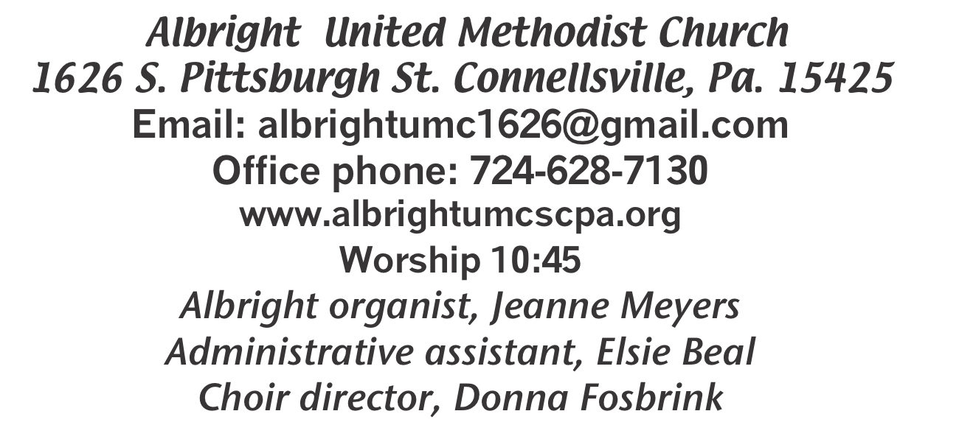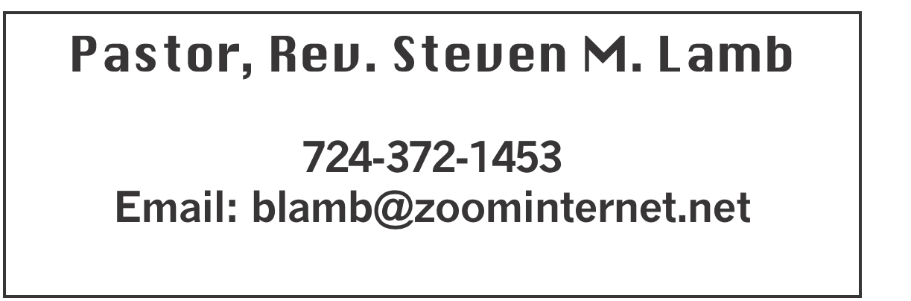

**\*\*\*\*\*\*\*\*\*\*\*\*\*\*\*\*\*\*\*\*\*\*\*\*\*\*\*\*\*\*\*\*\*\*\*\*\*\*\*\*\*\*\*\*\*\*\*\*\*\*\*\*\*\***

**October 13, 2024 Liturgist, Bonnie Bloom 10:45a.m.**

**Pastor Appreciation Sunday**

**\*\*\*\*\*\*\*\*\*\*\*\*\*\*\*\*\*\*\*\*\*\*\*\*\*\*\*\*\*\*\*\*\*\*\*\*\*\*\*\*\*\*\*\*\*\*\*\*\*\*\*\*\*\*\*\*\***

**WELCOME AND ANNOUNCEMENTS**

**PRELUDE “For Those Tears I Died” Stevens**

**\*OPENING HYMN “Hymn of Promise” 707**

**\*CALL TO WORSHIP**

**L: Sing for joy, O heavens, and exult, O earth;**

P: break forth, O mountains, into singing!

**L: For the Lord has comforted his people and will have**

**compassion on his suffering ones.**

***All: Sing praises to the LORD, for he has done***

***gloriously; let this be known in all the earth. Let us***

***sing to God!***

**\*OPENING PRAYER**

**Renew your church, Lord, your people in this land. Save us from cheap words and self-deception in your service. In the power of your Spirit transform us and shape us by your cross. Amen.**

**\*GLORIA PATRI 70**

**OLD TESTAMENT READING Job 23:1-9, 16-17**

**The word of God for the people of God. Thanks be to God**

**CHILDREN’S MOMENT & Coin offering**

**\*PASSING THE PEACE**

**OFFERING**

**OFFEERTORY “Living for Jesus” Lowden**

**\*DOXOLOGY**

**\*OFFERTORY PRAYER**

**PRAYERS OFFERED IN PRAISE AND PETITION**

**(Please give prayer cards to acolytes)**

**PRAYER HYMN “Be Thou My Vision” 451**

**PASTORAL PRAYER**

**SILENT MEDITATION**

**THE LORD’S PRAYER**

**ANTHEM “Tell it To Jesus/What A Friend”**

**EPISTLE READING Hebrews 11:1-3, 8-16**

**The word of God for the people of God. Thanks be to God.**

***Thy Word is a lamp unto my feet and a light unto my path***

**MESSAGE “That’s Life!”**

**\*CLOSING HYMN “Joyful, Joyful” 89**

**\*BENEDICTION**

**\*POSTLUDE**

**\*\*\*\*\*\*\*\*\*\*\*\*\*\*\*\*\*\*\*\*\*\*\*\*\*\*\*\*\*\*\*\*\*\*\*\*\*\*\*\*\*\*\*\*\*\*\*\*\***

WELCOME

***In the days of his flesh, Jesus offered up prayers and supplications...” (Hebrews 5:7). We, too, have come to pray and ask for God’s help and guidance. Let us unite our hearts as brothers and sisters before the Lord. Everyone is sincerely welcomed.***

**PRAYER CONCERNS THIS WEEK**

**Don Heckathorne Ray Knopsnider Thomas Leeder**

**Paul & Myra Holden Baby Thompson Becky Irwin**

**James & Deanna Sherbondy Trey Corvin Paula Snyder**

**Allen Mellinger Chadd Tressler Mary Swope**

**Jeffrey Sarnelli Emma Jobbs Paul Martin**

**Margaret Shultz Larry Murray Pat Tinkey**

**Bobby Kozel Rev. Rob & Lynn Kifer Kenny Urbach**

**Shannon Mack Randy Jacobs Carol Daniels**

**Tina Hiltabidel Scott Wagner Emryn Swaney**

**Judy Strickler Paula Shaffer Patty Lint**

**Gary Bungard Taran Miller Karen Halfhill**

**Shannon Halfhill Justin Teets Rick Miller**

**Randy Fisher John Shaw George Mariotti**

**Eddie John Buddy Richter Lee Mimless**

**Shirley Kozel Buzz & Barb Stuart Kathy Meyers**

**Sue Billeaudeau Rebecca Snyder Sandy Fox**

**Ted Zigler Anita Norris Roger Richter**

**Lincoln Dunseth** Pastor Steve & Bev  **Rev. Ross Pryor Bishop Sandra Steiner Ball**

DEEPEST SYMPATHY TO FAMILY & FRIENDS OF:

**Charlotte Holt who passed away October 5.**

Homebound persons:  **Edna Baker, Polly Basinger, Evelyn Curry, Sherrill Goodwin, Chuck Hall, Dolly King, Jimmy Lynn, Shirley Mathias, Stephanie Mattis, Mariloyd McClintock, Ed Miller, Judy Morris, Dorene Provance, Ozella Roy**

Unspoken Requests All Military All churches

Government leaders Those with cancer Homeless people

Those battling addiction Hurricane vistims

Praise for answered prayers Families of those who take their own life

If you want a name on prayer list, please use the prayer cards in the pew - give to acolytes.

**THIS WEEK AT ALBRIGHT**

**WEDNESDAY: Bible study 6:30**

**THURSDAY: Otterbein pasta meal 4-6**

**Choir practice 7:00**

**SATURDAY: Saturday Morning Special 11:00 Halloween party**

OFFICE HOURS**: Tuesday, Wednesday, Thursday 10:00-3:00**

OUR STEWARDSHIP - October 6

**Weekly need for budget ........................................... $ 2,214.00**

**Sunday offering ............................................................... $ 2, 621.00**

**(Coin offering $62.00 )**

**Sunday morning worship attendance ..................................... 50**

General Fund balance as of Oct. 1...... Minus - $18,831.39

Monthly need is $10, 506.38

AUGUST income for the month $ 10,156.00

SEPTEMBER income for the month $9,840.65

WE NEED YOUR HELP & SUPPORT!

**GREETING YOU TODAY: Pamela Lynn**

**October 20: Michelle Reich**

**LITURGIST: October 20: Karen Stimmell**

**October 27: Donna Fosbrink**

**ACOLYTES TODAY: October 13: Andrew Lynn & Beau Wagner**

**October 20: Thelma Swope & Estella Gallagher**

**JUNIOR CHURCH TODAY: Kelli Armstrong & Nancy Mimless**

**Occtober 20: Bonnie & Larry Bloom**

**USHERS:Larry Bloom, Scott Murray, Sally Fosbrink, Michelle Reich**

**Oct. 20: Jay & Judy Whipkey, Linda Burnworth, Pinky Smiley**

**COUNTERS: October: Sherry Grote & Sue Harvey**

**November: Ed Jacobs & Nancy Mimless**

**BLUE PLATE SPECIAL**

**This lunch will be Tuesday, October 22 at 11:00-1:00. Open to the public. Free with donations accepted. @3 ask $5 for take out.**

TRUNK OR TREAT

Friday, October 31 @ 6-8 p.m. in the north parking lot near the gazebo.

ROAST BEEF DINNER

**November 16: Otterbain is having a Roast Beef Dinner from 4-7. Cost is $15 for adults, $8 for children 4-12 and children 3 and under eat for free. Menu includes roast beef, mashed potatoes and gravy, vegetable, dessert and drink.**

**WEEKLY BIBLE STUDY**

**Every Wednesday 6:30-7:30 at Albright. We are currently watching season 4 of The Chosen. Everyone welcome.**

PASTA DINNER

Otterbein Pasta dinner Thursday, Oct. 17 at 4-6. Free with donations accepted. $5 for take out.

**SATURDAY MORNING SPECIAL**

Saturday, October 19 at 11:00. It is their halloween party. Lunch is sloppy joes.

OPERATION CHRISTMAS CHILD

**We will be doing shoeboxes again this year. You may use the regular shoe boxes or get plastic shoebox size. We need them in by November 17.**

**OCTOBER CALENDAR**

**16th: Bible study 6:30**

**17th: Pasta meal at Otterbein 4-6**

**Choir practice 7:00**

**19th: Saturday Morning Special halloween party 11:00**

**22nd: Blue Plate Special: this is a free lunch for the**

**community served from 11 to 1. Donations accepted.**

**There is a $5 charge for take out.**

**24th: Bishop Sandra Steiner Ball: Bishop’s Day on the**

**District. 12:00 pm Clergy- Worship and Light Lunch:**

**Albright UMC**

**3:00 pm Connellsville Area Community Ministries Visit**

**6:30 pm Laity- Dialogue and Light Snacks: Barren Run**

**UMC 569 Barren Run Rd, Smithton 15479**

**27th: Sheila Remembrance Day. Wear purple in honor of Sheila Jacobs’ favorite color.**

**31st: Trunk or Treat in the Albright North parking lot near gazebo from 6 to 8**

November Happenings:

**1st: Sub sale from 10-1**

**2nd: Soup and Sub Sale from 10-1**

**9th: Basket class 10:00**

**16th: Saturday Morning special 11:00. T’giving meal by Jacobs family.**

**21st: Otterbein pasta dinner 4-6**

**26th Blue Plate Special**

**27th: Thanksgiving Eve Service 7PM**

**30th: Hanging of the Greens Christmas Cantata with a play;**

**Everyone is welcome to celebrate the start of the Advent Season with our annual Hanging of the Greens. This year we will have a cantata along with a play reminding us of the meaning of the season. We will end the evening with our goofy gift exchange and light refreshments.**

December Happenings:

**14th: Annual Cookie Walk from 9-1 where you can purchase a variety of homemade cookies.**

**19th: Otterbein pasta dinner 4-6**

**21st: Saturday Morning Special Christmas Party from 11-1.**

**21st: Blue Christmas Service at 7PM remembering & celebrating the lives of those we lost and acknowledging the grief we feel in**

**this season.**

**24th: Christmas Eve Candlelight service 7:00 at Otterbein**

**Albright will also be doing Christmas for veterans families.**