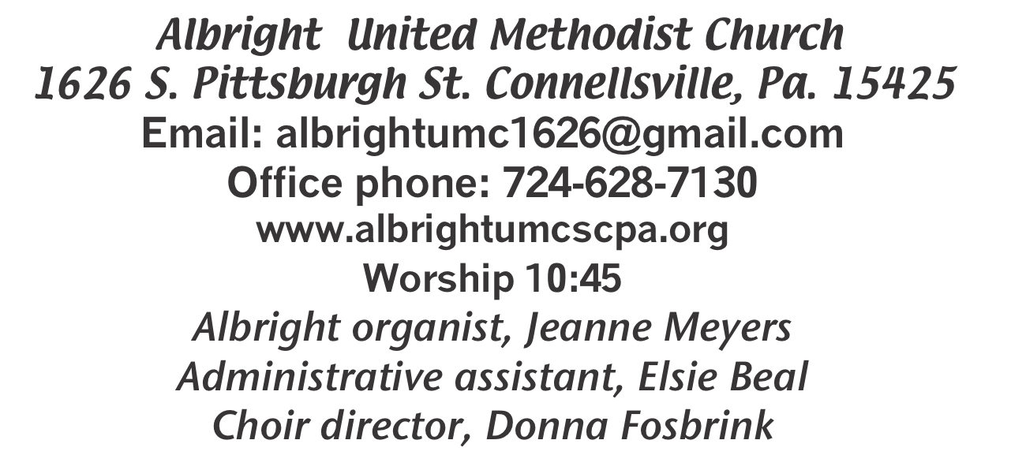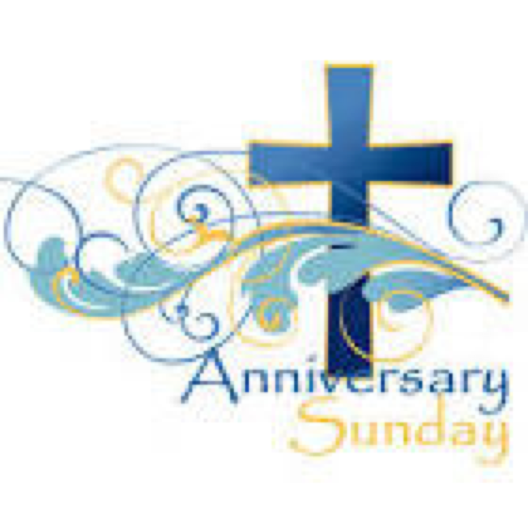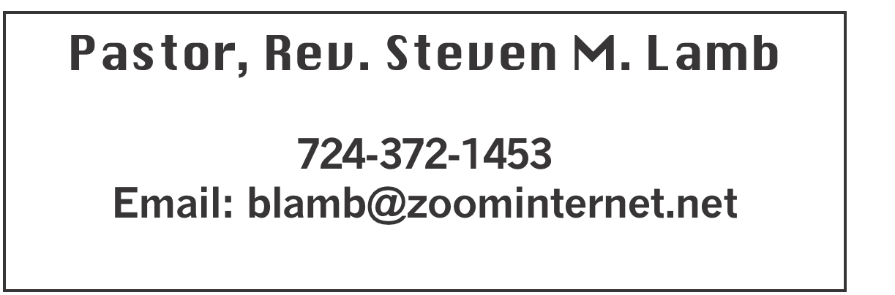

**\*\*\*\*\*\*\*\*\*\*\*\*\*\*\*\*\*\*\*\*\*\*\*\*\*\*\*\*\*\*\*\*\*\*\*\*\*\*\*\*\*\*\*\*\*\*\*\*\*\*\*\*\*\***

**September 29, 2024 Liturgist, Sherry Grote 10:45a.m.**

**Anniversary Sunday**

**\*\*\*\*\*\*\*\*\*\*\*\*\*\*\*\*\*\*\*\*\*\*\*\*\*\*\*\*\*\*\*\*\*\*\*\*\*\*\*\*\*\*\*\*\*\*\*\*\*\*\*\*\*\*\***

**WELCOME AND ANNOUNCEMENTS**

**PRELUDE “If Jesus Goes With Me” Miles**

**BRINGING FORTH THE LIGHT**

**\*OPENING HYMN “The Church’s One Foundation” 545**

**\*CALL TO WORSHIP**

**Leader: Jesus, thy saving word**

**Wounds of this world will cure;**

People: Our prayer attend;

Come and thy people bless

***All: And give thy word success,***

***Author of righteousness, savior and friend.***

**\*OPENING PRAYER**

**Holy Spirit, before we even open the Scriptures today, we need to stop and ask for your guidance. We tend to believe we have all the answers, and we know all there is to know. Humble us so we may learn from you. Studying the word of God is no small matter, so let us not enter in lightly. Let us prepare our hearts to be stirred and changed by the truth we will encounter. Holy Spirit, be our guide. We will listen for your voice. Amen.**

**\*GLORIA PATRI 70**

**OLD TESTAMENT READING Psalm 124**

**The word of God for the people of God. Thanks be to God.**

LIGHTING THE REMEMBRANCE CANDLES

**CHILDREN’S MOMENT & Coin Offering**

**PASSING THE PEACE**

**OFFERING**

**OFFERTORY“There’s Something About that Name”**

**\*DOXOLOGY Gaither**

**\*OFFERTORY PRAYER**

**PRAYERS OFFERED IN PRAISE AND PETITION**

**PRAYER HYMN “I Surrender All” 354**

**PASTORAL PRAYER**

**SILENT MEDITATION**

**THE LORD’S PRAYER**

**ANTHEM “Wake Up Church, Wake Up!”**

**GOSPEL READING Mark 9:38-50**

**The word of God for the people of God. Thanks be to God.**

***Thy Word is a lamp unto my feet and a light unto my path***

**MESSAGE “Death Cleaning”**

**\*CLOSING HYMN “I Am the Church (v.1-4) 558**

**\*BENEDICTION**

**\*POSTLUDE**

**\*\*\*\*\*\*\*\*\*\*\*\*\*\*\*\*\*\*\*\*\*\*\*\*\*\*\*\*\*\*\*\*\*\*\*\*\*\*\*\*\*\*\*\*\*\*\*\*\*\*\***

WELCOME

***We welcome one and all to this special worship service on Anniversary Sunday. We count your prsence at worship as a blessing. May the grace of God dwell in us all. Lift up your hearts unto the Lord.***

**PRAYER CONCERNS THIS WEEK**

**Don Heckathorne Ray Knopsnider Thomas Leeder Paul & Myra Holden Baby Thompson Becky Irwin James & Deanna Sherbondy Trey Corvin Paula Snyder**

**Allen Mellinger Chadd Tressler Mary Swope Jeffrey Sarnelli Emma Jobbs**

**Paul Martin Margaret Shultz Larry Murray Jack Burke Pat Tinkey**

**Bobby Kozel Rev. Rob Kifer Kenny Urbach Salem Skukar Shannon Mack**

**Bradley Sharp Randy Jacobs Carol Daniels Tina Hiltabidel Scott Wagner**

**Emryn Swaney Judy Strickler Donna Mills Paula Shaffer Patty Lint**

**Gary Bungard Taran Miller Karen Halfhill Shannon Halfhill Justin Teets**

**Rick Miller Bruce Fosbrink Randy Fisher John Shaw George Mariotti**

**Eddie John Buddy Richter Mary Swope Lee Mimless Kathy Meyers**

**Buzz & Barb Stuart Sue Billeaudeau Sandy Fox Ted Zigler Pat Schroyer**

**Lincoln Dunseth Shirley Metsger** **Sandy Reich John North** Pastor Steve & Bev  **Rev. Ross Pryor Bishop Cynthia Moore-Koikoi**

Homebound persons:  **Edna Baker, Polly Basinger, Evelyn Curry, Sherrill Goodwin, Chuck Hall, Charlotte Holt, Dolly King, Jimmy Lynn, Shirley Mathias, Stephanie**

**Mattis, Mariloyd McClintock, Ed Miller, Judy Morris, Dorene Provance, Ozella Roy**

Unspoken Requests All Military All churches

Government leaders Those with cancer

Those battling addiction Those on Hospice

Praise for answered prayers Homeless people Travelers

Families of those who take their own life

IF YOU WANT A NAME ON PRAYER LIST, PLEASE USE THE PRAYER CARDS IN THE PEW - give to Acolytes.

**THIS WEEK AT ALBRIGHT**

**TODAY: Covered dish potluck after church service. Join us!**

**WEDNESDAY: Bible study 6:30**

**THURSDAY: Choir practice 7:00**

**SATURDAY: Basket class 10:00**

OFFICE HOURS**: Tuesday, Wednesday, Thursday 10- 3**

**WEEKLY BIBLE STUDY**

**Every Wednesday at 6:30 at Albright. Everyone welcome.**

Meeting with DS Pryor at Albright UMC Oct. 7th

Albright leadership (CoOp representatives and members of finance) will meet in the sanctuary at 5:30 prompt to discuss our ability in fiscal support for the cooperative.  **Those who should be present are: Eve Shupe, Sherry Grote, Jeremy Gray, Michelle Reich, Randy Fisher, Jackie Bartholomai, Rick Tressler & Sandy Russell**

***Meeting will last no more than ½ hour.***

UNITED WOMEN IN FAITH

Tues., October 8: We will host the Otterbein ladies at 6:30 for the annual Thank Offering meal & program. All ladies of the church are invited to join us.

**PASTOR APPRECIATION DINNER**

**Sun., Oct. 13 at noon at Albright our annual appreciation day to say “Thank You” to Pastor Steve & Bev for all they do in our churches. Catered by Hartsek. Cost $15 each.**

**Menu: Stuffed chicken breast, Ham, mashed potatoes & gravy, green beans,penne pasta with red sauce, salad & rolls. Cake provided by Otterbein church.** Please make reservations. Put money in an envelope with how many attending & give to Eve Shupe by October 6.

OPERATION CHRISTMAS CHILD

**We will be doing shoeboxes again this year. You may use the regular shoe boxes or get plastic shoebox size. We need them in by November 17.**

**OCTOBER CALENDAR**

**Sat., 5: Basket class 10:00**

**Sun., 6: World Communion Sunday**

**Mon., 7: Co-op leadership meet with D.S. Prior 5:30**

**Tues., 8: U.Women in Faith 6:30 host Otterbein ladies**

OUR STEWARDSHIP - September 22

**Weekly need for budget ........................................... $ 2,214.00**

**Sunday offering ............................................................... $ 2,202.65**

**(Coin offering $74)**

**Sunday morning worship attendance ..................................... 54**

General Fund balance as of Sept. 1...... Minus - $17,416.95

Monthly need is $10, 506.38

JULY income for the month was $ 8,079.07

AUGUST income for the month $ 10,156.00

WE NEED YOUR HELP & SUPPORT!

**GREETING YOU TODAY: Elsie Beal**

**October 6: Sherry & Fred Grote**

**LITURGIST: October 6: Eve Shupe**

**October 13: Bonnie Bloom**

**ACOLYTES TODAY: Aubree & Kadey Shaffer**

**October 6: Piper Marko & Jameson Tony**

**JUNIOR CHURCH TODAY: Shelley Mattis & Mandy Lynn**

**October 6: Kathy Hixson & Linda Burnworth**

**USHERS: Volunteers**

**Oct, 6: Pinky Smiley, Sherry Grote, Jeremy Gray & Ed Jacobs**

**COUNTERS: September: Jay Whipkey & Karen Stimmell**

**October: Sherry Grote & Sue Harvey**

§§§§§§§§§§§§§§§§§§§§§§§§§§§§§§§§§§§§§§§§§§§§§§§§§§§§§§§

OCTOBERFEST &

CRAFT/VENDOR SHOW

SATURDAY, OCTOBER 12

***Octoberfest from 4:00-7:00. We are planning a variety of German foods available to purchase. Pork, sauerkraut, mashed potatoes, dumplings, hot dogs, apple streudel, etc.***

**We will have live music at 7:00 with the band “Winds of Change” (John Hammond’s group) 7:00-9:30 p.m**

Crafters & Vendors will be setting up 2:00-7:00 that day. If you would be interested in setting up, please contact Beverly Lamb at 724-372-1456 or call the church office 724-628-7130. Cost is $25 for first table and $15 for second table. **OPEN TO THE PUBLIC!!**

We invite you to come and have a good time with us.

§§§§§§§§§§§§§§§§§§§§§§§§§§§§§§§§§§§§§§§§§§§§§§§§§§§§