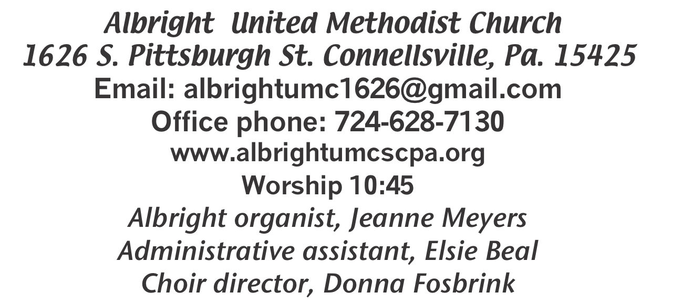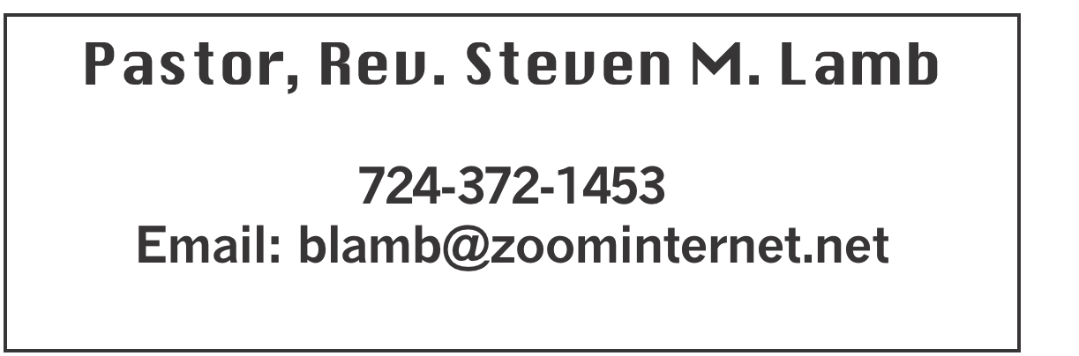

**\*\*\*\*\*\*\*\*\*\*\*\*\*\*\*\*\*\*\*\*\*\*\*\*\*\*\*\*\*\*\*\*\*\*\*\*\*\*\*\*\*\*\*\*\*\*\*\*\*\*\*\*\*\***

**August 11 , 2024 Liturgist, Rick Tressler 10:45a.m.**

**\*\*\*\*\*\*\*\*\*\*\*\*\*\*\*\*\*\*\*\*\*\*\*\*\*\*\*\*\*\*\*\*\*\*\*\*\*\*\*\*\*\*\*\*\*\*\*\*\*\*\*\*\*\*\*\*\***

**WELCOME AND ANNOUNCEMENTS**

**PRELUDE “I Believe in Miracles” Peterson**

**BRINGING FORTH THE LIGHT**

**\*OPENING HYMN “Pass Me Not, O Gentle Savior” 351**

**\*CALL TO WORSHIP**

**L: God resisteth the proud, but giveth to the humble.**

P: Submit yourselves therefore to God that he may exalt you.

**L: Resist the Devil and he will flee from you.**

P: Draw nigh to God and he will draw nigh to you.

**—1 Peter 5:5-9 and James 4:6-10 (KJV)**

**\*OPENING PRAYER**

**Holy God, we thank you for the example of Jesus, who made prayer the bedrock of his life and taught us to do the same. Through prayer he received strength to choose faithfulness rather than give in to temptation. Through prayer he remained connected to you and was sustained by your Spirit for the tasks of ministry. Through prayer he healed, taught, forgave and called. Through prayer he met the trials of life with grace, refusing to react in anger, blame or condemnation. Merciful Savior, grant us a deeper desire for prayer as we seek to follow Christ’s example. Amen.**

**\*GLORIA PATRI 70**

**OLD TESTAMENT READING 2 Samuel 18:5-9, 15, 31-33**

**The word of God for the people of God. Thanks be to God**

**CHILDREN’S MOMENT & Coin offering**

**\*PASSING THE PEACE**

**OFFERING**

**OFFEERTORY “He’ll Never Let Go of My Hand”**

**Jeanne Meyers & Sharon Grimm**

**\*DOXOLOG**

**\*OFFERTORY PRAYER**

**PRAYERS OFFERED IN PRAISE AND PETITION**

**(Please give prayer cards to acolytes)**

**PRAYER HYMN “This Is My Song” 437**

**PASTORAL PRAYER**

**SILENT MEDITATION**

**THE LORD’S PRAYER**

**SPECIAL MUSIC “Amazing Grace” Jeanne & Sharon**

**EPISTLE READING Ephesians 4:24-5:2**

**The word of God for the people of God. Thanks be to God.**

***Thy Word is a lamp unto my feet and a light unto my path***

**MESSAGE “No Vacancy Heart”**

**\*CLOSING HYMN “Precious Name” 536**

**\*BENEDICTION**

**\*POSTLUDE**

**\*\*\*\*\*\*\*\*\*\*\*\*\*\*\*\*\*\*\*\*\*\*\*\*\*\*\*\*\*\*\*\*\*\*\*\*\*\*\*\*\*\*\*\*\*\*\*\*\***

WELCOME

***Welcome to the worship and fellowship of God’s Church. May this time together in God’s presence lift your spirit, engender hope and fill everyone’s heart with love.***

**PRAYER CONCERNS THIS WEEK**

**Don Heckathorne Ray Knopsnider Thomas Leeder Paul & Myra Holden Baby Thompson Becky Irwin James & Deanna Sherbondy Trey Corvin Paula Snyder Susie Mongell Keith Morris Loretta Capo Allen Mellinger Kilee Robinson Chadd Tressler**

**Mary Swope Rich Marto Jeffrey Sarnelli Emma Jobbs Paul Martin Margaret Shultz Donna Fosbrink Madelyn Johnson Allen Thomas Larry Murray**

**Jack Burke Pat Tinkey Bobby Kozel Rev. Rob Kifer Kenny Urbach**

**Salem Skukar Shannon Mack Rebecca Snyder Bradley Sharp Randy Jacobs**

**Carol Daniels Denny Dunn Kayla Hann Toni Jones Will Johnson Tina Hiltabidel Zack Martin Scott Wagner Fred Grote Shirley Metsger**

**Emryn Swaney Betty Flynn Judy Strickler Donna Mills Paula Shaffer**

**Patty Lint Gary Bungard Taran Miller Chuck Reich’s family**

**Ethel Katona’s family** Pastor Steve & Bev  **Rev. Ross Pryor Bishop Cynthia Moore-Koikoi**

Homebound persons: **Polly Basinger, Charlotte Holt, Dolly King, Shirley Mathias, Mariloyd McClintock, Edna Baker, Jimmy Lynn, Ozella Roy, Evelyn Curry, Judy Morris, Ed Miller, Dorene Provance, Jean Rahl, Sherrill Goodwin, Chuck Hall, Stephanie Mattis**

Unspoken Requests All Military All churches

Government leaders Those with cancer

Those battling addiction Those on Hospice

Praise for answered prayers Homeless people

Families of those who take their own life

If you want a name on prayer list, please use the prayer cards in the pew - give to acolytes.

**THIS WEEK AT ALBRIGHT**

**THURSDAY: Pasta meal at Otterbein 4-6**

**FRIDAY & SATURDAY: Sub sale 10-1**

**SUNDAY: Special music: Bonnie Bloom**

OFFICE HOURS**: Tuesday, Wednesday, Thursday 10:00-3:00**

DONATIONS FOR BENCHES

We are asking for donations to help purchase benches for the gazebo. We have a sample in the downstairs hallway for you to see. Any size donation will be appreciated. Please use envelopes on the board in the back of sanctuary.

**PASTA MEAL**

Thursday, August 15 @ 4:00-6:00 at Otterbein UM Chuurch. Open to the public. Free with donations accepted, but not necessary. $5 for take out.

AUGUST CALENDAR

**Thursday 15th: Pasta meal at Otterbein 4-6**

**Fri., Aug. 16 & Sat, Aug.17: Sub sale 10-1. 12” for $10 each**

BLUE PLATE SPECIAL

**Tuesday, August 27 at 11:00-1:00. Light lunch includes dessert & beverage. Free with donations accepted. We ask $5 for take outs. Open to the Public.**

SEPTEMBER CALENDAR

Sat., Sept. 7 @ 11:00 - Saturday Morning Special

Sun., Sept. 8 @ 10:45 - Outdoor worship service

near the Gazebo; followed by a covered dish

picnic in the pavilion. Bring a lawn chair for

comfort.

Tues., Sept. 10 @ 7:00 - United Women in Faith mtg

Wed., Sept. 11 @ 6:30 - Weekly Bible study begins

Thurs., Sept. 12 @ 7:00 - Choir practices begin

Fri., Sept 13 & Sat., Sept 14 @ 10-1 Sub sale

Sat., Sept. 14 @ 10:00 - Basket class

Tues., Sept. 17 @ 7:00 - Church council meeting

Wed., Sept. 18 - Oct/Nov newsletter news deadline

Thurs., Sept. 19 @ 4-6 - Otterbein Pasta meal

Tues., Sept. 24 @ 11-1 - Blue plate special luncheon

Sun., Sept. 29 @ 10:45 Anniversary Sunday followed by a potluck covered dish lunch

OUR STEWARDSHIP - August 4

**Weekly need for budget ........................................... $ 2,214.00**

**Sunday offering ............................................................... $ 3,135.00**

**Includes Coin offering $79.00**

**Sunday morning worship arrendance ..................................... 70**

General Fund balance as of Aug. 1...... Minus - $20,264.71

Monthly need is $10, 506.38

JUNE (5 Sundays) income for the month was $9,624.65

JULY income for the month was $ 8,079.07

WE NEED YOUR HELP & SUPPORT!

**GREETING YOU TODAY: Myra Holden**

**August 18: Eve Shupe**

**LITURGISTS: August 18: Nancy Mimless**

**August 25: Linda Burnworth**

**ACOLYTES TODAY: Kadey & Aubree Shaffer**

**August 18: Jameson Tony & Piper Marko**

**JUNIOR CHURCH TODAY: Kelly Armstrong & Nancy Mimless**

**August 18: Larry & Bonnie Bloom**

**USHERS: Larry Bloom, Scott Murray, Sally Fosbtrink, Michelle Reich**

**Aug. 18:Jay & Judy Whipkey, Linda Burnsorth & Pinky Smiley**

**COUNTERS: August: Jackie Bartholomai & Sally Fosbrink**

**September: Jay Whipkey & Karen Stimmell**

**SPECIAL MUSIC: August 18: Bonnie Bloom**

**August 25: Shelley Mattis & Donna Fosbrink**

SATURDAY MORNING SPECIAL

**This ministry for persons with special needs will gather Saturday, September 7 at 11:00.**

**UWF DAY APART AT JUMONVILLE**

Will be Thursday, September 5. Registration 9:00;

Program 9:30. Soup & salad lunch. Speaker: Trooper Blaine Henderson. Communion: Rev. Ross Prior, our new district Superintendent. Music: Bert Sesler

**On Saturday, October 12 from 2-7 Albright will be having a craft/vendor show along with our Octoberfest meal. Vendor times will be from 2:00-7:00 p.m. with the meal being from 4-7.**

**The Vendor fee iss $25 for the first table and $15 for the second table and is non refundable. One vendor for type of product. Set up will be Saturday from 10-1:30 and remain set up and on site until 7 p.m. Vendors are responsible for leaving their area in the same condition as found.**

**Albright UMC and any workers affiliated with said event will not be held responsible for any injuries, damages incurred or lost or stolen items.**

**Submitting this application with your fee is a commitment to participate in the Albright UMC Vandor show and is non refundale. For any questions please call Bev 724-372-1456 pr the church office 724-628-7130.**

**------------------------------------------------------------------------**

**Complete & return application below with a check made out to Albright UMC by Sept. 15 (Your spot is not guaranteed until your registration form and payment are received.)**

**Please mail completed form & payment to:**

**Bev Lamb - 1526 Chestnut St. - Connellsville, Pa. 15425**

**Vendor Name___________________________________**

**Contact Person ___________________________________**

**Phone #__________________**

**Email _________________________**

**Address______________________________________________**

**_____________________________________________________**

**Description of craft or merchandise:**

**_____________________________________________________**

**Need electricity? Yes _____ No _____**

**Tables requested $25/1_______ $15 2nd __________**

**Total amount due__________Amt. Pd.____________**

**Date received_________________**