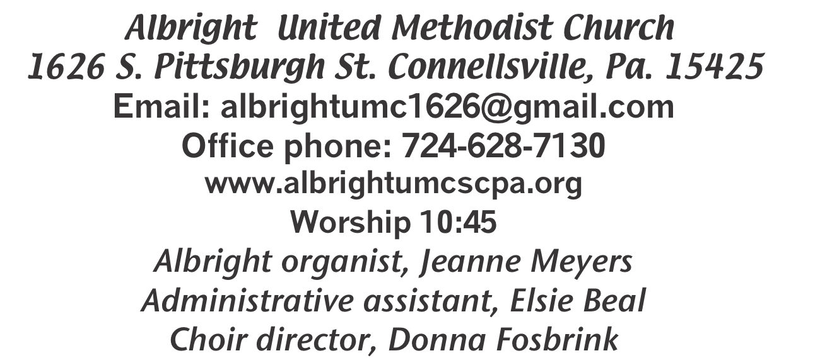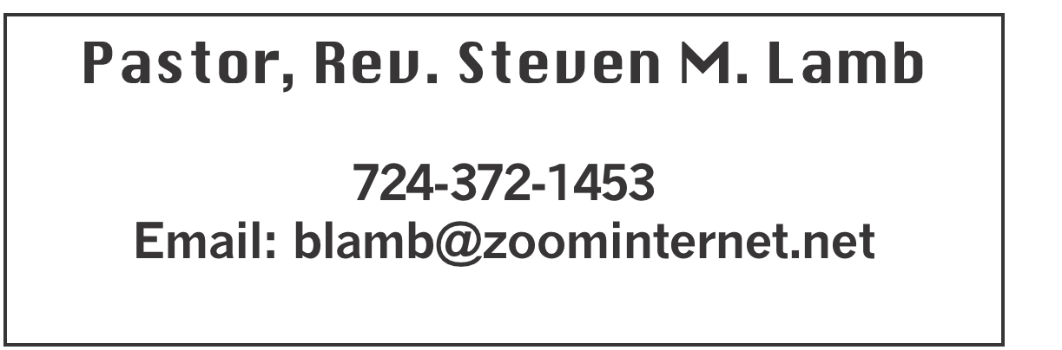

**\*\*\*\*\*\*\*\*\*\*\*\*\*\*\*\*\*\*\*\*\*\*\*\*\*\*\*\*\*\*\*\*\*\*\*\*\*\*\*\*\*\*\*\*\*\*\*\*\*\*\*\*\*\***

**August 4, 2024 Liturgist, Shelley Mattis 10:45a.m.**

**\*\*\*\*\*\*\*\*\*\*\*\*\*\*\*\*\*\*\*\*\*\*\*\*\*\*\*\*\*\*\*\*\*\*\*\*\*\*\*\*\*\*\*\*\*\*\*\*\*\*\*\*\*\*\*\***

**WELCOME AND ANNOUNCEMENTS**

**PRELUDE “Ivory Palaces” Barraclaugh**

**BRINGING FORTH THE LIGHT**

**\*OPENING HYMN “Bread of the World” 624**

**\*CALL TO WORSHIP**

**L: Let all who hunger for God come to God’s holy hill!**

P: Blessed are those whose desire is for the Lord; let us

lift our hearts and voices in thanksgiving.

**L: Let all who thirst for God enter the temple of the**

**Lord.**

P: Blessed are those who worship in spirit and in truth.

Let us worship God with prayer and praise!

**\*OPENING PRAYER**

**Give me daily bread, dear Lord, I pray. I am so much in need of bread to feed all the hungry parts of me. Keep me aware, please, that food for mind and feeling and spirit is as important as my body’s bread. And give me love, and hope, and trust, and openness, too, on which to feed, on which to live. In Jesus’ name. Amen.**

**\*GLORIA PATRI 70**

**OLD TESTAMENT READING Psalm 51:1-12**

**The word of God for the people of God. Thanks be to God.**

**SPECIAL MUSIC Don & Micki Richter**

**SERVICE OF HOLY COMMUNION**

**THE LORD’S PRAYER**

**CHILDREN’S MOMENT & Coin offering**

**PASSING THE PEACE**

**PRAYER REQUESTS**

**(give prayer cards to acolytes)**

**OFFERING**

**OFFERTORY Special music by Don & Micki Richter**

**\*DOXOLOGY**

**\*OFFERTORY PRAYER**

**PRAYERS OFFERED IN PRAISE AND PETITION**

**PRAYER HYMN “Fill My Cup, Lord” INSERT**

**PASTORAL PRAYER**

**SILENT MEDITATION**

**GOSPEL READING John 6:24-35**

**The word of God for the people of God. Thanks be to God.**

***Thy Word is a lamp unto my feet and a light unto my path***

**MESSAGE “How’s The Diet Going?”**

**\*CLOSING HYMN “Leave It There” 522**

**\*BENEDICTION**

**\*POSTLUDE**

**\*\*\*\*\*\*\*\*\*\*\*\*\*\*\*\*\*\*\*\*\*\*\*\*\*\*\*\*\*\*\*\*\*\*\*\*\*\*\*\*\*\*\*\*\*\*\*\*\*\***

**WELCOME**

***We extend a hand of Christian fellowship to all who have come to worship. May this be a joyous time when we***

***approach the throne of grace with love and praise. Welcome!***

**PRAYER CONCERNS THIS WEEK**

**Don Heckathorne Ray Knopsnider Thomas Leeder Paul & Myra Holden Baby Thompson Becky Irwin James & Deanna Sherbondy Trey Corvin Paula Snyder Susie Mongell Keith Morris Loretta Capo Allen Mellinger Kilee Robinson Kathy Anthony Brennan Sechrist Barb & Buzz Stuart Chadd Tressler Ryker Klingensmith Mary Swope**

**Rich Marto Jeffrey Sarnelli Emma Jobbs Paul Martin Margaret Shultz Donna Fosbrink Linda Burnworth Bill Bryner Madelyn Johnson Allen Thomas**

**Larry Murray Jack Burke Pat Tinkey Bobby Kozel Rev. Rob Kifer**

**Kenny Urbach Daniel Jr. Salem Skukar Shannon Mack Rebecca Snyder**

**Bradley Sharp Randy Jacobs Carol Daniels Denny Dunn Kayla Hann**

**Toni Jones Will Johnson Tina Hiltabidel Zack Martin Scott Wagner**

**Fred Grote Shirley Metsger** Pastor Steve & Bev  **Rev. Ross Pryor**

**Bishop Cynthia Moore-Koikoi**

Homebound persons: **Polly Basinger, Charlotte Holt, Dolly King, Shirley Mathias, Mariloyd McClintock, Edna Baker, Jimmy Lynn, Ozella Roy, Evelyn Curry, Judy Morris, Chuck Watson, Ed Miller, Dorene Provance, Jean Rahl (now on Hospice), Sherrill Goodwin, Chuck Hall, Stephanie Mattis**

Unspoken Requests All Military All churches

Government leaders Those with cancer Homeless persons

Those battling addiction Praise for answered prayers

Families of those who take their own life

If you want a name on prayer list, please use the prayer cards in the pew - give to acolytes.

**THIS WEEK AT ALBRIGHT**

**TODAY: Game night 2-7. Bring a game or play one here**

**SATURDAY: Ice Cream Social 4:007:00 Tickets at the door**

**SUNDAY: Special music: Jeanne Meyers & Sharon Grimm**

OFFICE HOURS**: Tuesday, Wednesday, Thursday 10:00-3:00**

DONATIONS FOR BENCHES

We are asking for donations to help purchase benches for the gazebo. We have a sample in the downstairs hallway for you to see. Any size donation will be appreciated. Please use envelopes on the board in the back of sanctuary.

MARILYN’S BOOKS

***There’s a box of books in the downstairs hallway. They are Christian books that Marilyn Banks enjoyed reading. There are also devotional books from her home. If you would like to have some of them, please help yourself. They are FREE!***

GAME NIGHT TODAY 2:00-7:00

**Bring a game to play with others OR there will be games here for your use. We will have popcorn, water, soft drinks available. We will also have pizza for $1 a slice. This is a fun time for us to come together & get better acquainted.**

ICE CREAM SOCIAL AUGUST 10, 2024

4:00-7:00p.m.

On The Menu: Sandwich & chips $5

Ice cream float $4; Sundae $5

Banana split $6; Bottle water $1; Free coffee

**PASTA MEAL**

Thursday, August 15 @ 4:00-6:00 at Otterbein UM Chuurch. Open to the public. Free with donations accepted, but not necessary. $5 for take out.

SUB SALE

Friday 8/16 & Saturday 8/17. 10-1. $10 each Order by Aug. 11.

OUR STEWARDSHIP - July 28

**Weekly need for budget ........................................... $ 2,214.00**

**Sunday offering ............................................................... $ 1,611.00**

**Includes Coin offering $47.00**

**Sunday morning worship arrendance ..................................... 59**

General Fund balance as of Aug. 1...... Minus - $20,264.71

Monthly need is $10, 506.38

JUNE (5 Sundays) income for the month was $9,624.65

JULY income for the month was $ 8,079.07

WE NEED YOUR HELP & SUPPORT!

**GREETING YOU TODAY: Elaine & Donna Fosbrink**

**August 11: Myra Holden**

**LITURGISTS: August 11: Rick Tressler**

**August 18: Nancy Mimless**

**ACOLYTES TODAY: Olivia Lynn & Kamrie Kimmel**

**August 11: Kadey & Aubree Shaffer**

**JUNIOR CHURCH TODAY: Kathy Hixson & Linda Burnworth**

**August 11: Kelly Armstrong & Nancy Mimless**

**USHERS:Jackie Bartholomai, Jeremy Gray, Sherry Grote, Ed Jacobs**

**Aug. 11: Larry Bloom, Scott Murray, Sally Fosbtrink, Michelle Reich**

**COUNTERS: August: Jackie Bartholomai & Sally Fosbrink**

**September: Jay Whipkey & Karen Stimmell**

**SPECIAL MUSIC: August 11: Jeanne Meyers & Sharon Grimm**

**August 18: Shelley Mattis & Donna Fosbrink**

AUGUST SCHEDULE

Sunday 4th: Game night 2-7. Bring a game or play one already there. Refreshments provided.

Saturday 10th: Ice Cream Social 4-7. Float $4;

Sundae $5; Banana split $6.

Sandwich with chips $5; Water $1; Coffee free

Thursday 15th: Pasta meal at Otterbein 4-6

Friday 8/16 & Saturday 8/17: Sub sale 10-1. $10 each

Order by August 11.