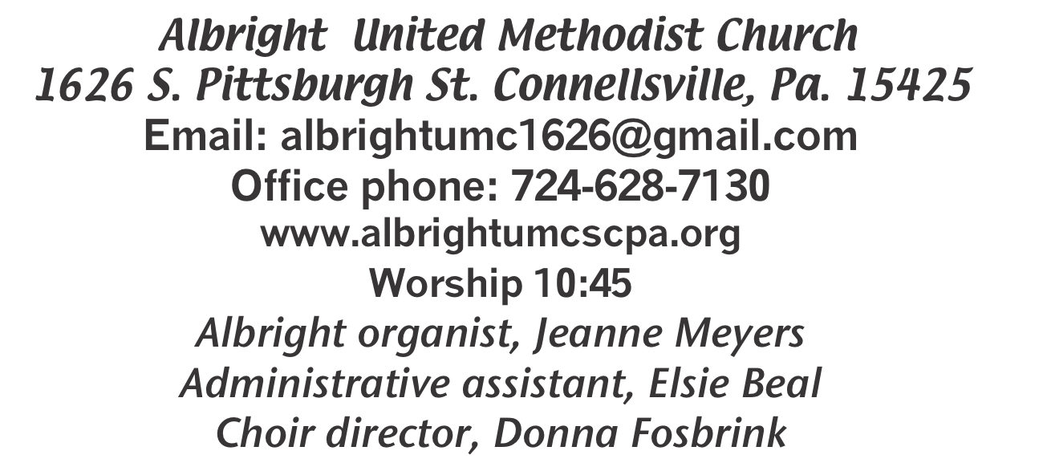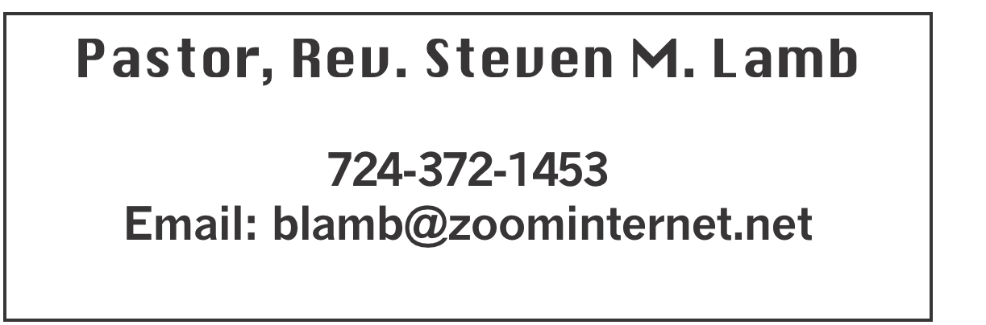

**\*\*\*\*\*\*\*\*\*\*\*\*\*\*\*\*\*\*\*\*\*\*\*\*\*\*\*\*\*\*\*\*\*\*\*\*\*\*\*\*\*\*\*\*\*\*\*\*\*\*\*\*\*\***

**July 7, 2024 Liturgist, Donna Fosbrink 10:45a.m.**

**\*\*\*\*\*\*\*\*\*\*\*\*\*\*\*\*\*\*\*\*\*\*\*\*\*\*\*\*\*\*\*\*\*\*\*\*\*\*\*\*\*\*\*\*\*\*\*\*\*\*\*\*\*\*\*\***

**WELCOME AND ANNOUNCEMENTS**

**PRELUDE “God Bless America” Berlin**

**BRINGING FORTH THE LIGHT**

**\*OPENING HYMN “Grace Greater Than Our Sins” 365**

**\*CALL TO WORSHIP**

**L: We have been called together as the body of Christ.**

P: We are one body, though we have many members.

**L: Each part gets its meaning from the body as a whole, and**

**not the other way around.**

P: But not all members have the same function; we have

different gifts.

**L: God calls us to use these gifts generously, maturely and**

**cheerfully to build up the body of Christ.**

P: Together we present ourselves in service to God and each

other.

**L: Let us worship God!**

**\*OPENING PRAYER**

**Holy Spirit, what beautiful gifts you have given us! We are a diverse, but unified, body of believers. We are unique yet, even in our differences, we are one. Let us celebrate the gifts you have given each brother and sister here. We need each other, and so we ask you to help us love and support one another. Use each person here to further your kingdom and the gospel. We are your hands, feet, head, heart and more. Let us serve, walk, guide, love and follow. Amen.**

**\*GLORIA PATRI 70**

**GODPEL READING Mark 6:1-13**

**The word of God for the people of God. Thanks be to God.**

**SPECIAL MUSIC “Just To Know” Ray Knopsnider**

**SERVICE OF HOLY COMMUNION**

**THE LORD’S PRAYER**

**CHILDREN’S MOMENT & Coin offering**

**PASSING THE PEACE**

**PRAYER REQUESTS**

**(give prayer cards to acolytes)**

**OFFERING**

**OFFERTORY “Heaven’s Echos” Ray Knopsnider**

**\*DOXOLOGY**

**\*OFFERTORY PRAYER**

**PRAYERS OFFERED IN PRAISE AND PETITION**

**PRAYER HYMN “Take Time to be Holy” 395**

**PASTORAL PRAYER**

**SILENT MEDITATION**

**EPISTLE READING 2 Corinthians 12:2-10**

**The word of God for the people of God. Thanks be to God.**

***Thy Word is a lamp unto my feet and a light unto my path***

**MESSAGE “Sufficient Grace”**

**\*CLOSING HYMN “Amazing Grace” 378**

**\*BENEDICTION**

**\*POSTLUDE**

**\*\*\*\*\*\*\*\*\*\*\*\*\*\*\*\*\*\*\*\*\*\*\*\*\*\*\*\*\*\*\*\*\*\*\*\*\*\*\*\*\*\*\*\*\*\*\*\*\*\***

**WELCOME**

***On this Sunday after we celebrate our nation’s independence, we are pleased that you have come to worship Almighty God who continues to bless our land in ways too numerous to count. Welcome all!***

**PRAYER CONCERNS THIS WEEK**

**Don Heckathorne Ray Knopsnider Thomas Leeder Paul & Myra Holden Baby Thompson Bill Harden James & Deanna Sherbondy Amy Zavara Trey Corvin Becky Irwin**

**Paula Snyder Susie Mongell Keith Morris Loretta Capo Maggie Grimm Allen Mellinger Kilee Robinson Kathy Anthony Brennan Sechrist Gretchen Mundorff**

**Barb & Buzz Stuart Ryker Klingensmith Mary Swope Chadd Tressler Rich Marto**

**Jeffrey Sarnelli Emma Jobbs Paul Martin Margaret Shultz Toni Hiltabidel**

**Donna Fosbrink Linda Burnworth Bill Bryner Madelyn Johnson Emogene Vinoski Allen Thomas Larry Murray Jack Burke Pat Tinkey**

**P.J. & Jackie Holden & unborn baby Bobby Kozel Carol Daniels John Kuzyck**

**Rev. Rob Kifer Kenny Urbach Daniel Jr. Chuck Watson’s family Salem Skukar**

**Shannon Mack Rebecca Snyder Jean Rahl Traveling mercies for Richard & Erica Burnworth**

**Aleesha & Ayla Schuurg - mother donated kidney to daughter Young family in car accident** Pastor Steve & Bev

**Rev. Ross Pryor Bishop Cynthia Moore-Koikoi**

Homebound persons: **Polly Basinger, Charlotte Holt, Dolly King, Shirley Mathias, Mariloyd McClintock, Edna Baker, Jimmy Lynn, Ozella Roy, Evelyn Curry, Judy Morris, Chuck Watson, Ed Miller, Dorene Provance, Jean Rahl (now on Hospice), Sherrill Goodwin, Chuck Hall, Stephanie Mattis**

Unspoken Requests All Military All churches Government leaders Those with cancer

Those battling addiction Praise for answered prayers Families of those who take their own life

If you want a name on prayer list, please use the prayer cards in the pew - give to acolytes.

**THIS WEEK AT ALBRIGHT**

**SATURDAY: CRAFT & VENDOR SHOW 9-4**

**SUNDAY: Special music: Jeanne Meyers & Sharon Grimm**

OFFICE HOURS**: Tuesday, Wednesday, Thursday 10:00-3:00**

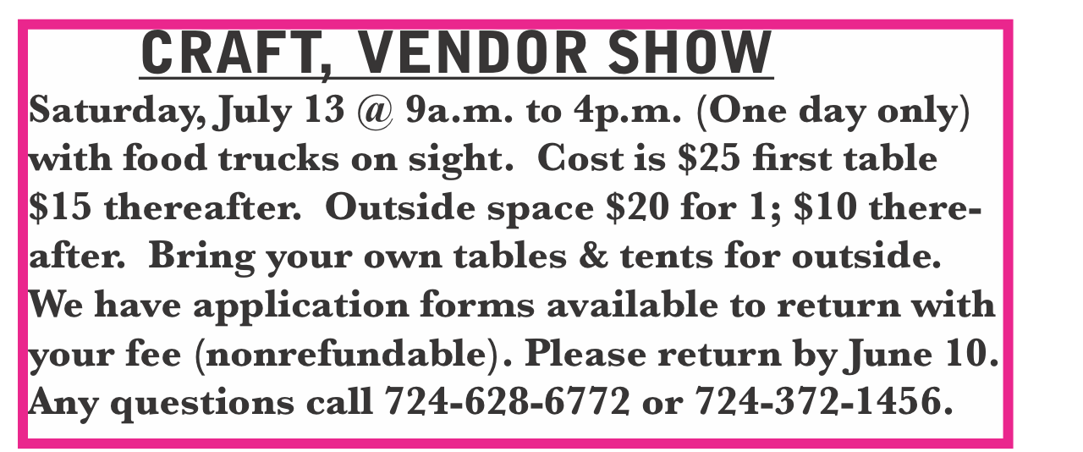

PASTA MEAL

**Thursday, July 18 at Otterbein UM Church at 4:00-6:00. Open to the public. Donations accepted, but not necessary. $5 for take outs.**

**SUB SALE**

Friday, July 19 & Saturday, July 20 beginning at 10:00. 12” sub $10. Condiments all packaged separately for quality & freshness. Please use order forms out near bulletins. Order ahead to be sure you get what you want.

BASKET CLASS

**Elsie will have a basket class Saturday, July 20 at 10:00. $20 for the class. Let Elsie know if you plan to attend.**

BLUE PLATE SPECIAL

**Tuesday, July 23 at 11:00-1:00 at Albright UMC. Open to the public. Donations accepted, but not necessary. $5 for take outs.**

DONATIONS FOR BENCHES

**We are asking for donations to help purchase benches for the gazebo. We have a sample in the downstairs hallway for you to see. Any size donation will be appreciated. Please use envelopes on the board in the back of sanctuary.**

**STREAKFREE CLOTHS**

We have the Streak Free cleaning cloths. They are $4 each. See Elsie or stop by the office to get them.

OUR STEWARDSHIP - June 30

**Weekly need for budget ........................................... $ 2,214.00**

**Sunday offering ............................................................... $ 2,314.00**

**(Includes $44.00 for coin offering)**

General Fund balance as of July 1...... Minus - $21,739.62

Monthly need is $10, 506.38

MAY total income for the month was $7,676.37

JUNE (5 Sundays) income for the month was $9,624.65

WE NEED YOUR HELP & SUPPORT!

**Sunday 6/30 morning worship attendance ....................... 64**

**GREETING YOU TODAY: David & Shelley Mattis**

**July 14: Sally Fosbrink**

**LITURGISTS: July 14: Bev Lamb**

**July 21: Emma Karfelt**

**ACOLYTES TODAY: Piper Marko & Jameson Tony**

**July 14: Beau Wagner & Andrew Lynn**

**JUNIOR CHURCH TODAY: Kathy Hixson & Linda Burnworth**

**July 14: Kelly Armstrong & Nancy Mimless**

**USHERS: Jackie Bartholomai, Jeremy Gray, Sherry Grote, Ed Jacobs**

**July 14: Larry Bloom, Fred Grote, Sally Fosbrink, Michelle Reich**

**COUNTERS: July: Karen Marko & Linda Burnworth**

**August: Jackie Bartholomai & Sally Fosbrink**

**SPECIAL MUSIC: July 14: Jeanne Meyers & Sharon Grimm**

**July 21: Rick Tressler**

**Saturday, July 13**

**9:00 - 4:00**

Albright U.M. Church

South Connellsville

Variety of homemade items and several vendors

Kitchen open: Sandwiches for sale

Food Trucks on Site

**SUB SALE**

**Seller _______________________________ 12” Subs $10.00**

**Day Name Phone # How many Total Due Paid**

**1. ______________________________________________________________**

**2._______________________________________________________________**

**3._______________________________________________________________**

**4._______________________________________________________________**

**5._______________________________________________________________**

**6._______________________________________________________________**

**7._______________________________________________________________**

**8._______________________________________________________________**

**9._______________________________________________________________**

**10.______________________________________________________________**

**11.______________________________________________________________**

**12.______________________________________________________________**

**Orders due by July 14. May be picked up Friday, July 19 & Saturday, July 20 @ 10-1 or until sold out at Albright UM Church.**

