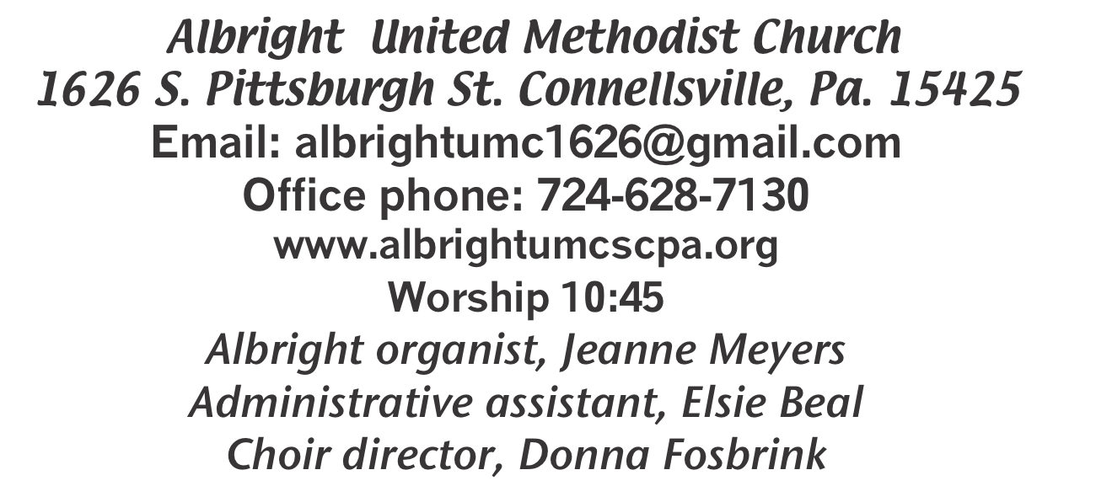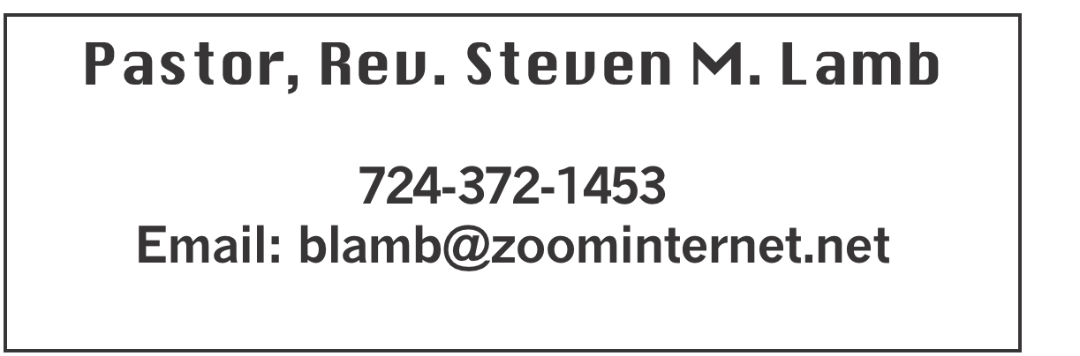

**\*\*\*\*\*\*\*\*\*\*\*\*\*\*\*\*\*\*\*\*\*\*\*\*\*\*\*\*\*\*\*\*\*\*\*\*\*\*\*\*\*\*\*\*\*\*\*\*\*\*\*\*\*\***

**July 28, 2024 Liturgist, Karen Marko 10:45a.m**

**\*\*\*\*\*\*\*\*\*\*\*\*\*\*\*\*\*\*\*\*\*\*\*\*\*\*\*\*\*\*\*\*\*\*\*\*\*\*\*\*\*\*\*\*\*\*\*\*\*\*\*\*\*\*\*\***

**WELCOME AND ANNOUNCEMENTS**

**PRELUDE “Whispering Hope” Hawthorne**

**BRINGING FORTH THE LIGHT**

**\*OPENING HYMN “In The Garden” 314**

**\*CALL TO WORSHIP**

**L: The earth shakes and the water quivers.**

P: The wind whistles and the sun listens.

**L: The beauty of creation mingles with the power of**

**creation.**

P: Awed in wonder and trembling with fear, we seek a safe

place,

**L: A place to voice our awe in song,**

P: And welcome God’s love that conquers our fear.

**\*OPENING PRAYER**

**Spirit of the living God, help us this day to focus on doors and windows, opportunities and thresholds. Let us cross and cross — even when we are afraid, even when we don’t know where we are going, even when there may be risk to us or those we love. Come with us. Show us the ways to love what we are often afraid to love. Show us the ways to enjoy what we are often afraid to enjoy. Let us be as canny about our comfort as we are about discomfort. Grant us eyes to see the openings that you provide at every turn, gateways from “now time” to “your time,” from here to there. Amen.**

**\*GLORIA PATRI 70**

**EPISTLE READING Ephesians 3:14-21**

**The word of God for the people of God. Thanks be to God.**

**CHILDREN’S MOMENT & Coin Offering**

**PASSING THE PEACE**

**OFFERING**

**OFFERTORY Special music - Emma Karfelt**

**\*DOXOLOGY**

**\*OFFERTORY PRAYER**

**PRAYERS OFFERED IN PRAISE AND PETITION**

**PRAYER HYMN “Nearer My God to Thee” 528**

**PASTORAL PRAYER**

**SILENT MEDITATION**

**THE LORD’S PRAYER**

**SPECIAL MUSIC Emma Karfelt**

**GOSPEL READING John 6:1-21**

**The word of God for the people of God. Thanks be to God.**

***Thy Word is a lamp unto my feet and a light unto my path***

**MESSAGE “Turn Your Eyes Upon Jesus”**

**\*CLOSING HYMN “I Need Thee Every Hour” 397**

**\*BENEDICTION**

**\*POSTLUDE**

**\*\*\*\*\*\*\*\*\*\*\*\*\*\*\*\*\*\*\*\*\*\*\*\*\*\*\*\*\*\*\*\*\*\*\*\*\*\*\*\*\*\*\*\*\*\*\*\*\***

WELCOME

***It’s our desire to be a warm, friendly congregation. Please take the time to get to know those around you. Your smile and outreached hand to others will be a blessing.***

**PRAYER CONCERNS THIS WEEK**

**Don Heckathorne Ray Knopsnider Thomas Leeder**

**Paul & Myra Holden Baby Thompson Becky Irwin**

**James & Deanna Sherbondy Trey Corvin Paula Snyder**

**Susie Mongell Keith Morris Loretta Capo**

**Allen Mellinger Kilee Robinson Kathy Anthony**

**Brennan Sechrist Barb & Buzz Stuart Chadd Tressler**

**Ryker Klingensmith Mary Swope Rich Marto**

**Jeffrey Sarnelli Emma Jobbs Paul Martin**

**Margaret Shultz Donna Fosbrink Linda Burnworth**

**Bill Bryner Madelyn Johnson Allen Thomas**

**Larry Murray Jack Burke Pat Tinkey**

**Bobby Kozel Rev. Rob Kifer Kenny Urbach**

**Daniel Jr. Salem Skukar Shannon Mack**

**Rebecca Snyder Bradley Sharp Randy Jacobs**

**Carol Daniels Denny Dunn Kayla Hann**

**Toni Jones Will Johnson Tina Hiltabidel**

**Charles Biler’s family Winfield Tressler’s family**

**Gene Cavanaugh’s family Zack Martin Scott Wagner**

**Fred Grote** Pastor Steve & Bev  **Rev. Ross Pryor**

**Bishop Cynthia Moore-Koikoi**

Homebound persons: **Edna Baker, Polly Basinger, Evelyn Curry, Sherrill Goodwin, Chuck Hall, Charlotte Holt, Dolly King, Jimmy Lynn, Shirley Mathias, Stephanie**

**Mattis, Mariloyd McClintock, Ed Miller, Judy Morris, Dorene Provance, Jean Rahl, Ozella Roy,**

Unspoken Requests All Military All churches

Government leaders Those with cancer

Those battling addiction Those on Hospice

Praise for answered prayers Homeless people

Families of those who take their own life

**THIS WEEK AT ALBRIGHT**

**SATURDAY: Basket weaving class 10:00**

**SUNDAY: Special music - Don & Micki Richter**

**Game Night 2:00-7:00. Refreshments**

**available. Bring a game or play one**

**already there.**

OFFICE HOURS**: Tuesday, Wednesday, Thursday 10:00-3:00**

**ICE CREAM SOCIAL - Saturday, August 10 @ 4-7**

DONATIONS FOR BENCHES

We are asking for donations to help purchase benches for the gazebo. We have a sample in the downstairs hallway for you to see. Any size donation will be appreciated. Please use envelopes on the board in the back of sanctuary.

NOTE OF THANKS

**Thank you to everyone who helped with & everyone who supported our One Day Fun Day VBS.**

MARILYN’S BOOKS

***There is a box of books in the downstairs hallway. They are Christian books that***

***Marilyn Banks enjoyed reading. There are also devotional books from her house. If you would like to have some of them, please help yourself. They are FREE!***

GAME NIGHT

Sunday, August 4 2:00-7:00

**Bring a game to play with others OR there will be games here for your use. We will have popcorn, water, soft drinks available. We will also have pizza for $1 a slice.**

**This is meant to be a fun time for us to come together & get better acquainted.**

ICE CREAM SOCIAL AUGUST 10, 2024

4:00-7:00p.m.

On The Menu: Sandwich & chips $5

Ice cream floats $4; Sundaes $5

Banana split $6; Bottle water $1; Free coffee

OUR STEWARDSHIP - July 21

**Weekly need for budget ........................................... $ 2,214.00**

**Sunday offering ............................................................... $ 1,699.00**

**Includes Coin offering $48.00**

**Sunday morning worship arrendance ..................................... 57**

General Fund balance as of July 1...... Minus - $21,739.62

Monthly need is $10, 506.38

MAY total income for the month was $7,676.37

JUNE (5 Sundays) income for the month was $9,624.65

WE NEED YOUR HELP & SUPPORT!

**GREETING YOU TODAY: Sandy Russell**

**August 4: Elaine & Donna Fosbrink**

**LITURGISTS: August 4: Shelley Mattis**

**August 11: Rick Tressler**

**ACOLYTES TODAY: Keelan & Kayton Callahan**

**August 4: Olivia Lynn & Kamrie Kimmel**

**JUNIOR CHURCH TODAY: Katrina Bair & a volunteer**

**August 4: Kathy Hixson & Linda Burnworth**

**USHERS: Jeremy Gray, Scott Murray, Ed Jacobs, Larry Bloom**

**Aug. 4: Jackie Bartholomai, Jeremy Gray, Sherry Grote, Ed Jacobs**

**COUNTERS: July: Karen Marko & Linda Burnworth**

**August: Jackie Bartholomai & Sally Fosbrink**

**SPECIAL MUSIC: August 4: Don & Micki Richte**

**August 11: Jeanne Meyers & Sharon Grimm**

AUGUST SCHEDULE

Saturday 3rd: Basket class 10:00.

Sunday 4th: Game night 2-7. Bring a game or play one already there. Refreshments provided.

Saturday 10th: Ice Cream Social 4-7. Float $4;

Sundae $5; Banana split $6; Sandwiches with chips also available $5

Thursday 15th: Pasta meal at Otterbein 4-6

Friday 8/16 & Saturday 8/17: Sub sale 10-1. $10 each