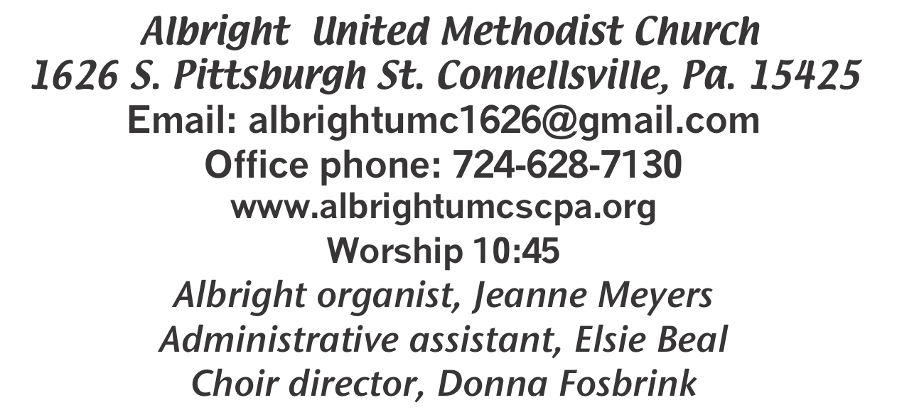



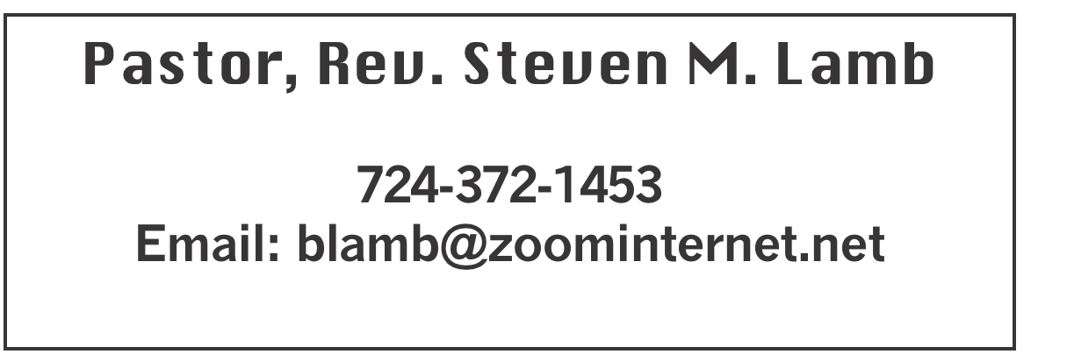

******************************************************
July 21, 2024 Liturgist, Emma Karfelt 10:45a.m.
********************************************************
WELCOME AND ANNOUNCEMENTS
PRELUDE “Jesus Will Outshine Them All” Jensen
BRINGING FORTH THE LIGHT

*OPENING HYMN “Let There Be Peace on Earth” 431

*CALL TO WORSHIP
One: This is the day our God is making.
All: Let us rejoice.
One: This is the time when God is present.
All: Let us be open.
One: This is the moment when forgiveness flows and life is renewed.
All: Let us sing.

*OPENING PRAYER
O God, your graciousness is found in a cool breeze on a warm night; your compassion is seen in the embrace given to a person suffering illness; your joy is noticed in children jumping rope and in the elderly couple holding hands; your peace is felt when we know that we are being lifted up in prayer.
You are the song in every singer’s heart; you are the touch in every lover’s embrace; you are the spark in every creative moment. Our hearts long to praise you, and we hope our lives please you. On this day, kindle a memory of joy, light a candle of hope, heal a broken relationship, grant a forgiveness that is deeper than “I’m sorry.” In Jesus’ name. Amen.

*GLORIA PATRI 70

OLD TESTAMENT READING Psalm 130
The word of God for the people of God. Thanks be to God

CHILDREN’S MOMENT & Coin offering

PASSING THE PEACE

PRAYER REQUESTS
(give prayer cards to acolytes)

OFFERING
OFFERTORY “How Long Has It Been?” Rick Tressler
*DOXOLOGY
*OFFERTORY PRAYER

PRAYERS OFFERED IN PRAISE AND PETITION

PRAYER HYMN “It Is Well With My Soul” 377

PASTORAL PRAYER

SILENT MEDITATION

THE LORD’S PRAYER

SPECIAL MUSIC “Thy Word” Rick Tressler

EPISTLE READING Ephesians 2:11-22
The word of God for the people of God. Thanks be to God.
Thy Word is a lamp unto my feet and a light unto my path

MESSAGE “Healing Day”

*CLOSING HYMN
“They’ll Know We Are Christians by Our Love” INSERT

*BENEDICTION

*POSTLUDE
****************************************************
WELCOME
Welcome! We rejoice in your presence as we gather in unity about the throne of grace. We hope to see you again next Sunday.

PRAYER CONCERNS THIS WEEK
Don Heckathorne Ray Knopsnider Thomas Leeder Paul & Myra Holden Baby Thompson Becky Irwin James & Deanna Sherbondy Trey Corvin Paula Snyder Susie Mongell Keith Morris Loretta Capo Allen Mellinger Kilee Robinson Kathy Anthony Brennan Sechrist Barb & Buzz Stuart Ryker Klingensmith Mary Swope Chadd Tressler
Rich Marto Jeffrey Sarnelli Emma Jobbs Paul Martin Margaret Shultz Donna Fosbrink Linda Burnworth Bill Bryner Madelyn Johnson Allen Thomas
Larry Murray Jack Burke Pat Tinkey Bobby Kozel Rev. Rob Kifer
Kenny Urbach Daniel Jr. Salem Skukar Shannon Mack Rebecca Snyder
Sara Sarno Bradley Short Randy Jacobs Carol Daniels Denny Dunn
Kayla Hann Toni Jones Will Johnson Gene Cavanaugh Family of Jean Helms Tina Hiltabidel John Huey Pastor Steve & Bev Rev. Ross Pryor Bishop Cynthia Moore-Koikoi

Homebound persons: Polly Basinger, Charlotte Holt, Dolly King, Shirley Mathias, Mariloyd McClintock, Edna Baker, Jimmy Lynn, Ozella Roy, Evelyn Curry, Judy Morris, Chuck Watson, Ed Miller, Dorene Provance, Jean Rahl, Sherrill Goodwin, Chuck Hall, Stephanie Mattis

Unspoken Requests All Military All churches Government leaders Those with cancer
Those battling addiction Praise for answered prayers Families of those who take their own life
If you want a name on prayer list, please use the prayer cards in the pew - give to acolytes.

THIS WEEK AT ALBRIGHT
TUESDAY: Blue Plate Special 11:00-1:00
WEDNESDAY: Aug/Sept news deadline
SATURDAY: ONE DAY VBS 11:00-5:00
SUNDAY: Special music: Emma Karfelt

OFFICE HOURS: Tuesday, Wednesday, Thursday 10:00-3:00

OUR STEWARDSHIP - July 7 & 14
Weekly need for budget ........................................... $ 2,214.00
Sunday offering 7/7 ............................................................ $ 1,768.07
Includes Coin offering $56.07
Sunday offering 7/14 ............................................................ $ 3,001.00
Includes coin offering $42.00
Sunday morning worship attendance 7/7 ................................. 43
Sunday morning worship arrendance 7/14 ................................ 51

General Fund balance as of July 1...... Minus - $21,739.62
Monthly need is $10, 506.38
MAY total income for the month was $7,676.37
JUNE (5 Sundays) income for the month was $9,624.65
WE NEED YOUR HELP & SUPPORT!

GREETING YOU TODAY: Nancy Mimless & Ed Jacobs
July 28: Sandy Russell

LITURGISTS: July 28: Karen Marko
August 4: Shelley Mattis

ACOLYTES TODAY: Thelma Swope & Emmaleigh Kalembo
July 28: Keelan & Kayton Callahan

JUNIOR CHURCH TODAY: Bonnie & Larry Bloom
July 28: Katrina Bair & a volunteer

USHERS: Jay & Judy Whipkey, Linda Burnworth, Pinky Smiley
July 28: Jeremy Gray, Scott Murray, Ed Jacobs, Larry Bloom

COUNTERS: July: Karen Marko & Linda Burnworth
August: Jackie Bartholomai & Sally Fosbrink

SPECIAL MUSIC: July 28: Emma Karfelt
August 4: Don & Micki Richte

AUGUST SCHEDULE
Saturday 3rd: Basket class 10:00.
Sunday 4th: Game night 2-7. Bring a game or play one already there. Refreshments provided.
Saturday 10th: Ice Cream Social 4-7. Floats $4;
Sundae $5; Banana split $6. Sandwiches with chips also available $5
Thursday 15th: Pasta meal at Otterbein 4-6
Friday 8/16 & Saturday 8/17: Sub sale 10-1. $10 each

BLUE PLATE SPECIAL
Tuesday, July 23 at 11:00-1:00 at Albright UMC. Open to the public. Donations accepted, but not necessary. $5 for take outs.

AUGUST/SEPTEMBER NEWSLETTER
News deadline is Wednesday, July 24.

DONATIONS FOR BENCHES
We are asking for donations to help purchase benches for the gazebo. We have a sample in the downstairs hallway for you to see. Any size donation will be appreciated. Please use envelopes on the board in the back of sanctuary.

NOTES OF THANKS
Thank you very much for all your prayers after my accident. I appreciate your concern & love. Toni Hiltabidel

Many thanks to everyone who worked so hard for the Carft/Vendor Show. And thanks to those who helped with the Sub Sale and those who supported it. We appreciate all of you and the work you do for the church.

MARILYN’S BOOKS
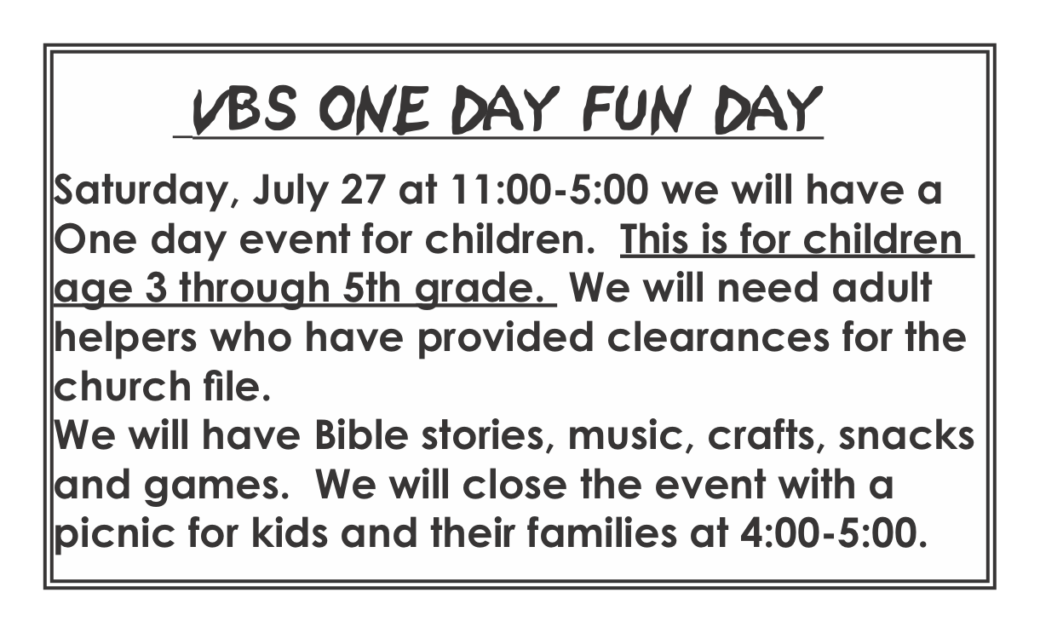
There is a box of books in the downstairs hallway. They are Christian books that Marilyn Banks enjoyed reading. There are also devotional books from her house. If you would like to have some of them, please help yourself. They are FREE!

