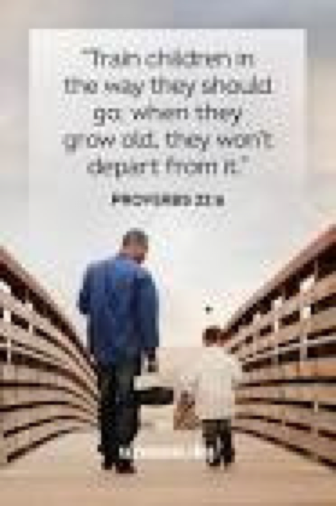

*Father’s Day*

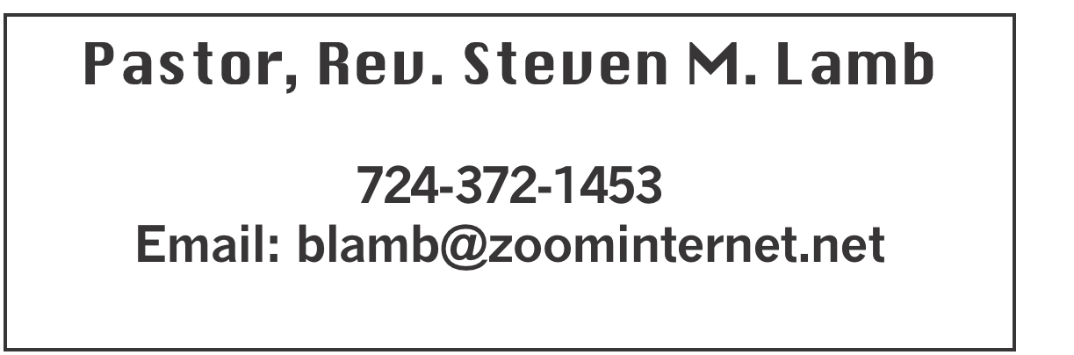

**\*\*\*\*\*\*\*\*\*\*\*\*\*\*\*\*\*\*\*\*\*\*\*\*\*\*\*\*\*\*\*\*\*\*\*\*\*\*\*\*\*\*\*\*\*\*\*\*\*\*\*\*\*\***

**June 16, 2024 Liturgist, Eve Shupe 10:45a.m.**

**Father’s Day**

**\*\*\*\*\*\*\*\*\*\*\*\*\*\*\*\*\*\*\*\*\*\*\*\*\*\*\*\*\*\*\*\*\*\*\*\*\*\*\*\*\*\*\*\*\*\*\*\*\*\*\*\*\*\*\*\***

**WELCOME AND ANNOUNCEMENTS**

**PRELUDE “I’d Rather Have Jesus” Shea**

**BRINGING FORTH THE LIGHT**

**\*OPENING HYMN “Morning Has Broken” 145**

**\*CALL TO WORSHIP**

**L: Jesus spoke to the people in parables, saying, “The**

**kingdom of heaven is like a mustard seed. Smallest of**

**seeds, yet greatest of trees; home for the birds of the air.”**

P: Let our faith bloom and grow in this time of worship; let this

place be a shelter and home for all who are weary.

**L: The kingdom of heaven is like yeast, kneaded into flour,**

**that it might rise and feed many.**

P: Let the community gathered here increase in faith and

devotion, so that we might nourish the world with the good

news of God.

**L: The kingdom of heaven is like hidden treasure, buried in a**

**field until it is discovered in joy.**

P: Let this time of worship be an uncovering of God’s mysteries.

God is here! Christ is revealed! The Spirit lives among us! Let

us worship God!

**\*OPENING PRAYER**

**Gracious God, it is a sign of our times that we look down on small things: Seeds do not impress us. The flicker of a candle, a pinch of yeast, a granule of salt: What are these in the face of wars, poverty, violence, exploitation of the earth, addictions and soul-crushing isolation? Against these forces you have armed us with nothing but love, joy, peace and hope -- and the power of your Holy Spirit who called Jesus Christ from the tomb, defeating sin, suffering, sorrow and the greatest enemy of all, death. Remind us, Lord, of what we all too often forget: Your kingdom is here. It is breaking out every day, all around us, in ways large and small. Your invitation to us is to be part of it. For that undeserved grace, we give you thanks and praise. Amen.**

**\*GLORIA PATRI 70**

**OLD TESTAMENT READING Psalm 20**

**The word of God for the people of God. Thanks be to God**

**SPECIAL MUSIC The Women of the church**

**CHILDREN’S MOMENT & Coin offering**

**PASSING THE PEACE**

**PRAYER REQUESTS**

**(give prayer cards to acolytes)**

**OFFERING**

**OFFERTORY “Take the Name of Jesus With You” Doane**

**\*DOXOLOGY**

**\*OFFERTORY PRAYER**

**PRAYERS OFFERED IN PRAISE AND PETITION**

**PRAYER HYMN “Sweet Hour of Prayer” 496**

**PASTORAL PRAYER**

**SILENT MEDITATION**

**THE LORD’S PRAYER**

**SPECIAL MUSIC Mattis family**

**GOSPEL READING Mark 4:26-34**

**The word of God for the people of God. Thanks be to God.**

***Thy Word is a lamp unto my feet and a light unto my path***

**MESSAGE “Seeds and Harvest”**

**\*CLOSING HYMN “Pass It On” 572**

**\*BENEDICTION**

**\*POSTLUDE**

**\*\*\*\*\*\*\*\*\*\*\*\*\*\*\*\*\*\*\*\*\*\*\*\*\*\*\*\*\*\*\*\*\*\*\*\*\*\*\*\*\*\*\*\*\*\*\*\*\***

WELCOME

***Father’s day is a time for us to show our appreciation to God for our families. As we pray for our fathers and all other members of our families, let us also show kindness toward all who have come to worship We are very pleased that you are here.***

**PRAYER CONCERNS THIS WEEK**

**Don Heckathorne Ray Knopsnider Thomas Leeder Paul & Myra Holden Baby Thompson Bill Harden James & Deanna Sherbondy Amy Zavara Trey Corvin Becky Irwin**

**Paula Snyder Susie Mongell Keith Morris Loretta Capo Maggie Grimm Allen Mellinger Kilee Robinson Kathy Anthony Brennan Sechrist Gretchen Mundorff**

**Barb & Buzz Stuart Ryker Klingensmith Mary Swope Chadd Tressler Rich Marto**

**Jeffrey Sarnelli Emma Jobbs Wyatt Corvin Paul Martin Margaret Shultz**

**Toni Hiltabidel Donna Fosbrink Linda Burnworth Bill Bryner Madelyn Johnson Emogene Vinoski Allen Thomas Larry Murray Joyce Shaffer**

**P.J. & Jackie Holden & unborn baby Jack Burke Pat Tinkey Bobby Kozel**

**Rob Kifer Lori Geisler’s family** Pastor Steve & Bev  **Rev. Ross Pryor Rev. Bob & Amy Zilhaver Bishop Cynthia Moore-Koikoi**

Homebound persons: **Polly Basinger, Charlotte Holt, Dolly King, Shirley Mathias, Mariloyd McClintock, Edna Baker, Jimmy Lynn, Ozella Roy, Evelyn Curry, Judy Morris, Chuck Watson, Ed Miller, Dorene Provance, Jean Rahl, Sherrill Goodwin, Chuck Hall, Stephanie Mattis**

Unspoken Requests All Military All churches

Government leaders Those with cancer

Those battling addiction Praise for answered prayers

Families of those who take their own life

If you want a name on prayer list, please use the prayer cards in the pew - give to acolytes.

THIS WEEK AT ALBRIGHT

**MONDAY: Children’s Church meeting 6:00**

**WEDNESDAY: Bible study 6:30**

**THURSDAY: Pasta meal 4-6 at Otterbein**

**SUNDAY: Special music: Bonnie Bloom**

OFFICE HOURS**: Tuesday, Wednesday, Thursday 10:00-3:00**

CHILDREN’S CHURCH MEETING

**Monday, June 17 at 6:00 we will have a meeting to plan for the future of Children’s Church. If you are interested in helping, please come to this meeting.**

PASTA MEAL

**Thursday, June 20 Otterbein will have their pasta meal 4:00-6:00. Donations accepted. $5 for take out.**

**BUS TRIP TO LANCASTER**

**Thursday, June 20 we will go to see Daniel at Lancaster. Leave at 6:30 a.m. and return at about 10:00 p.m.**

BLUE PLATE SPECIAL

**Tuesday, June 25 at 11:00-1:00. Donations accepted, but not required. $5 for take outs.**

**BIBLE STUDY**

**Final Bible study for the summer will be June 26 at 6:30. We have been studying Daniel. No Bible study in July or August.**

FIFTH SUNDAY POTLUCK

Sunday, June 30 after church we will have a potluck lunch. Bring a dish to share and join the fellowship following the morning worship.

CRAFT, VENDOR SHOW

**Saturday, July 13 @ 9a.m. to 4p.m. (One day only) with food trucks on sight. Cost is $25 first table $15 thereafter. Outside space $20 for 1; $10 thereafter. Bring your own tables & tents for outside. We have application forms available to return with your fee (nonrefundable). Please return by June 10. Any questions call 724-628-6772 or 724-372-1456.**

**ALTAR FLOWERS**

**If you are putting flowers on the altar, please call the office by Tuesday morning (or sooner) and let us know.**

OUR STEWARDSHIP - June 9

**Weekly need for budget ........................................... $ 2,214.00**

**Sunday offering ............................................................... $ 2,316.00**

**(Includes coin offering $ )**

**Sunday morning worship attendance .............................. 62**

**GREETING YOU TODAY: Eve Shupe**

**June 23: Larry & Lori Geisler**

**LITURGISTS: June 23: Bonnie Bloom**

**June 30: Karen Stimmell**

**ACOLYTES TODAY: Kayton & Keelan Callahan**

**June 23: Kamrie Kimmel & Olivia Lynn**

**CHILDREN CHURCH TODAY: Larry & Bonnie Bloom**

**June 23:**

**USHERS: Jay & Judy Whipkey, Linda Burnworth, Pinky Smiley**

**June 23: Jeremy Gray, Scott Murray, Ed Jacobs, Larry Bloom**

**COUNTERS: June: Ed Jacobs & Nancy Mimless**

**July: Karen Marko & Linda Burnworth**

**SPECIAL MUSIC: 23: Bonnie Bloom**

**June 30: Lori Geisler**

DONATIONS FOR BENCHES

**We are asking for donations to help purchase benches for the gazebo. We have a sample in the downstairs hallway for you to see. Any size donation will be appreciated.**

STREAKFREE CLOTHS

We have the Streak Free cleaning cloths. They are $4 each. See Elsie or stop by the office to get them.

BASKET CLASS

**Elsie will have a basket class Saturday, July 20 at 10:00. $20 for class ($15 goes to the church). You can**

**make a basket you will be proud of in the class. Let Elsie know if you or anyone you know plan to attend.**

FATHER’S DAY CARNATIONS

**To the GLORY OF GOD and IN LOVING MEMORY OF:**

**Gene Beal, Clarence P. Upton, Mac Cable**

**BY: Elsie Beal 2R 2W**

**Dorman Jacobs**

**BY: Ed Jacobs & Nancy Mimless 2R**

**Dad & Grandfather, Jack Evans**

**BY: Lisa, Christian and Amanda 2R 2W**

**James Corvin Sr. and Charles Smiley**

**BY: Pinky Smiley 2R 2W**

**My dad, Carl Hixson**

**BY: Kathy Hixson 1R 1W**

**Bob Adey Sr.**

**BY: Bob & Vicky Adey 1R**

**To the GLORY OF GOD and IN LOVING HONOR OF:**

**David Mattis**

**BY: Shelley, Stephanie, Andy & Elliot 3R 3W**

**Bob Adey Jr.**

**BY: Rob & Ty Adey 1R**

**Rob Adey**

**BY: Renley, Brax & Brielle 1W**

**Ty Adey**

**BY: Branch & Baby Adey 1W**