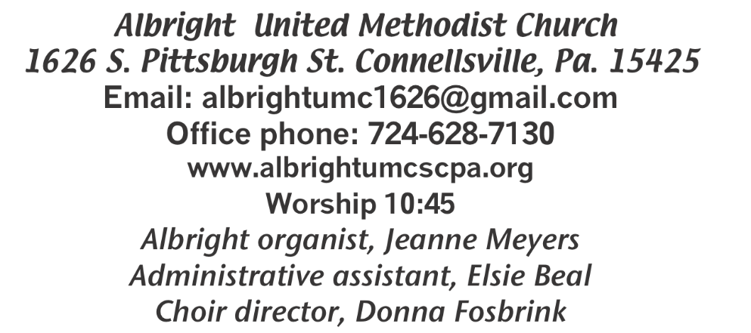



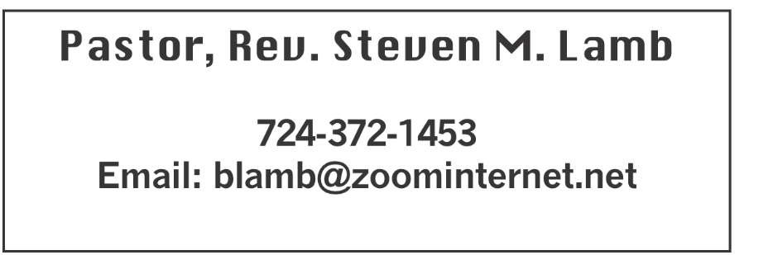

**\*\*\*\*\*\*\*\*\*\*\*\*\*\*\*\*\*\*\*\*\*\*\*\*\*\*\*\*\*\*\*\*\*\*\*\*\*\*\*\*\*\*\*\*\*\*\*\*\*\*\*\*\*\*\*\*\*\*\*\***

**April 14, 2024 Liturgist, Shelley Mattis 10:45a.m.**

**WELCOME AND ANNOUNCEMENTS**

**PRELUDE “Shepherd of Love” Peterson**

**BRINGING FORTH THE LIGHT**

**\*OPENING HYMN “Only Trust Him” 337**

**\*CALL TO WORSHIP**

**L: Let all in this place be filled with joy for you are loved**

**by God! No one here will be left out -- God’s love is for**

**everyone! Come now and worship. Let nothing hinder**

**you. God sees you and loves you just as you are.**

***All: Let us worship him now together.***

**\*OPENING PRAYER**

**God of grace and mercy, we kneel before you today. We recognize that we are unworthy to be called your children; we are unworthy to be called your friends. Yet you call us son, daughter and friend. You love us with a love unlike any we have ever known – love that is completely unconditional. We cannot wrap our human minds around what it would look like to love someone unconditionally. We often try, but we fail. But you love us, even in our failings. You love us, even in our unworthiness. We also confess the ways that we have rejected your love. Give us hearts that are open to receiving it -- that we may experience the full measure of the love of a Father, a Mother, a friend like no other. And may we love you always in return. Amen.**

**\*GLORIA PATRI 70**

**OLD TESTAMENT READING Psalm 4:1-8**

**The word of God for the people of God. Thanks be to God**

**CHILDREN’S MOMENT & Coin offering**

**\*PASSING THE PEACE**

**PRAYER REQUESTS**

**(give prayer cards to acolytes)**

**OFFERING**

**OFFEERTORY “Savior, Like A Shepherd Medley” Bradbury *DOXOLOGY**

**\*OFFERTORY PRAYER**

**PRAYERS OFFERED IN PRAISE AND PETITION**

**PRAYER HYMN “O Love That Will Not Let Me Go” 480**

**PASTORAL PRAYER**

**SILENT MEDITATION**

**THE LORD’S PRAYER**

**ANTHEM “Everlasting Arms”**

**EPISTLE READING I John 3:1-7**

**The word of God for the people of God. Thanks be to God.**

***Thy Word is a lamp unto my feet and a light unto my path***

**MESSAGE “How Many People Can God Love?”**

**\*CLOSING HYMN “Blessed Assurance” 369**

**\*BENEDICTION**

**\*POSTLUDE**

**\*\*\*\*\*\*\*\*\*\*\*\*\*\*\*\*\*\*\*\*\*\*\*\*\*\*\*\*\*\*\*\*\*\*\*\*\*\*\*\*\*\*\*\*\*\*\*\*\***

WELCOME

***Welcome to our church on the first day of the week. Christ was raised on a Sunday, therefore each Sunday is a remembrance of Easter. Let us unite in celebrating the mighty acts of God in Jesus Christ our Lord.***

**PRAYER CONCERNS THIS WEEK**

**Tom McMurray Tina Hiltabidel Janice Bailey David & Tammy Leeder Misty Hiltabidel**

**Sandy Reich Don Heckathorne Betty Kooser Chuck Watson Ray Knopsnider Thomas Leeder Paul & Myra Holden Parker Scary Baby Thompson Brian Foz**

**James & Deanna Sherbondy Bill Harden Amy Zavara Trey Corvin Becky Irwin**

**John Welsh Sara Gianotti Bill Bauer Bonnie Folly Paula Snyder**

**Susie Mongell Keith Morris John Yost Pat McClelland Katy & Travis**

**Terry Mattis Tilly Harvey Kara McMullen Loretta Capo Sheila Hart**

**Ralph Bliss Maggie Grimm Allen Mellinger Kelly Thompson Jeff Spiker**

**Beverly Sheppard Pat Tikey Kilee Robinson Judy McClain Kathy Anthony**

**Brennan Sechrist Bonnie Parker Gretchen Mundorff Barb & Buzz Stuart Jan & Brian Haviker Ryker Klingensmith Kay Jacobs Mary Swope Chadd Tressler Rich Marto**

**Jeffrey Sarnelli Emma Jobbs Carol Daniels Paul Martin Margaret Shultz**

**Lou Delossio** Pastor Steve & Bev  **Rev. Bob & Amy Zilhaver**

**Bishop Cynthia Moore-Koikoi *General Conference***

Homebound persons: **Polly Basinger, Charlotte Holt, Dolly King, Shirley Mathias, Mariloyd McClintock, Edna Baker, Jimmy Lynn, Ozella Roy, Evelyn Curry, Judy Morris, Chuck Watson, Ed Miller, Dorene Provance, Jean Rahl, Sherrill Goodwin, Chuck Hall, Stephanie Mattis**

Unspoken Requests All Military All churches

Government leaders Those with cancer

Those battling addiction Praise for answered prayers

Families of those who take their own life

If you want a name on prayer list, please use the prayer cards in the pew - give to acolytes.

**THIS WEEK AT ALBRIGHT**

**WEDNESDAY: Bible study 6:30**

**THURSDAY: Pasta meal 4-6 at Otterbein**

**Choir practice 7:00**

**SATURDAY: Saturday Morning Special 11:00**

**OFFICE HOURS: Tues., Wed., Thurs., 10:00-3:00**

**ALTAR FLOWERS**

**If you are providing flowers, please let Elsie know by Tuesday morning or sooner.**

OUR STEWARDSHIP - April 7

**Weekly need for budget ........................................... $ 2,214.00**

**Sunday offering ............................................................... $ 1,783.61**

**Includes coin offering $109.00)**

**Sunday morning worship attendance .............................. 67**

**GREETING YOU TODAY: Cathy Dillinger**

**April 21: Kay Jacobs**

**LITURGISTS: April 21: Rick Tressler**

**April 28: Nancy Mimless**

**ACOLYTES TODAY: Jameson Tony & Rhyley Kimmel**

**April 21: Beau Wagner & Andrew Lynn**

**CHILDREN CHURCH TODAY: Kelly Armstrong & Jeremy Gray**

**April 21: Bonnie & Larry Bloom**

**USHERS: Larry Bloom, Fred Grote, Sally Fosbrink, Michelle Reich**

**Apr. 21: Jay & Judy Whipkey, Linda Burnwworth, Jackie Bartholomai**

**COUNTERS: Rick Tressler & Sandy Russell**

GENERAL CONFERENCE OF U.M. CHURCH

Will be April 23- May 3 in Charlotte, N.C. Please keep all those attending in prayer that they will be guided by God in decisions that are made.

SUB SALE

**Fri., May 3 & Sat., May 4 @ 10:00. $10 each. Get order forms out near bulletins.**

***OTTERBEIN RUMMAGE SALE***

**Will be Saturday, May 4. Doors open at 8:00 a.m.**

CRAFT, COLLECTABLES, VENDOR SHOW

**Saturday, July 13 9a.m. to 4p.m. (One day only) with food trucks on sight. Cost is $25 first table $15 thereafter. Outside space $20 for 1; $10 thereafter. Bring your own tables & tents for outside. We have application forms available to return with your fee (nonrefundable). Please return by June 10. Any questions call 724-628-6772 or 724-628-7130.**

MOTHER/DAUGHTER/FRIEND DINNER

**Our annual Mother,Daughter,Friend dinner will be on Monday, May 13 at 6:00p.m. Dinner will be catered by Hartsek catering and will include: Stuffed chicken breast with gravy, mashed potatoes, italian green beans, tossed salad with dressings, dinner rolls with butter. Cupcakes made by Sandy McClelland. Cost will be $13. Our program will be at 7p.m. and will be a visit fromt he past portrayed by Luella Krieger. All are invited to attend the program. A free will offering will be taken for Luella during the program. Please save the date and plan to attend. You may use the form in the bulletin to make paid reservations. Need them by May 5. Hope to see you there.**

**YOUTH NEWS**

*Youth group (grade 3 through 12). They meet the 2nd & 4th Sunday mornings (April 28) at 1O:OO at the church.*

**PASTA MEAL**

**Thursday, April 18 @ 4-6 at Otterbein church. Free with donations accepted. $5 for take out.**

SATURDAY MORNING SPECIAL

Will gather on April 20 at 11:00. We have a story, sing, do a craft & eat lunch.

BASKET WEAVING CLASS

**Elsie & Karen will be teaching a basket class on Sat., May 4 at 10:00. Cost is $20 each ($15 benefits the church). If interested in attending, please let Elsie know by April 28.**

CONNELLSVILLE DISTRICT CONFERENCE

**Sunday, May 19 at Yough River Park. Will include a farewell gathering for Rev. Zilhaver.**

CARNATIONS FOR MOTHER’S DAY

**We are offering pink or white carnations for mother’s day. They will be $2.50 each. We have order forms out near the bulletin for your orders.**

C

***\*\*\*\*\*\*\*\*\*\*\*\*\*\*\*\*\*\*\*\*\*\*\*\*\*\*\*\*\*\*\*\*\*\*\*\*\*\*\*\*\*\*\*\*\*\*\*\*\*\*\*\*\*\****

**BASKET WEAVING CLASS**

***Elsie will be teaching a basket weaving class on Saturday, May 4***

***at 10:00. Cost is $20 ($15 will benefit the church).***

***If you are interested in attending, please fill out information below and put it with the money and give it to Elsie on Sunday or stop by the office.***

***She just needs to know how many people to prepare for.***

***Name ________________________________________________***

***Phone number _____________________***

***Bringing a friend (or 2) How many total _____________***

***Total enclosed $_____________***

**SUB SALE**

**Seller _______________________________ 12” Subs $10.00**

**Day Name Phone # How many Total Due Paid**

**1. ______________________________________________________________**

**2._______________________________________________________________**

**3._______________________________________________________________**

**4._______________________________________________________________**

**5._______________________________________________________________**

**Orders due by April 28. May be picked up Friday, May 3 & Saturday, May 4 @ 10-1 or until sold out at Albright UM Church.**