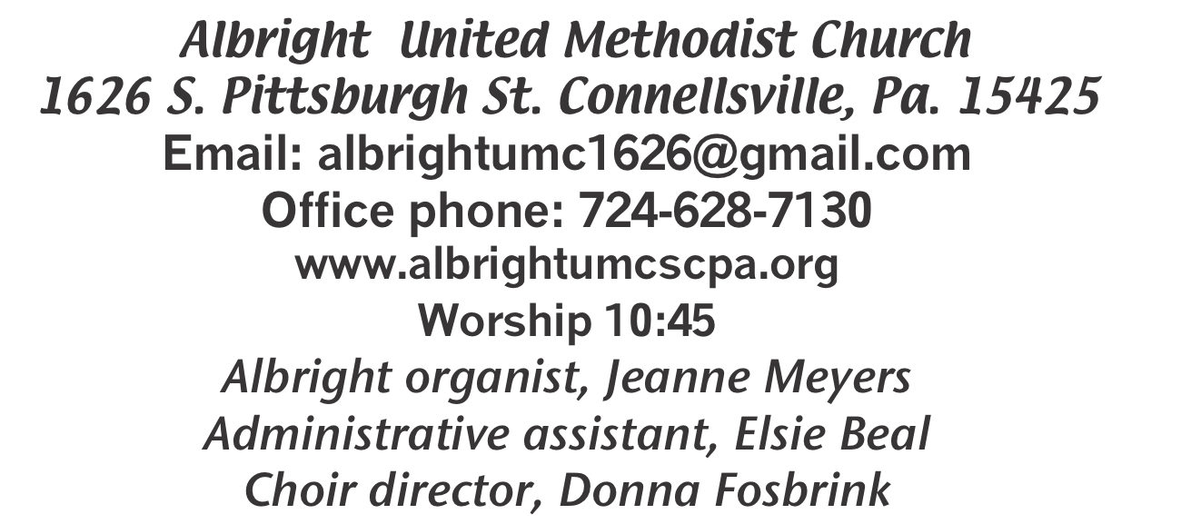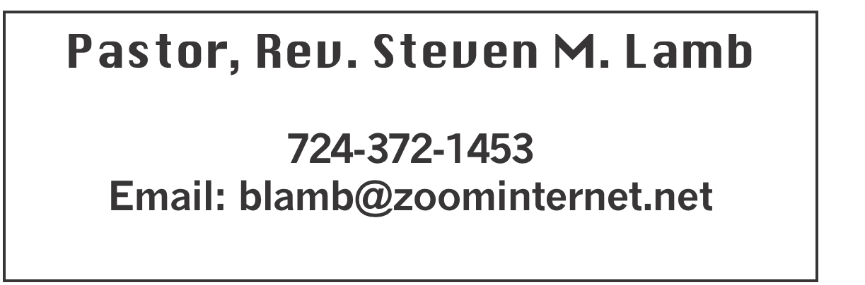

**\*\*\*\*\*\*\*\*\*\*\*\*\*\*\*\*\*\*\*\*\*\*\*\*\*\*\*\*\*\*\*\*\*\*\*\*\*\*\*\*\*\*\*\*\*\*\*\*\*\*\*\*\*\*\*\*\*\*\*\***

**March 31, 2023 Liturgist, Karen Marko 10:45a.m.**

**Easter Sunday**

**\*\*\*\*\*\*\*\*\*\*\*\*\*\*\*\*\*\*\*\*\*\*\*\*\*\*\*\*\*\*\*\*\*\*\*\*\*\*\*\*\*\*\*\*\*\*\*\*\*\*\*\*\*\*\*\*\***

**WELCOME AND ANNOUNCEMENTS**

**PRELUDE “He is Not Here, He Is Risen” Lillenas**

**BRINGING FORTH THE LIGHT**

**\*OPENING HYMN “Joyful, Joyful” 89**

**\*CALL TO WORSHIP**

**Leader: Quiet and persistent God,**

People: You work miracles in the silent hush before dawn.

**Leader: Strong and surprising God,**

P: You roll away every stumbling stone and bring life to all

our dead ends.

**Leader: Whirling and dancing God,**

People: You delight in empty tombs and surprising visits.

**Leader: Easter God,**

P: You give us joy and cause an alleluia to flow from head to toe.

**Leader: Risen God,**

P: Forever rising in us, we sing our joy.

**\*OPENING PRAYER**

**Christ is risen; our loads are lifted, and the path is cleared! Light rises over us as Jesus overcomes darkness and death. We need not struggle alone, pushing through pain, stumbling on sin and trying to walk life’s way**

**unaided. Lent is over, Easter has come, and our road is new. We are forgiven; Jesus leads the way! Thank you, O God! Amen.**

**\*GLORIA PATRI 70**

**GOSPEL READING Matthew 28:1-10**

**The word of God for the people of God. Thanks be to God.**

**HOLY COMMUNION**

**LORD’S PRAYER**

**CHILDREN’S MOMENT & Coin Offering**

**PASSING THE PEACE**

**PRAYER REQUESTS**

**(give prayer cards to acolytes)**

**OFFERING**

**OFFERTORY “He Rose Triumphantly” Ackley**

**\*DOXOLOGY**

**\*OFFERTORY PRAYER**

**PRAYERS OFFERED IN PRAISE AND PETITION**

**PRAYER HYMN “Because He Lives” 364**

**PASTORAL PRAYER**

**SILENT MEDITATION**

**THE LORD’S PRAYER**

**ANTHEM “Sing A New Alleluia”**

**EPISTLE READING I Corinthians 15:1-8, 12-22**

**The word of God for the people of God. Thanks be to God.**

***Thy Word is a lamp unto my feet and a light unto my path***

**MESSAGE “Believe It!”**

**\*CLOSING HYMN “Sing With All the Saints of Glory”702**

**\*BENEDICTION**

**\*POSTLUDE**

**\*\*\*\*\*\*\*\*\*\*\*\*\*\*\*\*\*\*\*\*\*\*\*\*\*\*\*\*\*\*\*\*\*\*\*\*\*\*\*\*\*\*\*\*\*\*\*\*\*\*\***

WELCOME

***O give thanks to the LORD, for he is good; his steadfast love endures forever” (Psalm 118:1). Happy Easter! We are very pleased that you have come to glorify God, our Redeemer, through Christ our Lord. Hallelujah! Christ is Risen!***

**PRAYER CONCERNS THIS WEEK**

**Tom McMurray Tina Hiltabidel Janice Bailey David & Tammy Leeder Misty Hiltabidel Sandy Reich Don Heckathorne Betty Kooser Chuck Watson Ray Knopsnider Thomas Leeder Paul & Myra Holden Parker Scary Baby Thompson Brian Foz**

**James & Deanna Sherbondy Bill Harden Amy Zavara Trey Corvin Becky Irwin**

**John Welsh Sara Gianotti Bill Bauer Bonnie Folly Paula Snyder Susie Mongell Keith Morris John Yost Pat McClelland Katy & Travis Terry Mattis Tilly Harvey Kara McMullen Loretta Capo Sheila Hart**

**Ralph Bliss Maggie Grimm Allen Mellinger Kelly Thompson Jeff Spiker**

**Beverly Sheppard Pat Tikey Kilee Robinson Judy McClain Kathy Anthony**

**Brennan Sechrist Bonnie Parker Barb & Buzz Stuart Jan & Brian Haviker Ryker Klingensmith Kay Jacobs Mary Swope Miranda John & family Paul Hammacker**

**Pastor Steve & Bev**  **Rev. Bob & Amy Zilhaver Bishop Cynthia Moore-Koikoi**

Homebound persons: **Polly Basinger, Charlotte Holt, Dolly King, Sue Corvin, Shirley Mathias, Mariloyd McClintock, Edna Baker, Jimmy Lynn, Ozella Roy, Evelyn Curry, Judy Morris, Chuck Watson, Ed Miller, Dorene Provance, Jean Rahl, Sherrill Goodwin, Chuck Hall, Stephanie Mattis**

Unspoken Requests All Military All churches

Government leaders Those with cancer

Those battling addiction Praise for answered prayers Families of those who take their own life

IF YOU WANT A NAME ON PRAYER LIST, PLEASE USE THE PRAYER CARDS IN THE PEW - give to Acolytes.

**THIS WEEK AT ALBRIGHT**

**WEDNESDAY: Bible study 6:30 at Albright lead by Rev. Lamb**

**THURSDAY: Choir practice 7:00**

**OFFICE HOURS: Tuesday, Wednesday, Thursday 10- 3**

**EASTER FLOWERS: Given by several members in loving memory and loving honor of loved ones.**

WEEKLY BIBLE STUDY

**Pastor Steve leads a Bible study every Wednesday at 6:30 at Albright church. Everyone is welcome**

**YOUTH NEWS**

*Youth group (grade 3 through 12). They meet the 2nd & 4th Sunday mornings (April 14 & 28) at 1O:OO at the church.*

UNITED WOMEN IN FAITH

**Will meet Tuesday, April 9 at 7:00. Hosting are Donna Fosbrink & Shelley Mattis. Devotions by Shelley. We are planning for the Mother/Daughter dinner on Monday, May 13 at 6:00. Luella Kreiger will present a program portraying a woman of the Bible. ALL WOMEN of the church are invited to join us for the meetings.**

CONNELLSVILLE DISTRICT CONFERENCE

**Sunday, May 19 at Yough River Park.**

CHOIR PRACTICE

**The choir practices every Thursday at 7:00. If you like to sing praises to the Lord, please join us.**

SATURDAY MORNING SPECIAL

Will gather on April 20 at 11:00. This

ministry is for persons with special needs of all ages. We have a story, sing, do a craft & eat lunch.

**FRIENDS OF ALBRIGHT FUND**

**There are yellow envelopes in the back of sanctuary for this fund. Please give a donation to help when there is a need in our church family.**

**ALTAR FLOWERS**

**If you are supplying flowers, please let Elsie know by Tuesday morning or sooner.**

OUR STEWARDSHIP - March 24

**Weekly need for budget ........................................... $ 2,214.00**

**Sunday offering ............................................................... $ 1,822.75**

**Sunday morning worship attendance .............................. 85**

**GREETING YOU TODAY: Nancy Mimless & Ed Jacobs**

**April 7: Jackie Bartholomai**

**LITURGISTS: April 7: Emma Karfelt**

**April 14: Shelley Mattis**

**ACOLYTES TODAY: Andrew Lynn & Emmaleigh Kalembo**

**April 7: Piper & Sadie Marko**

**CHILDREN CHURCH TODAY: Shelley Mattis & Mandy Lynn**

**April 7: Kathy Hixson & Linda Burnworth**

**USHERS: Volunteers. To volunteer see Karen Stimmell**

**USHERS 4/7: Pinky Smiley, Sherry Grote, Jeremy Gray, Ed Jacobs**

**COUNTERS: Jackie Bartholomai & Linda Burnworth**

CRAFT, COLLECTABLES, VENDOR SHOW

**Saturday, July 13 9a.m. to 4p.m. (One day only) with food trucks on sight. Cost is $25 first table $15 thereafter. Outside space $20 for 1; $10 thereafter. Bring your own tables & tents for outside. We have application forms available to return with your fee (nonrefundable). Please return by June 10. Any questions call 724-628-6772 or 724-628-7130.**

CARNATIONS FOR MOTHER’S DAY

**We will again be offering pink or white carnations for you to order for mother’s day. They will be $2.50 each. We will have order forms out for your orders.**