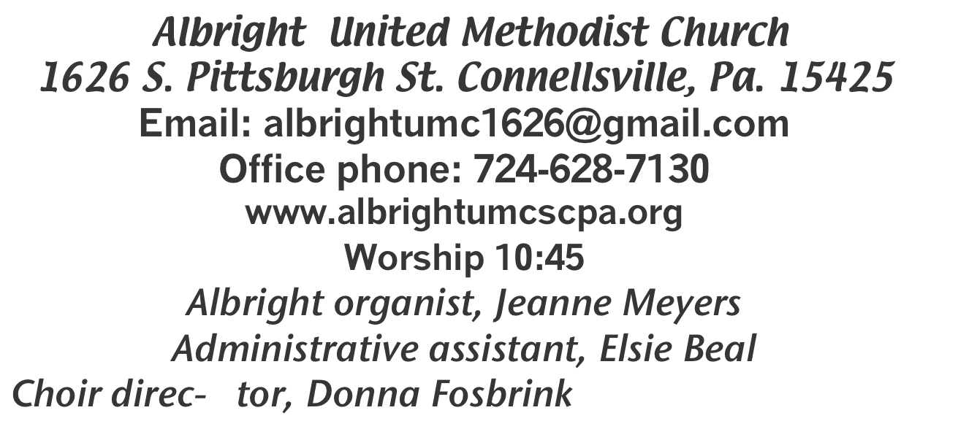

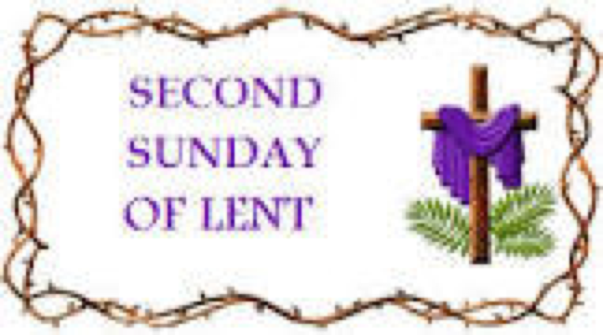

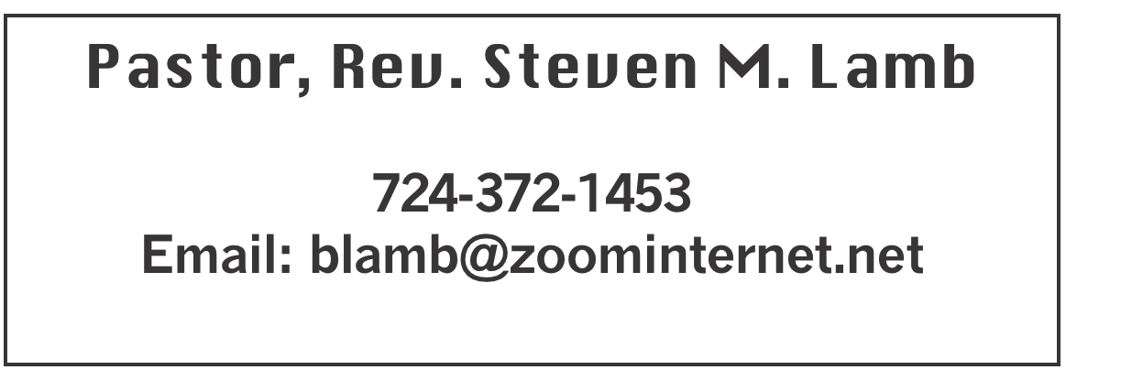

February 25, 2024 Liturgist, Bonnie Bloom 10:45a.m
Second Sunday in Lent
*******************************************************
WELCOME AND ANNOUNCEMENTS
PRELUDE “I’m On My Way” Slaughter
BRINGING FORTH THE LIGHT

*OPENING HYMN “My Faith Looks Up to Thee” 452

*CALL TO WORSHIP
One: Lent is a coming home,
All: Home to what really matters,
One: Home to a place of acceptance and love,
All: Home to a table of plenty,
One: Home from many journeys,
All: Home from bitter defeats,
One: Home from tearing losses,
All: Home to find our center,
One: Home to rest in God,
All: Home to sing praise to the One who welcomes us home.

*OPENING PRAYER
O, Lord, we come to you as a people so desperately in need of your unfailing love. Break up our souls’ unplowed ground, for it is time to seek the face of your Son, Jesus, until he comes and showers righteousness upon all who love and obey him. We pray that we would no longer become victims of the enemy’s lies, nor eat the fruit of deception, having depended on our own strength. In sowing repentance, we lay claim upon your covenant that we would indeed reap the fruit of unfailing love. For your blessings, O Lord, are showered upon all people, who in loyalty proclaim the name of your beloved Son, Jesus Christ, our Lord and Savior. Amen.

*GLORIA PATRI 70

EPISTLE READING Romans 4:13-25
The word of God for the people of God. Thanks be to God.

CHILDREN’S MOMENT & Coin Offering

PASSING THE PEACE

PRAYER REQUESTS
(give prayer cards to acolytes)

OFFERING
OFFERTORY “The Old Rugged Cross” Bennard
*DOXOLOGY
*OFFERTORY PRAYER

PRAYERS OFFERED IN PRAISE AND PETITION

PRAYER HYMN “Are Ye Able” 530

PASTORAL PRAYER

SILENT MEDITATION

THE LORD’S PRAYER

ANTHEM “Come to Jesus, Rest In Him”

GOSPEL READING Mark 8:31-38
The word of God for the people of God. Thanks be to God.
Thy Word is a lamp unto my feet and a light unto my path

MESSAGE “Willing to Suffer or Run Away?”

*CLOSING HYMN “Leave It There” 522

*BENEDICTION

*POSTLUDE
*************************************************
WELCOME
This is the second Sunday in Lent. We cherish the presence of everyone who has come to worship our loving Creator. May God touch each of our lives today. Welcome!

PRAYER CONCERNS THIS WEEK
Tom McMurray Tina Hiltabidel Janice Bailey
David & Tammy Leeder Misty Hiltabidel Dolly King Dorene Provance
Don Heckathorne Sandy Reich Betty Kooser Chuck Watson
Ray Knopsnider Charlotte Holt Thomas Leeder Jean Rahl
Shirley Mathias Gene LaPosta Paul & Myra Holden Parker Scary
Sherrill Goodwin Dick Goodwin Baby Thompson James & Deanna Sherbondy
Brian Fox Stephanie Mattis Elliot Mattis Amy Zavara
Bruce Johnson Lisa Helms Bill Harden
Maddy Bartholomai Trey Corvin Sue Corvin Becky Irwin
John Welsh Sara Gianotti Bill Bower Bonnie Folly
Paula Snyder Twila Filler Susie Mongell Dale Shaffer
Keith Morris John Yost Pat McClelland
Lila Yauger Katy & Travis Terry Mattis
Tilly Harvey Kara McMullen Pastor Stve & Bev
Rev. Bob & Amy Zilhaver Bishop Cynthia Moore-Koiki Our Churches
People with covid Military persons Government leaders Those with cancer
Unspoken requests Families of those who take their own life

IF YOU WANT A NAME ON PRAYER LIST, PLEASE USE THE PRAYER CARDS IN THE PEW - give to Acolytes.

THIS WEEK AT ALBRIGHT
MONDAY: T.O.P.S. 10 & 5
TUESDAY: Blue Plate Special 11:00-1:00
WEDNESDAT: Bible study 6:30 at Albright
THURSDAY: Choir practice 7:00

GREETING YOU TODAY: Linda Burnworth
March 3: Kelly Armstrong & Jeremy Gray

LITURGISTS: March 3: Karen Stimmell
March 10: Donna Fosbrink

ACOLYTES TODAY: Thelma Swope & Emmaleigh Kalenbo
March 3: Sadie & Piper Marko

CHILDREN’S CHURCH: Carol Wagner & Michelle Reich
March 3: Kathy Hixson & Linda Burnworth

USHERS: Jeremy Gray, Fred Grote, Ed Jacobs, Larry Bloom
March 3: Pinky Smiley, Sherry Grote, Jeremy Gray, Ed Jacobs

COUNTERS: Jay Whipkey & Karen Stimmell

BIBLE STUDY
Every Wednesday at 6:30 at Albright. Everyone is welcome.

CHOIR PRACTICE
The choir practices every Thursday at 7:00.

LAST SUPPER PRACTICE
Rehearsal for the Last Supper play will be March 3, 10 and 24 at 6:30 PM in the Otterbein fellowship hall. See pastor Steve for your script.
Players include: John Huey, Fred Grote, Rick Tressler, Jay Whipkey, John Hamon, Brian Suter, Jeremy Gray, Paul Bortz, Chris Lynn, Larry Bloom, David Groh, Doug Shaffer, and Ed Jacobs.
Help is needed for costumes, back drops and staging.
The play will take place at Otterbein UMC on March 28th at 7PM.

YOUTH NEWS
Youth group (grade 3 through 12). They meet the 2nd & 4th Sunday mornings (March 10 & 24) at 10:00 at the church.

BLUE PLATE SPECIAL
Will be Tuesday, February 27 at 11:00-1:00. Free with
donations accepted. $5 for take out.

FREE COMMUNITY EASTER DINNER
Saturday, March 23 at 4:00-7:00. Eat in or Take out available. Registrations Greatly Appreciated, but not
necessary. To pre-register call 724-628-7130.
Donations accepted. Please get pink envelopes off of the board in back of sanctuary.

SOUP & SUB SALES
Saturday, March 9 we will have a soup sale 10-1. $9 quart;
$7 pint.
Friday, March 8 & Saturday, March 9 we will have subs for sale 10-1 or until sold out. 12” sub $10 each.
To be sure you get what you want, please order by March 3. Order forms are out near the bulletins.
ALTAR FLOWERS
If you are ordering altar flowers and want information in the bulletin, please let Elsie know Tuesday morning.

OUR STEWARDSHIP - February 18
Weekly need for budget ........................................... $ 2,214.00
Sunday offering ............................................................... $ 2,257.00
Sunday morning worship attendance .............................. 42

OFFICE HOURS: Tuesday, Wednesday, Thursday 10- 3

EASTER CANDY
We have Easter candy available to order. Order forms are out for you to place paid orders. We need orders by March 3. Pick up orders March 24.

PIE ORDERS
We are taking orders for pies from the pie shoppe in Laughlintown. Order forms are out in back of the sanctuary. They have a larger variety of items available. Pick one up and check it out. We need paid orders to Bev by March 4. Delivery will be March 16

EASTER FLOWERS
The following Easter Flowers are available for you to order in memory or honor of someone special to you. 6” Lily $13.25; 6” Hyacinth $11.75; 6” Tulips $11.75
We cannot guarantee any specific colors. We need paid orders by March 3

CRAFT, COLLECTABLES, VENDOR SHOW
Saturday, July 13 9a.m. to 4p.m. (One day only) with food trucks on sight. Cost is $25 first table $15 thereafter. Outside space $20 for 1; $10 thereafter. Bring your own tables & tents for outside. We have application forms available to return with your fee (nonrefundable). Please return by June 10. Any questions call 724-628-6772 or 724-628-7130.

