ALBRIGHT UNITED METHODIST CHURCH
Rev. Steven Lamb, Pastor Home phone 724-628-6772 Office phone 724-628-7130
Cell phone: 724-372-1453; Email address: blamb@zoominternet.net
Church Email: albrightumc1626@gmail.com Worship service 10:45
Administrative Assistant, Elsie Beal Organist, Jeanne Meyers Choir director, Donna Fosbrink
Custodian, Glenn Siple Church treasurer, Randy Fisher
www.albrightumcscpa.org View weekly service on webpage & Bev’s facebook page
**************************************************************************************************
LITURGISTS
APRIL MAY
2: Glennda Groh 7: Shelley Mattis
9: Bev Lamb 14: Rick Tressler
16: Emma Karfelt 21: Nancy Mimless
23: Jason Jacobs 28: Linda Burnworth
30: Karen Marko
USHERS Head Usher, Glenn Siple
Offerings are placed in the offering plate in back of sanctuary.

COUNTERS
APRIL: Ed Jacobs & Nancy Mimless MAY: Bonnie Bloom & Eve Shupe
ALTAR FLOWERS
APRIL MAY
2: (1)Randy Fisher; (1) Sandy, Rick & Mark Tressler 7: (1)Barry Lincoln; (1) OPEN
9: (1) D. & K. Pasipanki & Dehn; (1) OPEN 14: (1)Tim & Gina Hough; (1) Laurie Arevalo
16: (1)Jared & Timmy Hough; (1) E.Curry & V.Adey 21: Both Don & Marcia Whittaker
23: (1)Elsie Beal; (1) Dave & Shelley Mattis 28: (1)Bob & Gayle Martin; (1) Jackie Bartholomai
30: Gayle & Bob Martin; (1) Kay Jacobs
Beginning in June we will be using silk flowers in the altar vases. Many people were not paying for their vases and this will save the church some added expense. If you would still like to reserve a vase of live flowers, please call the office, or Shelley Mattis and let us know.
ACOLYTES
APRIL MAY
2: Kayton & Keelan Callahan 7: Keelan & Kayton Callahan
9: Piper & Sadie Marko 14: Sadie & Piper Marko
16: Beau Wagner & Jack Geyer 21: Jack Geyer & Jameson Tony
23: Jaxson Jacobs & Andrew Lynn 28: Andrew Lynn & Beau Wagner
30: Olivia Lynn & Morgan Richter
CHILDREN’S CHURCH
First Sunday every month: Kathy Nebraski & Linda Burnworth
Second Sunday each month: Kelly Armstrong & Jeremy Gray
Third Sunday each month: Bonnie & Larry Bloom
Fourth Sunday each month: Carol Wagner & Michelle Reich
(April 30) When there is a Fifth Sunday: Shelley Mattis & Mandy Lynn
T.O.P.S. (Take Off Pounds Sensibly) FOOD PANTRY
Group #1463 meets at Albright each Monday at 10am Thanks for food donations for our local food pantry.
Group #1073 meets at Albright each Monday at 5 pm Non-perishable food & toiletry items appreciated.

WEEKLY BIBLE STUDY
Lead by Pastor Steve. We are watching “The Chosen” as our Bible study on Wednesdays at 6:30 in the sanctuary.
CHOIR PRACTICES
Thursdays at 7:00. We invite volunteers to come and join us.

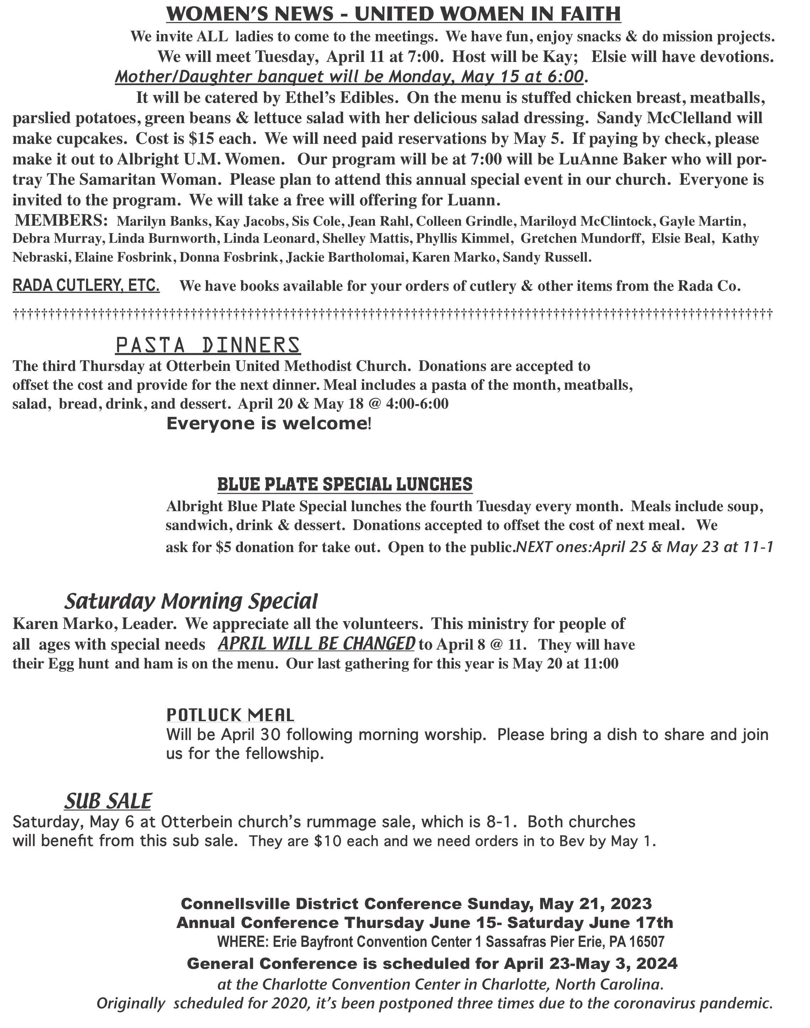

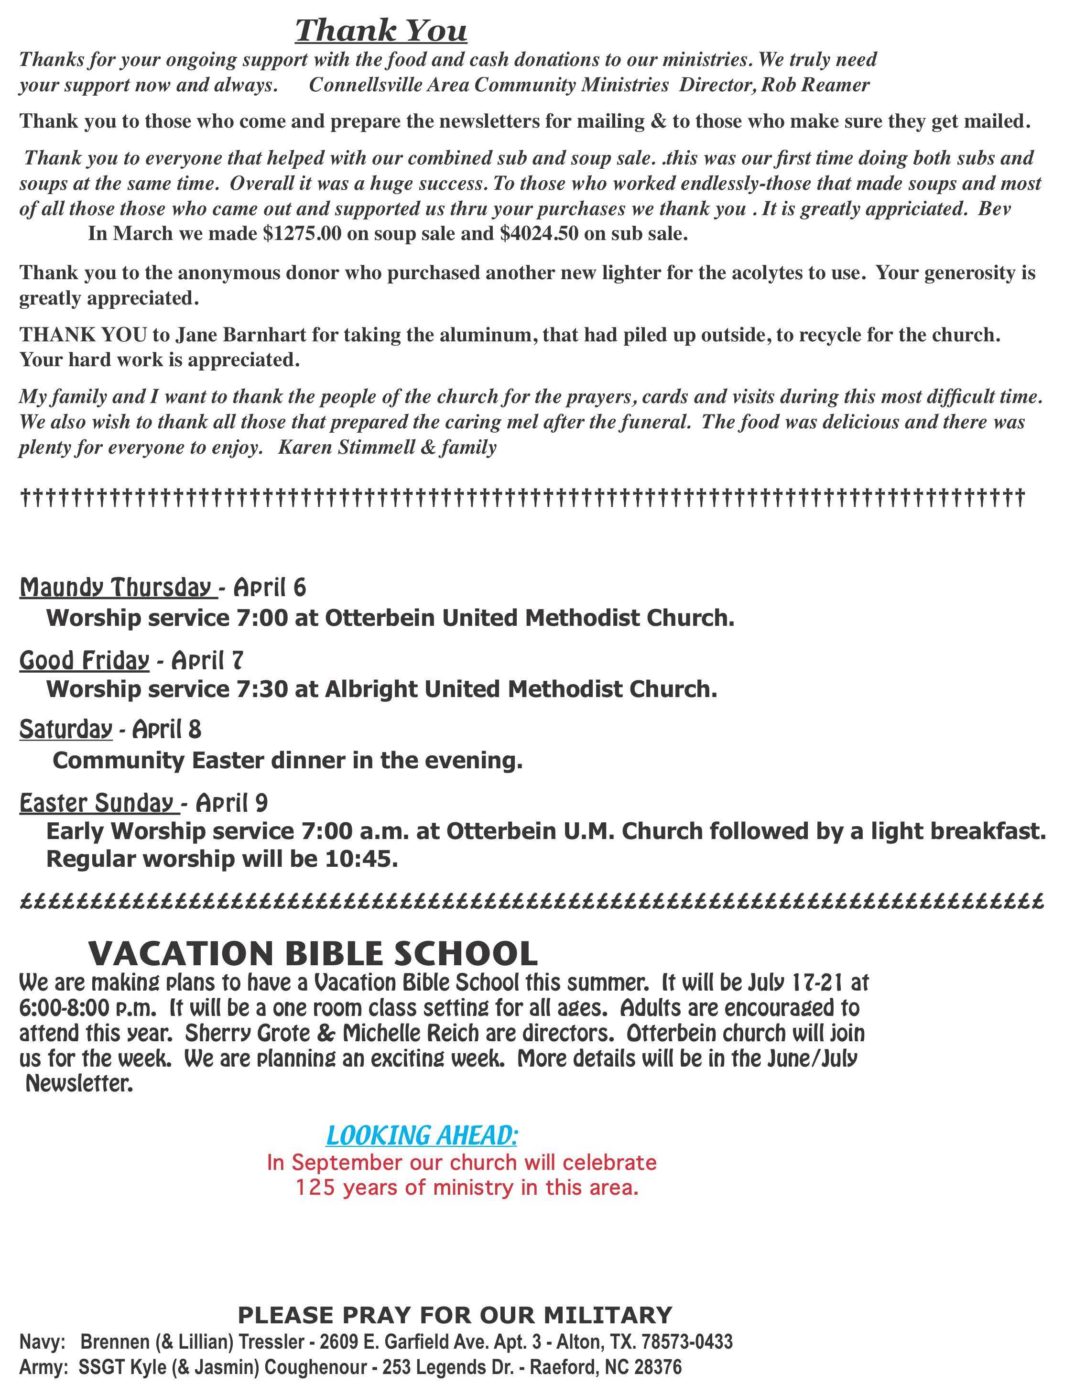

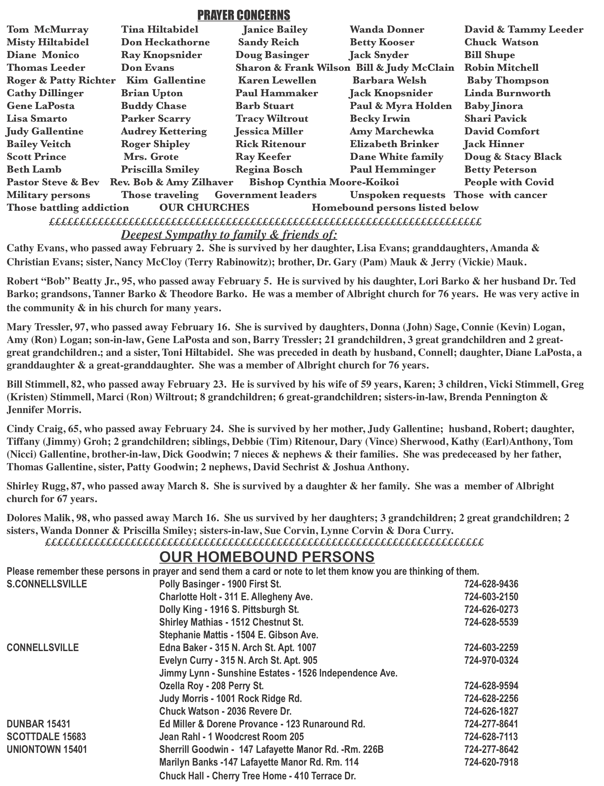

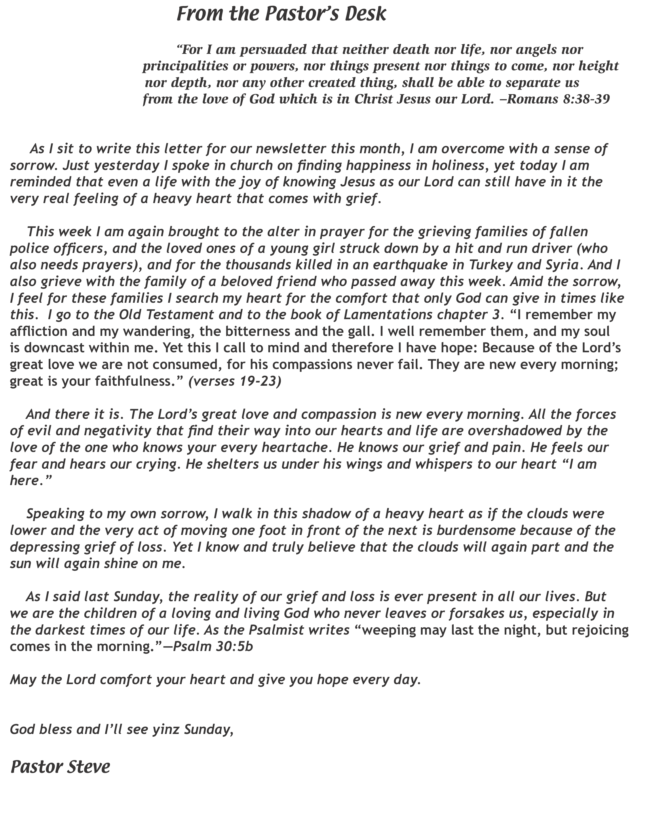

Happy Birthday - April Happy Birthday - May
3 - Don Whittaker, Lauren Porterfield 2 - William Bush
5 - Jimmy Lynn, Larry Geisler 3 - Sherrill Goodwin, Mark Tressler, Anthony Tressler, 7 - Scott Murray, Madison Richter Owen Coughenour
8 - Karson Snyder, Greg Stimmell 5 - David Mattis, Lyle Reagan Jr., Beth Sanner
9 - Patrick Schroyer 6 - Kathy Pasipanki, Joshua Shaffer Sr.
11 - Trista Callahan, Bob Martin 7 - Kayla Snyder, Joshua Strother
14 - David Pasipanki 8 - Lonnie Durst
15 - Vicky Adey 9 - Jackie Kimmel, Aubree Shaffer
16 - Fred Bates, Dale Provance 10 - Brianne Jacobs
18 - Cathy Mellinger 14 - Damien Dunseth
19 - Karen Holbrook 15 - Bill Shupe
20 - Laura Locke 16 - Amanda Evans
21 - Dorene Provance 18 - Elaine Fosbrink, Cheryl Fuchs, Melanie Joy
22 - Priscilla “Pinkie” Smiley 19 - Marci Wiltrout
23 - Lori Barko 20 - Anna Blanish
26 - Shelley Mattis, Alyana Mahokey 22 - Crystal Strother, Karen Lewis
27 - Lynne Corvin 23 - Jessica Obney
29 - Mia Shroyer 24 - Ryan Shupe, Judy Whipkey
25 - Bill Stimmell, Jared Hough
Happy Anniversary - April 27 - Lindsi Mahokey, Bailee Enos, Alison Johnson,
21 - Ed & Marsha Yankovich Susan Cole
21 - Jason & Brianne Jacobs 29 - Kaylee Obney
30 - Kasey Shultz
Happy Anniversary - May 31 - Ann Watson, Barry Tressler
5 - Tim & Beth Sanner
11 - Bill & Lori Newcomer
∑∑∑∑∑∑∑∑∑∑∑∑∑∑∑∑∑∑∑∑∑∑∑∑∑∑∑∑∑∑∑∑∑∑∑∑∑∑∑∑∑∑∑∑∑∑∑∑∑∑∑∑∑∑∑∑∑∑∑∑∑∑
UMCOR Cleaning Kit
Enabling those affected by floods, hurricanes and tornadoes to begin the overwhelming job of cleaning up.
Kit Value: $75 per bucket - May do them as a team or individual.
*One five-gallon round bucket with re-sealable lid (14.35” h x 12.19” w x 12.19” d)
No screw lids - May be used, but must be free from all residual product
Advertisements on the outside acceptable
*One 32-64 oz. bottle liquid laundry detergent
*One 16-40 oz. bottle liquid concentrate household cleaner - No spray cleaners
*One 16-34 oz. bottle dish soap
*One 4-8 oz. pump spray air freshener
*One 6-14 oz. pump spray insect repellent (pack of 10-20 wipes also acceptable)
Pump spray bottles must have protective covers
*One scrub brush - With or without handle
*18 re-useable cleaning wipes
No terrycloth, microfiber or paper towels - Remove from packaging
*Five scouring pads
No stainless-steel pads with soap in them - Remove from packaging
*36-50 clothespins
*One 50-100 ft. clothesline (cotton or plastic line)
*24 roll of heavy-duty trash bags (33-45-gallon sizes) - Remove from packaging
*Five N95 particulate respirator dust masks (1-3 mm thickness) - No surgical masks
*Two pairs kitchen gloves - Durable for multiple uses - Remove from packaging
*One pair work gloves - Cotton with leather palm or all leather
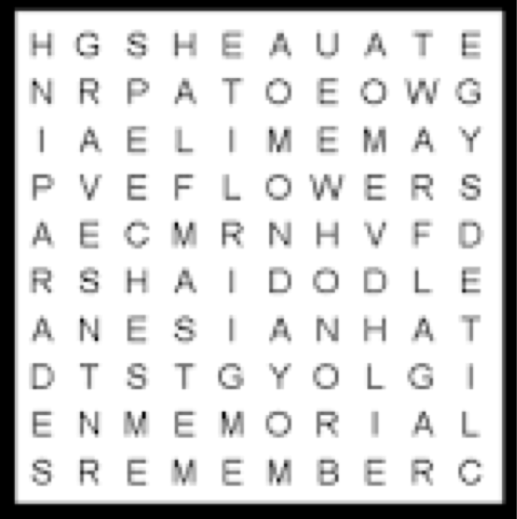

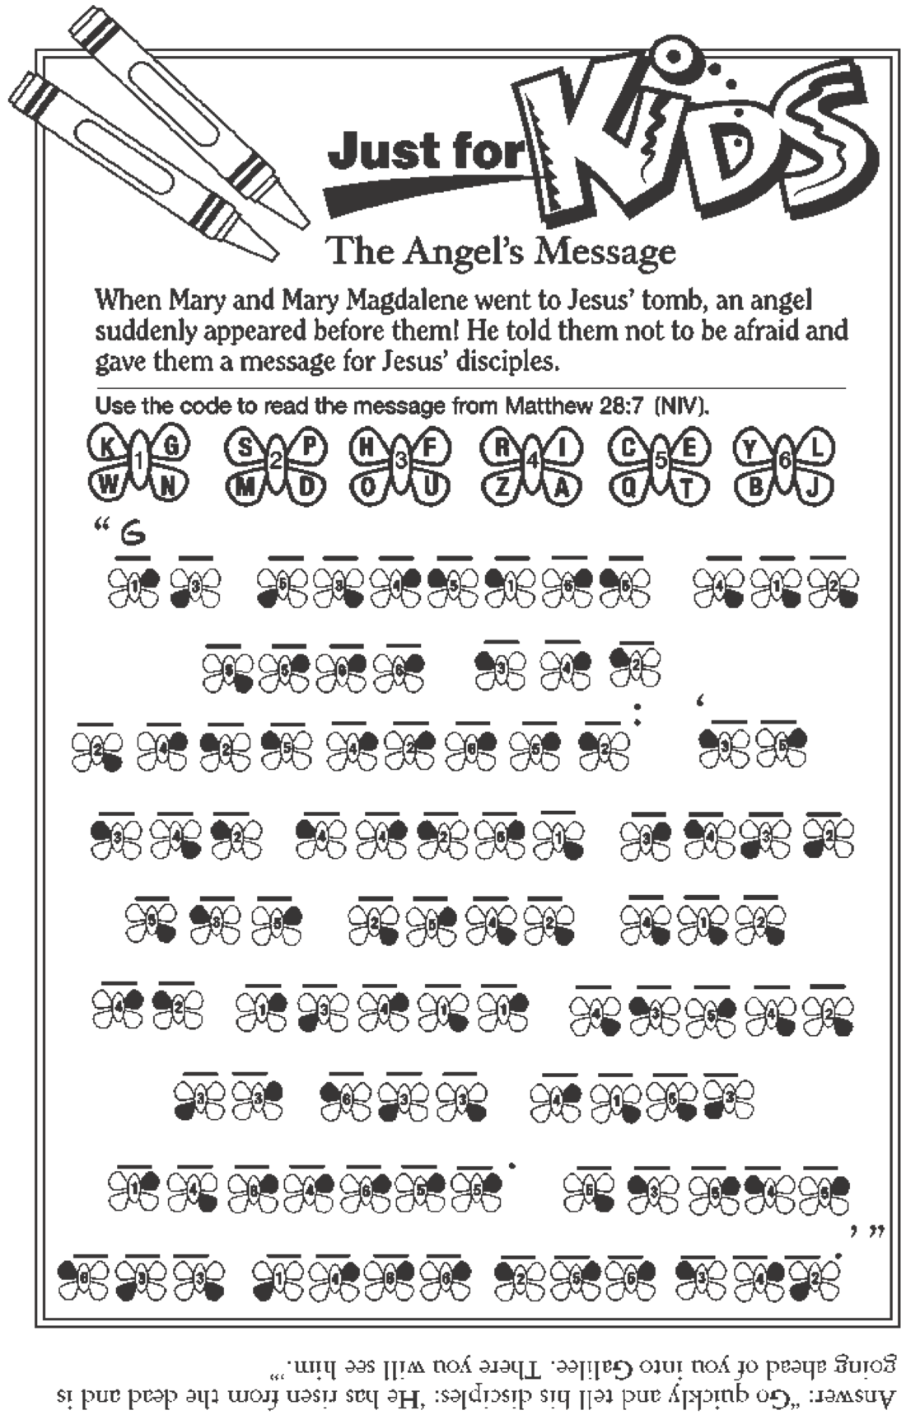

APRIL 2023
=====================================================================
S M T W T F S
_____________________________________________________________________________
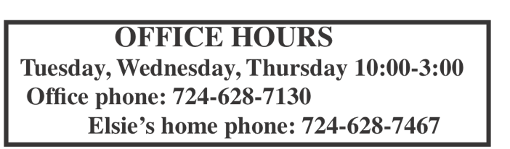
1

____________________________________________________________________________________________________________
2 3 4 5 6 7 8
Palm Sunday Maundy Thurs. Good Friday Sat. Morn. Spec Worship 7:00 @ Worship 7:30 @ 11:00 - Their egg
Otterbein Albright hunt
Bible study 6:30
Community
Easter dinner
T.O.P.S. 10 & 5 4:00-6:00p.m.
___________________________________________________________________________________________________________
9 10 11 12 13 14 15 Easter Sunday U.M.W. mtg 7
Early service
7a.m. @ Otter. Bible study 6:30
Reg. worship
9:00 @ Ott.
10:45 @ Alb.
T.O.P.S. 10 & 5 Choir prac. 7
____________________________________________________________________________________________________________ 16 17 18 19 20 21 22
O-Pasta meal 4-6
Bible study 6:30

Choir prac. 7
T.O.P.S. 10 & 5
____________________________________________________________________________________________________________
23 24 25 26 27 28 29
Al - Blue plate
spec. lunch 11-1
Bible study 6:30

____________________________________________________________________________________________________________
30
Potluck cov.
dish after church

______________

MAY 2023
=====================================================================
S M T W T F S
_____________________________________________________________________________
1 2 3 4 5 6
National Day Friendship day Ot: Rummage
of prayer sale 8-1
and
Al: Sub sale
10-12 benefit both churches

Choir prac. 7
____________________________________________________________________________________________________________
7 8 9 10 11 12 13

Choir prac. 7
______________________________________________________________ _____________________________________________
14 15 16 17 18 19 20
Church council News deadline Sat. Morning Mother’s day M/D/Friend mtg 7:00 June/July Special 11:00 dinner 6:00
Program 7:00 O - Pasta Vol. put flags on
Dinner 4-6 graves

T.O.P.S. 10 & 5 Choir prac. 7
_________ __________________________________________________________________________________________________
21 22 23 24 25 26 27 Ascension Sunday Assemble
A-Blue plate Spec. newsletter 10 Ot: Sundae
C’ville district lunch 11-1 Sale 11-1
conference
.

T.O.P.S. 10 & 5
___________________________________________________________________________________________________________
28 29 30 31
Pentecost Sunday
wear Red Memorial day

______________________________________________________________

