Albright United Methodist Churches
1626 S. Pittsburgh St. Connellsville, Pa. 15425
Email: albrightumc1626@gmail.com
Office phone: 724-628-7130
www.albrightumcscpa.org
Albright organist, Jeanne Meyers
Administrative assistant, Elsie Beal
Choir director, Donna Fosbrink

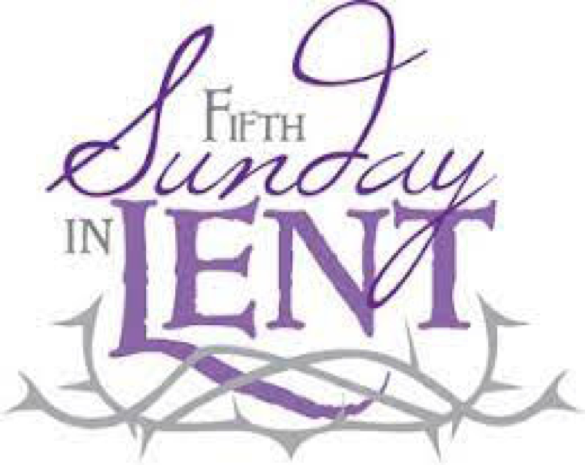

Pastor, Rev. Steven M. Lamb

724-372-1453
Email: blamb@zoominternet.net

*******************************************************
March 26, 2023 Liturgist, Karen Stimmell 10:45a.m.
Fifth Sunday in Lent
*******************************************************
WELCOME AND ANNOUNCEMENTS
PRELUDE “He Didn’t Come Down” Cooley

BRINGING FORTH THE LIGHT

*OPENING HYMN “Come Thou Fount of Every Blessing” 400

*CALL TO WORSHIP
One: Out of the depths I cry to you, O Lord.
All: Lord, hear our voice! Let your ears be attentive to our
call.
One: If you, O Lord, should mark iniquities, Lord, who could
stand?
All: But there is forgiveness with you, so that you may be
revered.
One: I wait for the Lord, my soul waits, and in his word, I
hope;
All: We wait for the Lord. We hope in his word.
One: My soul waits for the Lord more than those who watch
for the morning, more than those who watch for the
morning.
All: O people of God, hope in the Lord! For with the Lord
there is steadfast love, and with him is great power to
redeem.

*OPENING PRAYER
Resplendent God, we long to be people who live and walk in the light of your glory, but sometimes we find ourselves shrouded in the darkness of fear, loneliness, or despair. In our anguish, we cannot always find you. Help us trust that you will lead us out of the shadows and back into your radiant presence. Fill us with your light so we are able to chase away the demons that taunt us in the dark. Let your light shine in us so that our faces reflect your light and love to all those who don’t yet know your saving grace. Amen.

*GLORIA PATRI 70

GOSPEL READING John 11:1-45
The word of God for the people of God. Thanks be to God.

CHILDREN’S MOMENT

PASSING THE PEACE

OFFERTORY PRAYER
(Offerings can be placed in the plate as you leave today.)

*DOXOLOGY

PRAYERS OFFERED IN PRAISE AND PETITION

PRAYER HYMN “My Faith Looks Up to Thee” 452

PASTORAL PRAYER

SILENT MEDITATION

THE LORD’S PRAYER

ANTHEM “Lonesome Valley”

OLD TESTAMENT READING Psalm 130
The word of God for the people of God. Thanks be to God.
Thy Word is a lamp unto my feet and a light unto my path

MESSAGE “Holes”

*CLOSING HYMN “Something Beautiful” 394

*BENEDICTION

*POSTLUDE

*************************************************

WELCOME
Welcome to all! The Letter to the Hebrews tells us to approach worship “with a sincere heart in full assurance of faith” (Heb. 10:22). Therefore let us sincerely lift up our hearts to the Lord and extend our hands in loving fellowship to one another. God bless you all.

PRAYER CONCERNS THIS WEEK
Tom McMurray Tina Hiltabidel Janice Bailey Wanda Donner David & Tammy Leeder Misty Hiltabidel Dolly King Dorene Provance Don Heckathorne Sandy Reich
Betty Kooser Chuck Watson Diane Monico Ray Knopsnider Charlotte Holt
Doug Basinger Jack Snyder Sherrill Goodwin Thomas Leeder Jimmy Lynn
Don Evans Robin Mitchell Jean Rahl Shirley Mathias Sharon & Frank Wilson Bill & Judy McClain Marilyn Banks Roger & Patty Richter Kim Gallentine Karen Lewellen
Judy Morris Baby Thompson Cathy Dillinger Brian Upton Paul Hammaker
Jack Knopsnider Linda Burnworth Gene LaPosta Buddy Chase Barb Stuart Paul & Myra Holden Baby Jinora Lisa Smarto Parker Scarry Tracy Wiltrout Becky Irwin Shari Pavick Judy Gallentine Audrey Kettering Jessica Miller Amy Marchewka
David Comfort Bailey Veitch Roger Shipley Rick Ritenour Elizabeth Brinker
Jack Honner Scott Prince Daryl White Mrs. Grote Ray Keefer
Bill Shupe Bob Stout Doug Black Beth Lamb Paul Hemminger Betty Peterson Donna Fosbrink Pastor Steve & Bev Rev. Bob & Amy Zilhaver
Bishop Cynthia Moore-Koikoi People with Covid Military persons Those traveling
Government leaders Those with cancer Those battling addiction OUR CHURCHES
DEEPEST SYMPATHY TO FAMILY & FRIENDS OF:
Dolores Malik who passed away March 16. Sister of Pinky Smiley

THIS WEEK AT ALBRIGHT
MONDAY: T.O.P.S. 10:00 or 5:00
TUESDAY: Blue plate special lunch 11:00-1:00
WEDNESDAY: Bible study 6:30 in sanctuary
Assemble newsletter 10:00
THURSDAY: Choir practice 7:00

LITURGISTS: April 2: Glennda Groh
April 9: Bev Lamb
ACOLYTES TODAY: Morgan Richter & Jameson Tony
April 2: Keelan & Kayton Callahan
CHILDREN’S CHURCH: Carol Wagner & Michelle Reich
April 2: Kathy Nebraski & Linda Burnworth
COUNTERS: Rick Tressler & Sandy Russell

ALTAR FLOWERS
(1)To the GLORY OF GOD and IN LOVING MEMORY of grandmother, Sandra Sherrick - given by Chelsea Bartholomai.
(1) To the GLORY OF GOD and IN LOVING HONOR of my children - given by Dorene Provance.

ALTAR FLOWER INFORMATION
Put money in envelope & drop in offering plate marked for altar vase on or near the Sunday you have reserved.
OPEN VASES:
1 Vase: April 9, May 7, June 18, July 9 & 23
To reserve a vase, please call Shelley Mattis 724-363-6822.

OUR STEWARDSHIP - March 19, 2023
Weekly need for budget ....................................... $ 2,383.38
Sunday offering .................................................... $ 1,887.75
Sunday morning worship attendance.......................... 54

OFFICE HOURS: Tues., Wed., Thurs. 10:00-3:00

HOLY WEEK
Sunday, April 2
Palm Sunday worship 10:45

Maundy Thursday - April 6
Worship service 7:00 at Otterbein United Methodist Church.

Good Friday - April 7
Worship service 7:30 at Albright United Methodist
Church.

Saturday - April 8
Community Easter dinner 4:00-6:00 p.m.

Easter Sunday - April 9
Early Worship service 7:00 a.m. at Otterbein U.M. Church followed by a light breakfast.
Regular worship: 9:00 at Ott.; 10:45 at Alb.

BLUE PLATE SPECIAL
Tuesday, March 28 at 11:00-1:00 at Albright. Soup, sandwich, dessert & beverage. It is free with donations accepted to help with expense. We ask for a $5 donation for take outs.

BIBLE STUDY
We are watching “The Chosen Part 2” as our Bible study on Wednesdays at 6:30 in the
sanctuary.

APRIL/MAY NEWSLETTER
Will need volunteers to assemble & complete for mailing on Wednesday, March 29 at 10:00.

PRAYER CARDS
There are prayer cards in the pews. Please write prayer requests on them and give them to an acolyte. They will collect them during passing of the peace.

CHILDREN BULLETINS
We have bulletins for children out near the regular bulletins. They are for 2 different age groups. Please take them.

SATURDAY MORNING SPECIAL
APRIL 8 at 11:00. Their egg hunt is that day. We will have ham for lunch. This is a ministry of our church for persons with
special needs. Our volunteers are always appreciated.

COMMUNITY EASTER DINNER
We are planning for a Community Easter Dinner on
Saturday, April 8 @ 4:00-6:00. We are asking for
donations to help with the cost of this meal.

