Albright & Otterbein United Methodist Churches
1626 S. Pittsburgh St. Connellsville, Pa. 15425
Email: albrightumc1626@gmail.com
Office phone: 724-628-7130
www.albrightumcscpa.org
Worship 10:45
Albright organist, Jeanne Meyers
Administrative assistant, Elsie Beal
Choir director, Donna Fosbrink

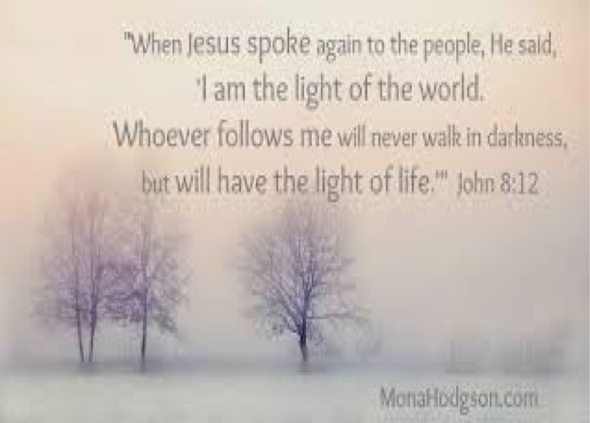

Pastor, Rev. Steven M. Lamb

724-372-1453
Email: blamb@zoominternet.net

*******************************************************
February 5, 2023 Liturgist, Jessicaa Tony 10:45a.m.
******************************************************
WELCOME AND ANNOUNCEMENTS

PRELUDE Everyday People” Parks

BRINGING FORTH THE LIGHT

*OPENING HYMN “Let Us Break Bread Together” 618

*CALL TO WORSHIP
L: Loving Christ, you are our gentle Shepherd.
P: We are your people; we long to know your will and
to live in your way.
L: Keep us safe and secure in your compassionate
hands.
P: Lead us, gentle Shepherd, lead us into new paths
of love and service.
L: As you lead and guide us, touch our hearts and
minds in this worship time,
P: So that our spirits may be refreshed and our lives
filled with joy and praise.

*OPENING PRAYER
Lord, we are a sinful people, living in a sinful world, suffering from our brokenness and separation from you. During this time of worship, we choose to disconnect ourselves from the ways and priorities of the world and to reconnect our focus back onto you. God, we invite you into this time of worship. We invite you into our lives. We pray that our lives will be made faithful in all things. Amen.

*GLORIA PATRI 70

EPISTLE READING I Corinthians 2:1-12
The word of God for the people of God. Thanks be to God.

ANTHEM “God Will Make A Way”

HOLY COMMUNION

THE LORD’S PRAYER

CHILDREN’S MOMENT

PASSING THE PEACE

OFFERTORY PRAYER
(Offerings can be placed in the plate as you leave today.)

*DOXOLOGY

PRAYERS OFFERED IN PRAISE AND PETITION

PRAYER HYMN “Come Ye Sinners, Poor and Needy” 140

PASTORAL PRAYER

SILENT MEDITATION

OLD TESTAMENT READING Psalm 112:1-10
The word of God for the people of God. Thanks be to God.
Thy Word is a lamp unto my feet and a light unto my path

MESSAGE “Happiness is Next to Holiness”

*CLOSING HYMN “Great is Thy Faithfulness” 340

*BENEDICTION

*POSTLUDE

**************************************************
WELCOME
We welcome all who have come to Worship our Lord with us. We pray you will be blessed and will be a blessing to others.

PRAYER CONCERNS THIS WEEK
Tom McMurray Tina Hiltabidel Janice Bailey Wanda Donner
David & Tammy Leeder Mary Tressler Rich Tressler Jr. Misty Hiltabidel
Dolly King Dorene Provance Don Heckathorne Sandy Reich
Betty Kooser Chuck Watson Dolores Malik Diane Monico
Ray Knopsnider Charlotte Holt Doug Basinger Jack Snyder
Bill Shupe Sherrill Goodwin Thomas Leeder Jimmy Lynn
Sharon & Frank Wilson Bill & Judy McClain Don Evans Roger & Patty Richter
Kim Gallentine Robin Mitchell Jean Rahl Shirley Mathias
Marilyn Banks Karen Lewellen Judy Morris Barbara Welsh
Baby Thompson Cathy Dillinger Paul Hammaker Jack Knopsnider
Brian Upton Linda Burnworth Gene LaPosta Charlie Picola
Barb Stuart Paul & Myra Holden Buddy Chase Baby Jinora
Lisa Smarto Lisa Helms Tracy Wiltrout Ron Keifer family
Parker Scarry Mr. Barko Becky Bloom Patty Richter
Becky Itwin Shari Pavick Jimmy Davis family Pastor Steve & Bev
Rev. Bob & Amy Zilhaver Bishop Cynthia Moore-Koikoi People with Covid 19
Unspoken requests Military persons Those traveling Government leaders
Those with cancer First Responders Those battling addiction
Homebound listed in newsletter OUR CHURCHES

THIS WEEK AT ALBRIGHT
TUESDAY: P.P.R.Committee meeting 7:00
THURSDAY: Choir practice 7:00
FRIDAY: Sub sale 10-12
SATURDAY: Sub sale 10-12; Soup sale 11-1
SUNDAY: Sweetie Tea Party $10 each See Sherry
Super bowl Sun. Bring food items for food pantry

LITURGISTS: February 12: Scott Murray
February 19: Sherry Grote

ACOLYTING: Kayton & Keelan Callahan
February 12:Piper & Sadie Marko

CHILDREN’S CHURCH: Kathy Nebraski & Linda Leonard
Feb. 12: Need a Volunteer. See Pastor Steve

COUNTERS: Larry Bloom & Karen Marko

OFFICE HOURS: Tues., Wed., Thurs. 10-2
Elsie at home 724-628-7467

PRAYER CARDS
There are prayer cards in the racks in the pews. Please write prayer requests on them and give them to the pastor or an acolyte. Thank you.

BIBLE STUDY
We are watching “The Chosen Part 2” as our Bible study on Wednesdays at 6:30 in the sanctuary.

PASTOR PARISH RELATIONS COMMITTEE MEETING
Tuesday, February 7 at 7:00
MEMBERS ARE: Sandy Russell, Jeremy Gray, Eve Shupe, Vicky Adey, Linda Burnworth, Karen Marko, Rick Tressler.

SUPER BOWL SUNDAY
Feb. 12 is Super Bowl Sunday. We are asking you to bring non-perishable food items to church.

SWEETIE TEA PARTY
Sunday, February 12 at 2:00. Tickets are $10 each. You will receive desserts, tea, coffee or other beverage. There will be a silent auction. See Sherry Grote to get tickets.

PASTA DINNER AT OTTERBEIN
Thursday, February 16 at 4:00-6:00. Donations are accepted to offset the cost of the next dinner. Meal includes a pasta of the month, meatballs, salad, bread, drink, and dessert. Everyone is welcome.

MEN COOKING BREAKFAST
Sat., Feb. 18 at 9:00 the men are cooking breakfast for the ladies. Please sign up on paper in back of sancturay so we know how many to cook for.

ASH WEDNESDAY
February 22 at 7:00 p.m. will be our Ash Wednesday worship service at Albright church. Everyone is invited to join us!

ALTAR FLOWERS
(1)To the GLORY OF GOD and IN LOVING MEMORY of Geneva Costello who died Feb. 5 - given by Kathy & David Pasipanki & Dehn Unterzuber & family.
(1) To the GLORY OF GOD and IN LOVING MEMORY of Carol Lynn - given by David & Pamela Lynn.

ALTAR FLOWER INFORMATION
Put money in envelope & drop in offering plate. To reserve or change a vase, please call Shelley Mattis 724-363-6822.

OUR STEWARDSHIP - January 29, 2023
Weekly need for budget ....................................... $ 2,383.38
Sunday offering .................................................... $ 1,529.00
Sunday morning worship attendance.......................... 66

NEW ADDRESS FOR MARY TRESSLER
She is now in Mt. Macrina Manor - 520 W. Main St. Room 506 - Uniontown, Pa. 15401

SOUP SALE
NEXT SOUP SALE: Saturday, February 11 at 11:00-1:00. $8 quart; $6 pint. Eat in for a donation. We need soup donated. Please sign the tablet in back of sanctuary to let us know what you will bring. Thank you!

SUB SALE
Friday, February 10 & Saturday, February 11 we will have a Sub sale. We need paid orders. Order forms are out in the back of the sanctuary near the bulletins. They are $10 each.
MUST ORDER AHEAD.

2023 CHURCH DIRECTORIES
The new directories are out in the back of the sanctuary and on the table by the side entrance. We ask for $1.25 donation for each one you take to cover cost of
printing.

