Albright & Otterbein United Methodist Churches
1626 S. Pittsburgh St. Connellsville, Pa. 15425
Email: albrightumc1626@gmail.com
Office phone: 724-628-7130
www.albrightumcscpa.org
Worship 10:45
Albright organist, Jeanne Meyers
Administrative assistant, Elsie Beal
Choir director, Donna Fosbrink

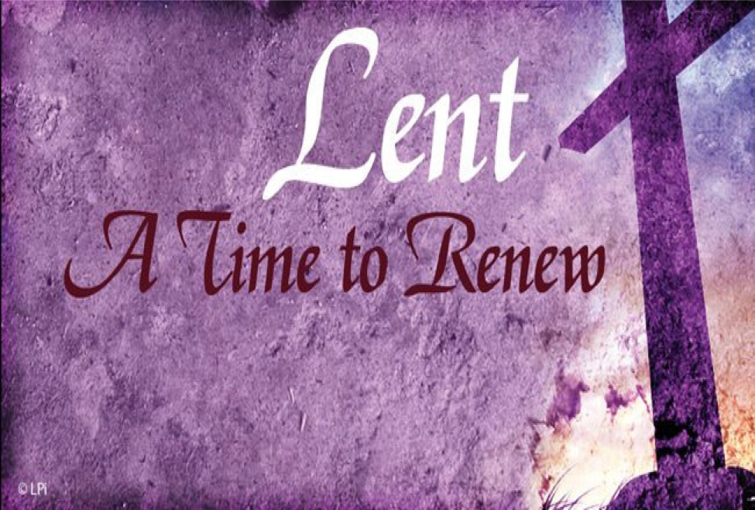

Pastor, Rev. Steven M. Lamb

724-372-1453
Email: blamb@zoominternet.net

*******************************************************
February 26, 2023 Liturgist, Eve Shupe 10:45a.m.
First Sunday in Lent
*******************************************************
WELCOME AND ANNOUNCEMENTS

PRELUDE “Lead Me to Calvary” Kirkpatrick
BRINGING FORTH THE LIGHT

*OPENING HYMN “Morning Has Broken” 145

*CALL TO WORSHIP
One: Unstop our ears,
All: Lace up our shoes,
One: Open up our hearts,
All: Turn our faces toward God,
One: For the Lenten journey begins.
All: To listen to the voice of Jesus,
One: To walk the narrow path of discipleship,
All: To trust our depths to the forgiving love of God,
One: To direct our attention to heaven’s song,
All: The eternal melody of love.

*OPENING PRAYER
Lord, we have heard this ancient story,
that comes from a place deep down in the traditions of your people. It’s a family story, brimming with grief and love and hunger. In it, we see our own deepest desires and most painful frustrations. In it, we see ourselves, in all our
complexity. Forgive us when we fail to live lives of
faithfulness and trust. Help us to know, always, that there is a way back from any moral failure: a way that passes by the cross of Jesus, that One who was tempted as we are, but without sin. Amen.
*GLORIA PATRI 70

GOSPEL READING Matthew 4:1-11
The word of God for the people of God. Thanks be to God.

CHILDREN’S MOMENT

PASSING THE PEACE

OFFERTORY PRAYER
(Offerings can be placed in the plate as you leave today.)

*DOXOLOGY

PRAYERS OFFERED IN PRAISE AND PETITION

PRAYER HYMN “Sweet, Sweet Spirit” 334
PASTORAL PRAYER

SILENT MEDITATION

THE LORD’S PRAYER

ANTHEM “This Is Amazing Grace”

OLD TESTAMENT READING Genesis 2:15-17;3:1-7
The word of God for the people of God. Thanks be to God.
Thy Word is a lamp unto my feet and a light unto my path

MESSAGE “Grace Over Temptation”

*CLOSING HYMN “The Gift of Love” 408

*BENEDICTION
*POSTLUDE
*************************************************
WELCOME
With joyful hearts we sincerely welcome you to this service of worship on this first Sunday in Lent. Let us approach the throne of grace with openness and love that we may all realize God’s presence and power.

PRAYER CONCERNS THIS WEEK
Tom McMurray Tina Hiltabidel Janice Bailey Wanda Donner
David & Tammy Leeder Misty Hiltabidel Dolly King Dorene Provance
Don Heckathorne Sandy Reich Betty Kooser Chuck Watson
Dolores Malik Diane Monico Ray Knopsnider Charlotte Holt
Doug Basinger Jack Snyder Bill Shupe Sherrill Goodwin
Thomas Leeder Jimmy Lynn Don Evans Sharon & Frank Wilson
Bill & Judy McClain Robin Mitchell Roger & Patty Richter Kim Gallentine
Jean Rahl Shirley Mathias Marilyn Banks Karen Lewellen
Judy Morris Barbara Welsh Baby Thompson Cathy Dillinger
Brian Upton Paul Hammaker Jack Knopsnider Charlie Picola
Linda Burnworth Gene LaPosta Buddy Chase Barb Stuart
Paul & Myra Holden Baby Jinora Lisa Smarto Parker Scarry
Becky Bloom Tracy Wiltrout Becky Irwin Shari Pavick
Judy Gallentine Audrey Kettering Jessica Miller Amy Marchewka
David Comfort Bailey Veitch Roger Shipley Rick Ritenour
Elizabeth Brinker Jack Hinner Pastor Steve & Bev Families of earthquake victims
Rev. Bob & Amy Zilhaver Bishop Cynthia Moore-Koikoi People with Covid Unspoken requests
Military persons Those traveling Government leaders Those with cancer First Responders Those battling addiction OUR CHURCHES

DEEPEST SYMPATHY TO FAMILY & FRIENDS OF:
Mary Tressler, 97, who passed away Feb. 16.

THIS WEEK AT ALBRIGHT
MONDAY: T.O.P.S. 10:00 or 5:00
TUESDAY: Blue plate special lunch 11:00-1:00
WEDNESDAY: Bible study 6:30 in sanctuary
THURSDAY: Choir 7:00

LITURGISTS: March 5:Bonnie Bloom
March 12: Karen Stimmell

ACOLYTES TODAY: Beau Wagner & Jaxson Jacobs
March 5: Jameson Tony & Olivia Lynn

CHILDREN’S CHURCH: Carol Wagner & Michelle Reich
March 5: Kathy Nebraski & Linda Burnworth

COUNTERS: Larry Bloom & Karen Marko

OFFICE HOURS: Tues., Wed., Thurs. 10-2. Elsie 724-628-7467

BLUE PLATE SPECIAL
Tuesday, February 28 at 11:00-1:00 at Albright. Soup,
sandwich, dessert & beverage. It is free with donations
accepted to help with expense. We ask for a $5 donation for take out.

HOMEMADE EASTER CANDY
Candy samples are out in the back of the sanctuary. Order forms are also there. Please have paid orders in to the church by Sunday, March 19. Orders will be available for pick up on Palm Sunday, April 2.

2023 Heart To Hope Telethon
The Connellsville Area Community Ministries will be hosting their 5th Annual Heart To Hope Telethon This will be live on Saturday March 11, 2023 at the Connellsville Community Center! The Telethon will be broadcast live on Facebook and via local television outlets, it is also open to the public to come and enjoy the day’s festivities.

SUB SALE
We are taking orders for another sub sale March 10 & 11. Pick up time is 10:30-1:00. $10 each and we need paid orders to Bev by March 5.

UNITED WOMEN IN FAITH
Will meed Tuesday, March 14 at 7:00. Jackie Bartholomai will have devotions & Sandy Russell will host.

SATURDAY MORNING SPECIAL
March 18 at 11:00. We will have sloppy joes for lunch. This is a ministry of our church for persons with special needs. Our volunteers are always appreciated.

APRIL/MAY NEWSLETTER
News deadline is Thursday, March 23. Will need volunteers to complete for mailing on Wednesday, March 29 at 10:00.

ALTAR FLOWERS
(1)To the GLORY OF GOD and IN LOVING MEMORY of our mother, grandmother & great grantmother, Evelyn Butela given by Evelyn Curry & family and Vicky Adey & family.
(1) To the GLORY OF GOD and IN LOVING MEMORY of dad, Ray Fisher - given by Randy Fisher Sr.

ALTAR FLOWER INFORMATION
Put money in envelope & drop in offering plate. To reserve or change a vase, please call Shelley Mattis 724-363-6822.

OUR STEWARDSHIP - February 19, 2023
Weekly need for budget ....................................... $ 2,383.38
Sunday offering .................................................... $ 2,075.35
Sunday morning worship attendance.......................... 63

OFFERING ENVELOPES
New ones should be here this week. They will be in the form of a book of envelopes with stubs attached for you to keep a record of your giving.

SOUP SALE Saturday, March 11 @ 10:30-1:00
$8 quart; $6 pint. Eat in for a donation. Please sign the tablet in back of sanctuary to let us know what you will bring. Thank you!

BIBLE STUDY
We are watching “The Chosen Part 2” as our Bible study on Wednesdays at 6:30 in the
sanctuary.

PRAYER CARDS
There are prayer cards in the racks in the pews. Please write prayer requests on them and give them to the pastor or an acolyte. Thank you.

