Albright & Otterbein United Methodist Churches
1626 S. Pittsburgh St. Connellsville, Pa. 15425
Email: albrightumc1626@gmail.com
Office phone: 724-628-7130
www.albrightumcscpa.org
Worship 10:45
Albright organist, Jeanne Meyers
Administrative assistant, Elsie Beal
Choir director, Donna Fosbrink
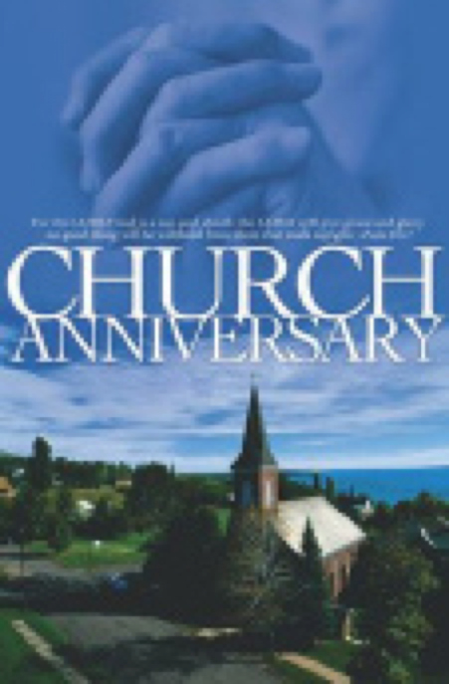

Pastor, Rev. Steven M. Lamb

724-372-1453
Email: blamb@zoominternet.net

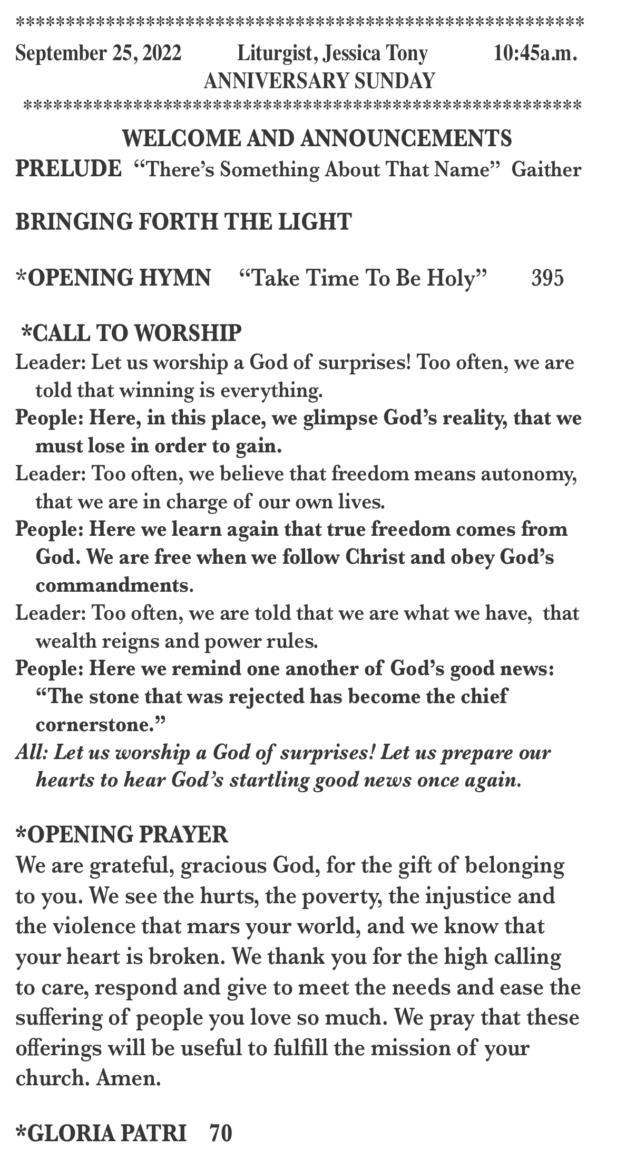

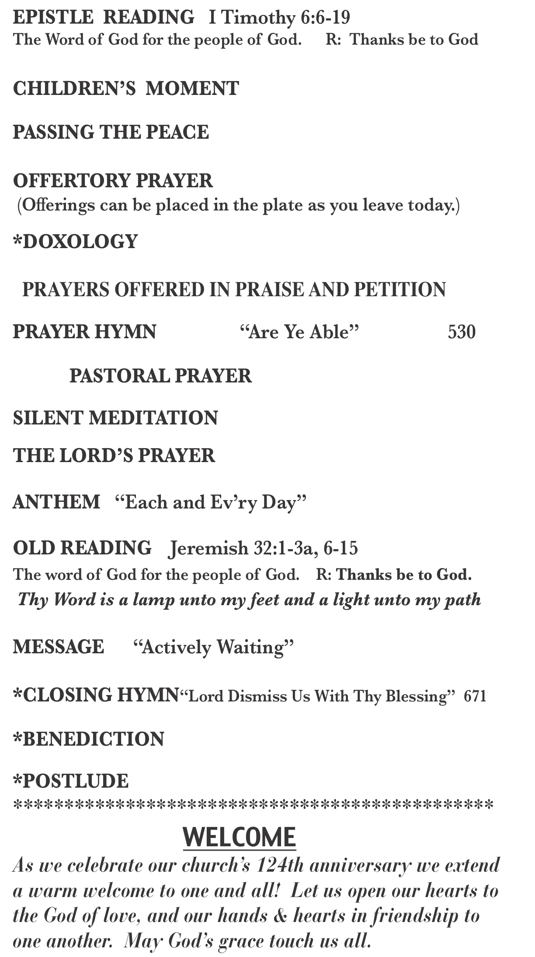

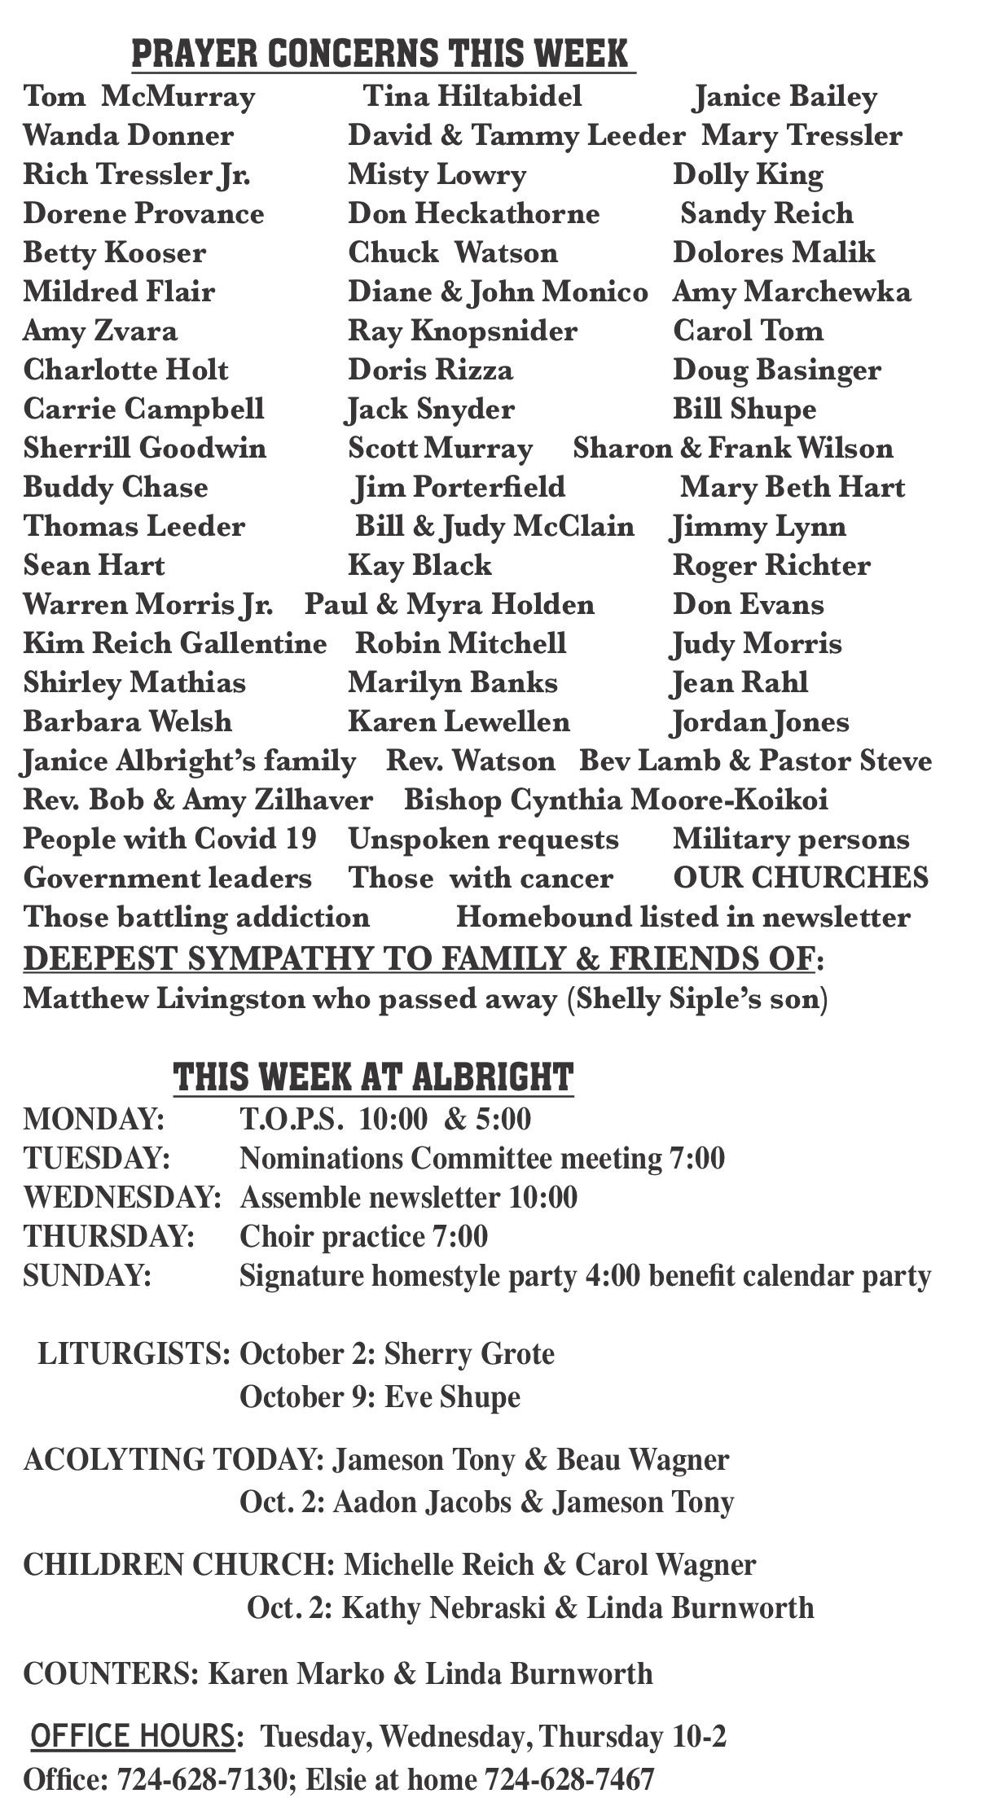

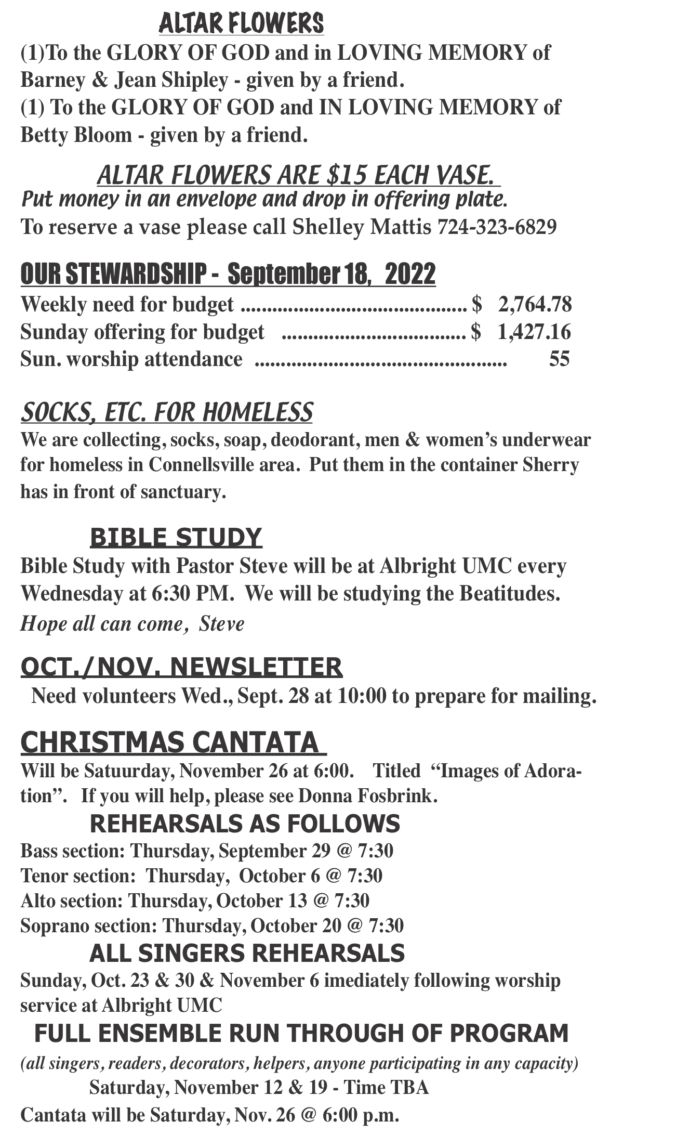

jk

