Albright & Otterbein United Methodist Churches
1626 S. Pittsburgh St. Connellsville, Pa. 15425
Email: albrightumc1626@gmail.com
Office phone: 724-628-7130
www.albrightumcscpa.org
Worship 10:45
Albright organist, Jeanne Meyers
Administrative assistant, Elsie Beal

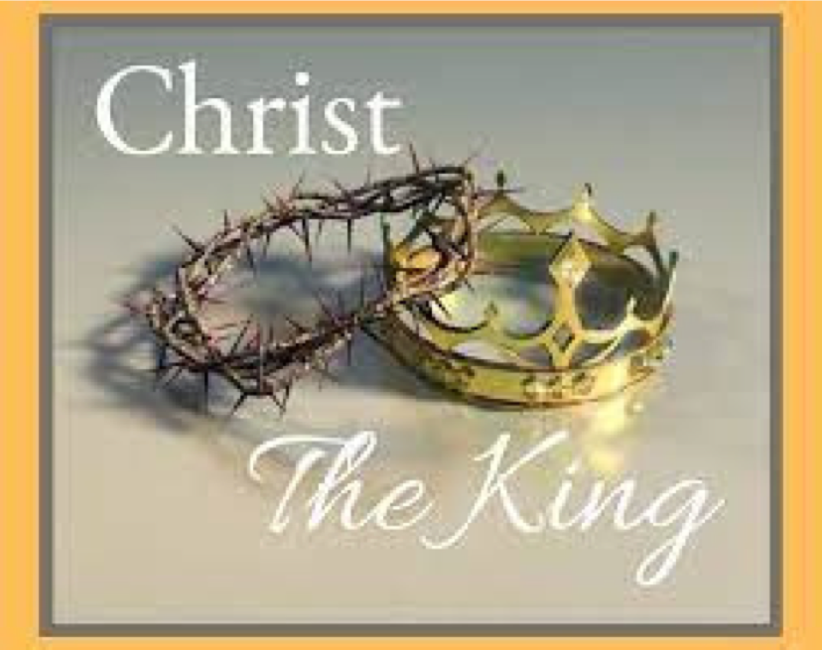

Pastor, Rev. Steven M. Lamb

724-372-1453
Email: blamb@zoominternet.net

******************************************************
November 21, 2021 Liturgist, Donna Fosbrink 10:45a.m.
********************************************************
WELCOME AND ANNOUNCEMENTS
PRELUDE “Thanks To Him” Croft
BRINGING FORTH THE LIGHT

*OPENING HYMN “Crown Him With Many Crowns” 327

*CALL TO WORSHIP
L: We are God’s handiwork,
P: Fashioned out of dust so we might never lose touch
with our mother Earth,
L: Shaped by God so we might never forget to whom we
belong,
P: Created with a heart so we might feel the bonds of
love that stretch between us,
L: Made with a deep yearning so we might seek and be
found by a faithful God.
P: We are God’s delight and we rejoice to praise our
Creator.

*OPENING PRAYER
Holy God, again and again we need to be reminded of our true home. The world continually tugs at us to believe that we belong here, that this is all there is, that hope and fulfillment can be found in what the world offers. We know the truth, Lord, but we forget. We know that you are the source of our life and breath. We know that every good gift we have comes from you. We know that in you we have redemption and forgiveness and are fully known and completely loved. Our true home is in you. Help us to remember. Help us to trust. Thank you for your grace and compassion that continually draw us back home. For the sake of Christ, we pray. Amen.

*GLORIA PATRI 70

NEW TESTAMENT READING Revelation 1:4b-8
The word of God for the people of God. Thanks be to God.

CHILDREN’S MOMENT

PASSING THE PEACE

OFFERTORY PRAYER
(Offerings can be placed in the plate as you leave today.)

*DOXOLOGY

PRAYERS OFFERED IN PRAISE AND PETITION
PRAYER HYMN “Lift High the Cross” 159
PASTORAL PRAYER
SILENT MEDITATION

THE LORD’S PRAYER

ANTHEM “Christians we Have Met/Join To Sing”

GOSPEL READING John 18:33-37
The word of God for the people of God. Thanks be to God.
Thy Word is a lamp unto my feet and a light unto my path

MESSAGE “True That”

*CLOSING HYMN “Majesty, Worship His Majesty” 176

*BENEDICTION
*POSTLUDE
*************************************************
WELCOME
Welcome to this worship service. A time to come away from the world and reflect on all our blessings God has given us.

PRAYER CONCERNS THIS WEEK
Tom & Gloria McMurray Tina Hiltabidel Charles Marko
Maddy Bartholomai Janice Bailey David Leeder
Rich Tressler Jr Mary Tressler Wanda Donner
Misty Lowry Shirley Mathias Marilyn Banks
Twila Filler Judy & Bill McClain Bonnie Bain
Don Heckathorne Dolly King Dorene Provance
Dolores Malik Charlie Smiley Sandy Reich
Edie Mancuso Wyatt Watson Betty Kooser
Chuck & Ann Watson Brenda Rechter Connie Work
Diane & John Monico Amy Marchewka Ozella Roy
Ray Knopsnider James Dougherty Donald Provance
Amy Zvara Carol Tom Jean Rahl
Robert Watson Joyce Pirl Charlotte Holt
Dennis Scheider Wyatt Corvin Trey Corvin
Susan R. Dr. Tom St.Clair Gene Beal
Darlene Borza Clarissa Brooks Paul Holden
Mary Beth Brown Clyde VanSickle Tammy Leeder
Kathy Jarros Angela Myers Paul Hammacker
Jeri Penrod Don Kegley Denny Taylor
Sherrill Goodwin Family of Danny Doppleheuer
Tom Pierce Pastor Steve & Bev
Rev. Bob & Amy Zilhaver Bishop Moore-Koikoi
People with Covid 19 Government leaders Unspoken requests
Folks battling cancer Military persons Those battling addiction
Homebound persons listed in newsletter

THIS WEEK AT ALBRIGHT
TODAY: Tea time & Silent Auction 2:00
MONDAY: T.O.P.S. 10:00 OR 5:00
WEDNESDAY: Assemble newsletter 9:30
Thanksgiving eve worship 7:00 @ Otterbein
THURSDAY: THANKSGIVING DAY
SATURDAY: Hanging of the Greens service 6:00 followed by
snacks & goofy gift exchange
SUNDAY: 1st Sun day of Advent
LAST DAY to order pies for Dec. 11

LITURGISTS: Nov. 28: Ray Keefer
Dec. 5: Glennda Groh
ACOLYTES TODAY: Jack & Lily Geyer
Nov. 28: Olivia Lynn & Mersadie Marko
CHILDREN’S CHURCH: Bonnie & Becky Bloom
COUNTERS: Sherry Grote, Michelle Reich, Allyson Wright

YOUTH NEWS
TEA TIME today at 2pm
Coffee, tea and an assortment of desserts plus a silent auction.

THANKSGIVING EVE SERVICE
At Otterbein. November 24th at 7PM. Please bring a food item for Community Ministries.

CONNELLSVILLE COOPERATIVE PARISH CHARGE
CONFERENCE @ Albright
Monday, December 6 at Parish Council meets at 6:30 the Charge Conference is at 7:30

HANGING OF THE GREENS
Hanging of the Greens is Saturday, Nov. 27 at 6:00. Theme is “White Christmas” . Refreshments & goofy gift exchange will follow the service. Please bring snacks to share.

DECEMBER/JANUARY NEWSLETTER
Need volunteers to assemble at 9:30 Wednesday, November 24.

U.M. WOMEN PROJECT
We are making Pad Empowerment Project kits to send to girls in Africa. We need donations of sewing kits & scissors. Bring items to the church and put them in the box outside the office.

PIE ORDERS
We are taking pie orders again this month with pick up date of December 11. Please see Glenn Siple to get an order form. Paid orders are due November 28. Orders help people attend Annual Conference in 2022.

POINSETTIA ORDERS
We need paid orders for poinsettias in by Dec. 1. No orders will be taken after that date. Order forms are out near the bulletins in the back of the sanctuary.

COIN OFFERING
We will have children take the coin offering the 2nd Sunday each month.

ALTAR FLOWERS
(1)To the GLORY OF GOD and IN LOVING HONOR of our wedding anniversary today (11-21) - Tim & Gina Hough.

(1)To the GLORY OF GOD and IN LOVING MEMORY of Richard Burnworth for what would have been our anniversary Nov. 16 - given by Linda Burnworth.

ALTAR FLOWERS ARE $15 EACH VASE.
Put money in an envelope and drop in offering plate.
To reserve a vase please call Shelley Mattis 724-323-6822

OUR STEWARDSHIP - November 14, 2021
Weekly need for budget ........................................... $ 2,102.31
Sunday offering for budget ................................... $ 1,778.00
Coin offering last Sunday $55.43; Soup sale $560)
Worship attendance ...................................................... 65

OFFICE HOURS Tuesday, Wednesday, Thursday 9:30-1:30 Office phone: 724-628-7130 Elsie at home 724-628-7467

SATURDAY MORNING SPECIAL
If you can help, please contact Karen Marko at 724-880-4500.
December 18 at 11:00-1:00. Christmas party. On the menu is grilled cheese sandwich with tomato soup. They will have a $5 gift exchange.
THANK YOU to those who have been helping with this very special ministry of outreach in our church.

ADVENT DONATIONS FOR FOOD PANTRY
We are asking you to fill a box with food items each day Dec. 1 through 24 add an item to a box. Christmas Eve donate the contents to the food pantry.
Dec. 1: Box of cereal;
2: Peanut butter;
3: Stuffing mix;
4: Boxed potatoes;
5: Macaroni & cheese;
6: Canned fruit;
7: Canned tomatoes;
8: Canned tuna;
9: Dessert mix;
10: Jar of applesauce;
11: Canned sweet potatoes;
12: Cranberry sauce;
13: Canned beans;
14: Box of crackers;
15: Package of rice;
16: Package of oatmeal;
17: Package of pasta;
18: Spaghetti sauce;
19: Chicken noodle soup;
20: Tomato soup;
21: Can corn;
22: Can mixed vegetables;
23: Can carrots;
24: Can green beans

