Albright & Otterbein United Methodist Churches
1626 S. Pittsburgh St. Connellsville, Pa. 15425
Email: albrightumc1626@gmail.com
Office phone: 724-628-7130
www.albrightumcscpa.org
Worship 10:45
Albright organist, Jeanne Meyers
Administrative assistant, Elsie Beal

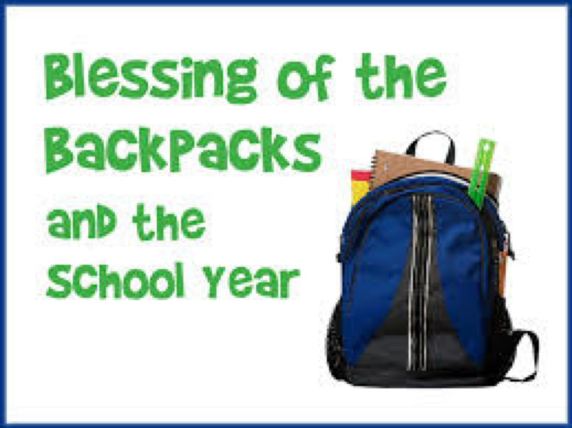

Pastor, Rev. Steven M. Lamb

724-372-1453
Email: blamb@zoominternet.net

August 22, 2021 Liturgist, Karen Marko 10:45a.m.
********************************************************
WELCOME AND ANNOUNCEMENTS
PRELUDE “Ivory Palaces” Barraclough
BRINGING FORTH THE LIGHT
*OPENING HYMN “Stand Up, Stand Up for Jesus” 514

*CALL TO WORSHIP
ONE: Calling all children of the Living God: the gospel is good
news for every age and every stage.
ALL: Let us worship together, the young and the old.
ONE: The good news is proclaimed in God’s words, and also
with crayons, silly songs, snacks, and rest time.
ALL: Let us worship together, every generation.
ONE: After months of learning behind screens or separated by
dividers and physical space,
ALL: Let us worship together, with our family of faith.
ONE: We may still feel uncertain, seeing so many faces again,
but we come together seeking God’s peace in this beautiful
community.
ALL: Let us worship together, united in Christ.

*OPENING PRAYER
God our teacher, who helps us to understand the world around us, Thank you for the privilege of education. In a year of turmoil, disruption, and loss, we recognize the gift of learning and the gift of teaching in ways we may not have appreciated before. You have blessed our communities with teachers who take new skills and concepts and pass them along to each new class of young people. God who came as a child to show us how to be fully human, to show us how to be children of God, You have given our children minds that grow and develop in unique ways, at unique speeds, and we are astounded by that miracle. You speak to us through the words, actions, play, and feelings of children. You call us to listen to the Spirit speaking through our young siblings in Christ. We celebrate the beginning of this school year and ask for your blessings upon the children, the educators, and the families who support them. But in this celebration of education and learning, we do not forget there are children and families and teachers who do not have the resources they need. When systems are unjust, who are beginning school this year: those who have what they need to learn and grow in safety, and those who lack supplies, teachers, safe buildings, and accommodations for all needs and abilities. We come to worship together, to lift up our young people and all those who care for them and teach them. Open our hearts to what you are saying to us today. Amen.

*GLORIA PATRI 70

OLD TESTAMENT READING Psalm 84
The Word of God for the people of God. Thanks be to God

PASSING THE PEACE

CHILDREN’S MOMENT & Blessing of the backpacks

SPECIAL MUSIC

OFFERTORY PRAYER
(Offerings can be placed in the plate as you leave today.)
*DOXOLOGY

PRAYERS OFFERED IN PRAISE AND PETITION

PRAYER HYMN “Precious Lord Take My Hand” 474

PASTORAL PRAYER

SILENT MEDITATION
THE LORD’S PRAYER

SPECIAL MUSIC

NEW TESTAMENT READING Ephesians 6:10-20
The word of God for the people of God. Thanks be to God.
Thy Word is a lamp unto my feet and a light unto my path

MESSAGE: PPE
CLOSING PRAYER

CLOSING HYMN “Onward Christian Soldiers” 575
*BENEDICTION
*POSTLUDE
WELCOME
Welcome to everyone! We pray you will stay safe and healthy. We pray you are blessed by being here.
PRAYER CONCERNS THIS WEEK
Tom & Gloria McMurray Tina Hiltabidel Charles Marko Maddy Bartholomai Janice Bailey David Leeder Rich Tressler Jr Mary Tressler Wanda Donner Misty Lowry Shirley Mathias Marilyn Banks
Twila Filler Judy & Bill McClain Ed Stout Don Heckathorne
Dr. Tom St.Clair Bonnie Bain Dolly King Dorene Provance Dolores Malik Charlie Smiley Sandy Reich Edie Mancuso
Chuck & Ann Watson Bernie Winemiller Brenda Rechter Wyatt Watson
Diane & John Monico Betty Kooser Jack Snyder Carma Locke
Connie Work John & Jean Shaffer Evelyn Curry Dorothy Ridgway George Duffer Susan McDorman Sally Heaton
Donna & John Sage Gloria Jean Porter Amy Marchewka Ozella Roy
Ray Knopsnider James Dougherty Donald Provance Amy Zvara Shelley Mattis Carol Tom Joe Childs Shirley Mays
Bill Shupe Kelly Addis Jean Rahl Randy Fisher
Patti Rhines Rebecca Rowan Robert Watson Judy Whipkey
Loren Krautz Joyce Pirl Scott Murray Kay Trump
Addison Schrock Leah Miller Pastor Steve & Bev Rev. Bob & Amy Zilhaver Those with Covid 19 Bishop Moore-Koikoi Government leaders Unspoken requests Folks battling cancer Those battling addiction Military persons
Homebound persons listed in newsletter
DEEPEST SYMPATHY TO the family of Tim Holt who passed away August 13. Jackie Bartholomai’s uncle.

THIS WEEK AT ALBRIGHT
TODAY: Blessing of backpacks service
MONDAY: T.O.P.S. 10:00 & 5:00
THURSDAY: 55+ luncheon 11:00-1:00
SATURDAY: Acolyte Training 10:00
SUNDAY: Potluck covered dish after church

LITURGISTS: August 29: Shelley Mattis
September 5: Chelsea Bartholomai

OFFICE HOURS:
Tuesday, Wednesday, Thursday 9:30-1:30
Office phone: 724-628-7130
You may call Elsie at home: 724-628-7467

FELLOWSHIP DINNER - Women, Men & Children
Tues., Sept. 14 U.M. Women are hosting a Fellowship dinner at 6:00; program at 7:00. The program will be an emotional presentation of “Mary, the Mother of Jesus” by Lou Ann Baker. Everyone is invited to attend. This is a program you won’t want to miss.
Reservations for the dinner are needed by Sept. 7.
Dinner is $12.00. Please use the form out near bulletins to make paid reservations. MENU: Breaded chicken, ham, scalloped potatoes, green beans, tossed salad, cole slaw,
dessert & beverage.

CONNELLSVILLE AREA COMMUNITY MINISTRIES
Is in GREAT NEED of VOLUNTEERS. Even an hour or two will be greatly appreciated. PLEASE HELP!!

55+ LUNCHEON
Thursday, August 26 at 11:00-1:00. If you are willing to serve one time, please let Bev know 724-372-1456.

COVERED DISH POTLUCK LUNCH
Sunday, August 29 following morning worship we will once again be having a covered dish potluck meal. Please bring a dish to share and join us for the fellowship.

OUTDOOR WORSHIP & PICNIC
Sun., Sept. 12: Our annual outdoor worship service near the memorial garden followed by a covered dish picnic in the pavilion. The Richters will be presenting special music for the worship service.

Connellsville District United Methodist Women
DAY APART at Jumonville Thursday, September 9
8:15 Coffee hour; 9:15 Worship
SPEAKER: District Superintendent Eric Park
“Knitted Together for God’s Good Work”
FULL DINNER $12.00; BROWN BAGGERS $1.50
Registration & money needed to Elsie by August 25.
ALL WOMEN OF THE CHURCH ARE INVITED TO ATTEND.

SATURDAY MORNING SPECIAL
We will be having a gathering the third Saturday each month through December. This ministry is for people with special needs. To volunteer, please see Karen Marko.

ALTAR FLOWERS
(1)To the GLORY OF GOD and IN LOVING MEMORY of Jane Williams - given by Randy Fisher.
(1) OPEN VASE - To the GLORY OF GOD and IN LOVING HONOR of Pastor Steve & Bev - given by the church.

ALTAR FLOWERS ARE $15 EACH VASE.
Put money in an envelope and drop in offering plate.
To reserve a vase please call Shelley Mattis 724-323-6822

OUR STEWARDSHIP - August 15, 2021
Weekly need for budget ........................................... $ 2,102.31
Sunday offering for budget ................................... $
Worship attendance ...................................................... 73

Attention Children
CHILDREN’S CHURCH
We will begin having Children’s church again. We need Children to come & volunteers to teach. If you are willing to voluntee, please see Pastor Steve. Clearances are needed.
Please use the form in this bulletin to volunteer. Thank you!

ACOLYTES
Children in first grade or older. A training session will be held on Saturday, August 28 at 10:00 a.m.

SUNDAY SCHOOL
We will begin having Sunday school at 9:30 on Sunday, Sept. 5. We need students & teachers. Please use the form in this bulletin to volunteer.

WESLEY HEALTH CENTER
Is in need of donations to be able to give free flu shots to everyone this fall - since the government doesn’t help.

BORN AT CONNELLSVILLE HOSPITAL?
If so, we need your picture for a celebration at the Hospital on September 17 - the 130th anniversary of the hospital & the Stork Club. This will be an annual celebration with all kind of activities
You may send pictures to Pam Bartholomai - c/o Highlands Hospital. For more information: email - Faypray@hotmail.

VOLUNTEER SHEET
We would appreciate volunteers to help with Children’s Church during morning worship and teachers for Sunday school. You will need to have clearances if you volunteer.

We also need to know names of children willing to be
acolytes for morning worship services.

Please use the space below to let us know if you are willing to volunteer and let us know names of children for acolyting.

I am willing to volunteer to be a leader for Children’s Church during morning worship

Name ________________________________________________

Phone number _____________________________

_____Have clearances _____Am getting clearances

I am willing to volunteer to be a Sunday school teacher for Sunday mornings

Name __________________________________________________

Phone number _____________________________

____Have clearances _____Am getting clearances
If you haven’t gotten clearances since 2016, you may get them at any State Police Station or go online: https;//epatch.state.pa.us
If you’re not sure, check with the church office. They are on file there.

My child would like to be an acolyte

Child’s name _________________________________Age_____

Parent’s name ________________________________________

Parent’s phone number ____________________________

