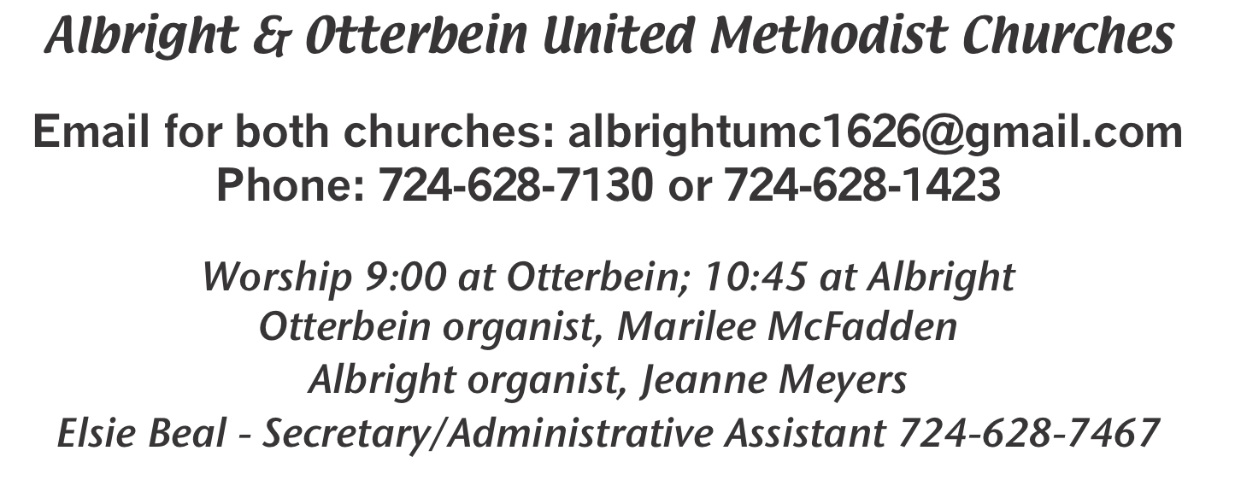

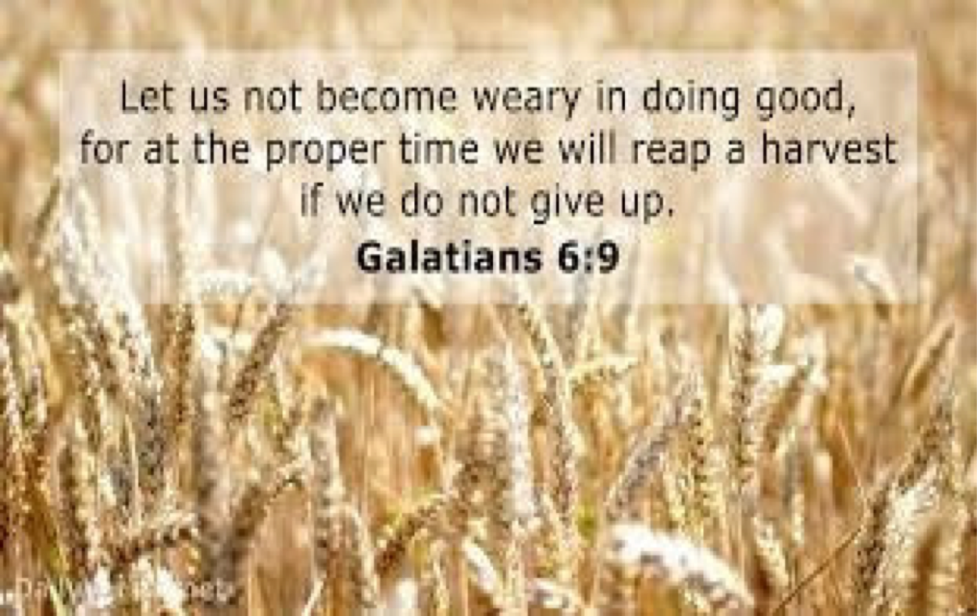

November 1, 2020 Otterbein 9:00; Albright 10:45
All Saints Day
????????????????????????????????????????????????????????????????????????????

WELCOME & ANNOUNCEMENTS

PRELUDE (A)“Reach Out to Jesus” Carmichael

*OPENING HYMN “The Church’s One Foundation” 545

*CALL TO WORSHIP
L: Jesus did not come to establish denominations.
P: He came to bring salvation to all who call upon his holy name.
Leader: Let us cast aside all that which is petty and irrelevant.
People: Let us put away childish things that only serve to bring division and duress.
Leader: The Lord calls us as one. God sees us as one.
All: We are the “church” together!

*OPENING PRAYER
O Lord, our Savior, you have warned us that you will require much of those to whom much is given; grant that we, whose lot is cast in so godly a heritage, may strive together more abundantly to extend to others what we so richly enjoy; and as we have entered into the labors of others, so to labor that others may enter into ours, to the fulfillment of your holy will; through Jesus Christ our Lord.
—St. Augustine of Hippo (354-430)

*GLORIA PATRI

OLD TESTAMENT READING Joshua 3:7-17
The Word of God for the people of God. RESPONSE: Thanks be to God.

(A)ANTHEM “When We Gather at the Table”

SERVICE OF HOLY COMMUNION

LORD’S PRAYER

PASSING THE PEACE

OFFERTORY PRAYER
(Offerings can be placed in the plate as you leave today.)
*DOXOLOGY

PRAYER HYMN “In The Garden” 314

PASTORAL PRAYER

EPISTLE READING I Thessalonians 2:9-13
The Word of God for the people of God. RESPONSE: Thanks be to God.
Thy Word is a lamp unto my feet and a light unto my path

MESSAGE “WE.....”

*CLOSING HYMN “I Am the Church” 558

*BENEDICTION

*POSTLUDE

*****************************************************

WELCOME: Welcome to worship on this All Saints Day. We are
glad to have you with us and pray you are blessed by being here.

*****************************************************

OTTERBEIN PRAYER CONCERNS
Art & Dorothy McGann Debbie Knupsky Joan Truxel
Jane McGann Gaylord Gardner Lisa Smarto
Leroy & Twila Filler Alicia Glassburn Regina Bosch
Jim Wagner Charlie Etling Elsie Beal
Connie Macioce Tammy Johnaon Pastor Steve & Bev
Easton & Elliott Hough Rev. Bob Zilhaver Bishop Moore-Koikoi
Our government leaders Those unable to attend worship
All military persons Those battling cancer
Those battling addiction Healthcare workers

NEW ADDRESSES
Art & Dorothy McGann
c/o Dick McGann -
1109 Wessington Manor Lane - Fort Mill, SC 29715

Rev. Craig & Beth Forsythe
PSC 47 Box 604
APO, AEO 09470

Please send cards to them and let them know we are thinking of them.

OTTERBEIN NEWS
OUR STEWARDSHIP - Oct. 25, 2020
Sunday offering ......................................................................... $ 2,153.79
Sunday worship attendance ...................................................... 41
Sunday school attendance ......................................................... 11
Sunday school offering .............................................................. $ 6.00

THANK YOU
We want to thank everyone who supported our sub sale last weekend. We made $723.21.

Thank you to those who came and prepared the Chronicles for mailing.

LITURGISTS
Today: John Huey; Nov. 8: Bev Lamb; Nov. 15: Linda Suter

ALTAR FLOWERS
To the GLORY OF GOD and IN LOVING HONOR of Char for her birthday
Oct. 27 - given by Donna.
To reserve a vase for an open week, please see the list posted in the Narthex. Cost is $15
a vase. Open vases: Nov. 8, 15; Dec. 20, 27.

Sunshine Circle News
November 8th is LAST day to order SOUP Cheesy Potato, Chicken Noodle, and
Vegetable beef. A sign-up sheet for orders ($6 qt) & is available in the Narthex.
All orders will be available for pick-up on Sunday, Nov. 15th.

SUB SALE
Albright United Methodist Church is taking orders for
12” subs until Nov. 8. Pick up Fri., Nov. 13 at 10:30-12:30.
$8 each. Use the order form in this bulletin to place orders.

OFFICE INFORMATION: To reach Elsie, call her 724-628-7467 or email church.

TUESDAY, NOVEMBER 3 - ELECTION DAY!! VOTE!!

EVERY WEDNESDAY
Bible study 6:30 at Albright in dining room. Everyone welcome!

THANKSGIVING FOOD BOXES
Albright youth will be preparing 12 boxes of food to be given to families in need
on Sunday, Nov. 22. It has everything needed for a Thanksgiving
dinner. This year we are asking for monitary donations and they will buy the
items for boxes. If you know of anyone who is in need of a food box, please call
Sherry Grote 724-562-2950 with names as soon as possible.

ALBRIGHT: PRAYER CONCERNS
Tom & Gloria McMurray Tina Hiltabidel Martha Roe
Charles Marko Maddy Bartholomai Janice Bailey
David Leeder Rich TresslerJr Tim Holt
Mary Tressler Wanda Donner Dorman Jacobs
Misty Lowry Shirley Mathias Marilyn Banks
Leroy & Twila Filler Judy & Bill McClain Ed Stout
John & Karen Hohmann Dolores Blaney Don Heckathorne
Butch Sandusky Ruby VanDyke John Shallenberger
Linda Philbaum Dr. Tom St.Clair George Pasipanki
Amy Zvara Kathy Cunningham Linda Burnworth
Elsie Beal Chuck & Ann Watson Michael Shoemaker
Shirley Peterson Deb Strother Tammy Brooks
Elaine Snyder Jackie’s friend Sue Bonnie Bain
George Flair Winona Johnson Savanah Simpson
Susie Kimmel Beverly Guynn Maggie Corvin
Joe Mongell Brown Family Pastor Steve & Bev
Rev. Bob Zilhaver Bishop Moore-Koikoi Healthcare workers
Government leaders Those battling cancer All military persons
Unspoken requests Those battling addiction Those with covid 19
Homebound persons listed in newsletter

ALBRIGHT NEWS
OUR STEWARDSHIP - Oct. 25, 2020
Sunday offering for budget ...................................................... $ 1,861.00
Worship attendance .................................................................... 52

LITURGISTS
Today: Karen Stimmell; Nov. 8: David Groh; Nov. 15: Donna Fosbrink

ALTAR FLOWERS
(1)To the GLORY OF GOD and IN LOVING MEMORY of mom, Audrey Fisher - given by Son, Douglas.
(1)To the GLORY OF GOD and IN LOVING HONOR of Mildred Flair for her birthday - given by Son, Mark.

BONFIRE TODAY
Beginning at 6:00 around the fire ring in the lawn. Snacks available.

CHANCEL CHOIR PRACTICE Thursdays at 7:00.

SOUP SALE
Saturday, November 14 at 11:00-1:00. A variety of homemade soups available for $6 a quart; $3 pint. We will need donations of soup. Please tell Siples, Pastor Steve, Bev or Elsie if you will donate and what kind.

Seller _______________________________ 12” Subs $8.00
Benefits Christmas gifts for Veterans

Name Phone # How many Total Due Paid

1. ______________________________________________________________

2._______________________________________________________________

3._______________________________________________________________
Orders due by November 8. May be picked up at Albright
at 10:30-12:30 Friday, November 13.

