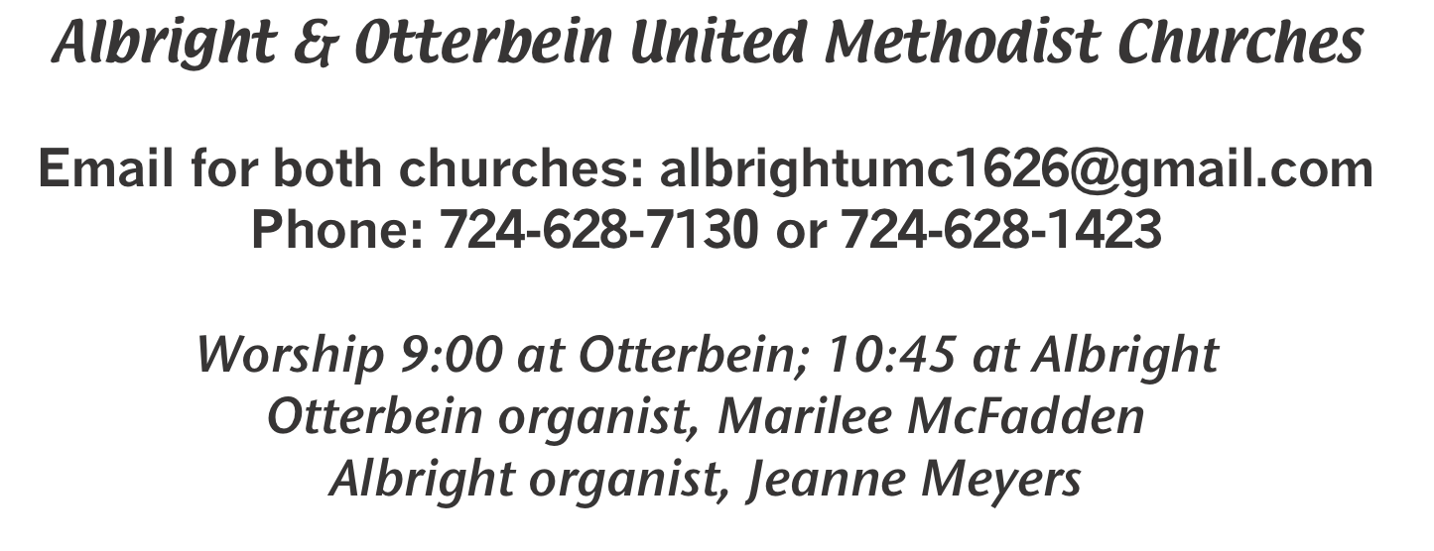

October 11, 2020 Otterbein 9:00; Albright 10:45
Albright & Otterbein United Methodist Churches
????????????????????????????????????????????????????????????????????????????
ANNOUNCEMENTS
PRELUDE (A) “Sheltered in the Arms of God” Rambo and Davis

*OPENING HYMN “Holy, Holy, Holy, Lord God Almighty” 64

*CALL TO WORSHIP
L: People of God, the Lord is merciful!
P: God forgives our sin and pardons all our debts.
L: People of God, the Lord is good!
P: God restores us to the way of salvation.
L: People of God, the Lord is love!
P: God revives our spirit so that we may rejoice.
L: People of God, the Lord is faithful!
P: God speaks so that we may follow.
L: People of God, the Lord is righteous!
P: God’s glory fills this place. Let us worship the Lord our God!
—Based on Psalm 85

*OPENING PRAYER
Persistent and loving God, you are forever seeking for your will to be done on Earth. You yearn for all creation to live in harmony. Forgive us for growing weary of the struggle for peace and justice, and for courting despair. Loosen our need to see the full results and to feel hopeful. Sustain us with an abundance of friends and a measure of faith. Give us the willingness to do the loving thing and to be faithful in the small acts of caring. God of the hidden seed and the promised resurrection, work your surprising and amazing grace in our lives and in our broken world. Amen.

OLD TESTAMENT READING Psalm 106: 1-6 & 19-23
The Word of God for the people of God. RESPONSE: Thanks be to God.

*GLORIA PATRI

PASSING THE PEACE

OFFERTORY PRAYER
(Offerings can be placed in the plate as you leave today.)

*DOXOLOGY
PRAYER HYMN “Precious Lord, Take My Hand” 474

PASTORAL PRAYER
SILENT PRAYER
LORD’S PRAYER

(A)ANTHEM “If We Ever needed/ Down by the Riverside”

EPISTLE READING Philippians 4:1-9
The Word of God for the people of God. RESPONSE: Thanks be to God.
Thy Word is a lamp unto my feet and a light unto my path

MESSAGE “Let your gentleness be evident to all” Guest speaker, Karen Sholtis
*CLOSING HYMN “Here I Am Lord” 593

*BENEDICTION
POSTLUDE

*****************************************************
WELCOME: Lord, in this beautiful time of year, may we
grow closer to You and enjoy what you have given us.
We welcome everyone who has come to worship with us.
*****************************************************

OTTERBEIN PRAYER CONCERNS
Art & Dorothy McGann Debbie Knupsky Joan Truxel
Jane McGann Gaylord Gardner Lisa Smarto
Leroy & Twila Filler Alicia Glassburn Regina Bosch
Jim Wagner Charlie Etling Elsie Beal
Connie Macioce Connie DeBolt Tammy Johnson
Pastor Steve & Bev Easton & Elliott Hough Rev. Bob Zilhaver
Bishop Moore-Koikoi Our government leaders
Those unable to attend worship All military persons Those battling cancer
Those battling addiction Healthcare workers

OFFICE INFORMATION
Elsie is working at home for awhile. To get in touch with her call 724-628-7467 or
email the church email address on front of this bulletin.

BIBLE STUDY
Pastor Steve leads Bible study on Wednesdays 6:30 in Albright dining hall.
Everyone is invited to join us.

ALBRIGHT: PRAYER CONCERNS
Tom & Gloria McMurray Tina Hiltabidel Martha Roe Charles Marko
Maddy Bartholomai Janice Bailey David Leeder Rich TresslerJr
Tim Holt Mary Tressler Wanda Donner Dorman Jacobs
Misty Lowry Shirley Mathias Marilyn Banks Leroy & Twila Filler
Yvonne Murray Judy & Bill McClain John & Karen Hohmann Ed Stout
Dolores Blaney Don Heckathorne Butch Sandusky Ruby VanDyke
John Shallenberger Linda Philbaum Dr. Tom St.Clair George Pasipanki
Amy Zvara Kathy Cunningham Linda Burnworth Elsie Beal
Chuck & Ann Watson Michael Shoemaker Shirley Peterson Deb Strother
Tammy Brooks Della Bittner Shelley Mattis Elaine Snyder
Barney & Kim Shipley Jackie’s friend Sue Bonnie Bain Pastor Steve & Bev
Rev. Bob Zilhaver Bishop Moore-Koikoi Healthcare workers Government leaders
Those battling cancer All military persons Unspoken requests Those battling addiction
Those with covid 19 Homebound persons listed in newsletter

ALBRIGHT: OUR STEWARDSHIP - Oct. 4, 2020
Sunday offering for budget ...................................................... $ 2,557.06
Worship attendance .................................................................... 39

LITURGISTS
Today: Sherry Grote
Oct. 18: Eve Shupe
Oct. 25: Bonnie Bloom

ALBRIGHT ALTAR FLOWERS
(1) To the GLORY OF GOD and IN LOVING MEMORY of of Alma “Peep” Burke - given by Laura & Bob Locke
(1) To the GLORY OF GOD and IN LOVING MEMORY of Clair Costello
given by Kathy & David Pasipanki & Dehn

CHANCEL CHOIR PRACTICE
Thursdays at 7:00. You are invited to join us. The only requirement is that you love to sing praises to God.

WOMEN’S NEWS
Tuesday, October 13 @ 6:30: Otterbein Sunshine Circle and Albreght United Methodist Women will have a combined Thank Offering & Memorial program at Albright church. A light lunch will be served.

OTTERBEIN: OUR STEWARDSHIP - Oct. 4, 2020
Sunday offering ......................................................................... $ 3,645.00
Sunday worship attendance ...................................................... 40
Sunday school attendance ......................................................... 7
Sunday school offering .............................................................. $ 7.00

LITURGISTS
Today: Melissa Miner
Oct. 18: Linda Suter
Oct. 25: Nancy Calisti

OTTERBEIN: ALTAR FLOWERS
To the GLORY OF GOD and IN LOVING HONOR of Jake Miller for his birthday today - given by wife, Sharon.
To reserve a vase for an open week, please see the list posted in the Narthex. Cost is $15 a vase. Open vases: Oct. 18, Nov. 8, 15, 29; Dec. 13, 20, 27.

OTTERBEIN: Sunshine Circle News
October 1st through November 8th: SOUP SALE again this fall including
Cheesy Potato, Chicken Noodle, and Vegetable. A sign-up sheet for orders ($6.00 quart) is available in the Narthex from Oct. 1st through Nov. 8th at both churches. All orders will be available for pick-up on Sunday, Nov. 15th.
Rada Cutlery catalogs will soon be available and orders may be placed
during October.

OTTERBEIN:
Saturday, October 24: Hoagie sale @ 10:30-12:30.
They are 12” and are $8 each. We are asking for pre sale orders. The LAST DAY to order is Oct. 18. Please use the order form in your bulletin. Anyone who would like to volunteer either Friday evening or Saturday morning see Sharon Miller after church, or call her at 724-628-3874.

Pastor Appreciation Day
Sunday, Oct. 18 during the morning worship we will honor
Pastor Steve & Bev. There will not be a dinner, but everyone will be given a cupcake as they leave the service. Next year we are hoping to have a dinner to honor them and show them our appreciation. There are offering envelopes available for your donations toward a gift for them.

IMPORTANT DATE FOR CALENDAR
December 8: C’ville Co-Op Council 6:30-7:30 @ Albright
C’ville Co-Op Charge Conference 7:30-8:30 @ Albright

